 

**Hiring Consulting Firm For**

**End line Evaluation**

World Vision Bangladesh (WVB) is hereby inviting Request for Proposal (RFP) from the experienced consulting firm for **“End line Evaluation for Capacity building of young entrepreneurs for the vitalization of the Digital Giga Island of Maheshkhali”.**

# General RFP Guidelines and Instructions:

•

|  |  |
| --- | --- |
| RFP Name: | **“End line Evaluation for Capacity building of young entrepreneurs for**  **the vitalization of the Digital Giga Island of Maheshkhali”.** |
| RFP Reference: | **BRCR-WVB-SCM-RFP-509833** |
| Date | 30/07/2024 |
| Proposal submission: | **No Soft Copy**  For Hard Copy  Tender Box-3, Sayeman Heritage Residence, Block B 2nd Floor,  Baharchara, Jhawtola, Cox’s Bazar-2700, Bangladesh  During WVB Office Working days (Sunday – Thursday) (09:00a.m. to 05:00p.m.) except Govt. Holidays. |
| Deadline for the submission of  proposals: | Deadline for proposal submission is: **On or before August 12, 2024**  **within 5.00 P.M** |
| Procurement Focal Point: | **Jesayel Hembrom**, Supply Chain Coordinate-BRCR, World Vision  Bangladesh, **Mobile: +8801712406745**, E-mail: [Jesayel_hembrom@wvi.org,](mailto:Jesayel_hembrom@wvi.org) |
| WVB Contact regarding | **Harun Ar Rashid**, Manager -MEAL, BRCR, World Vision |
| Technical Specification: | Bangladesh, Cox’s Bazar, **Mobile: +**8801716037122, Email: |
|  | [harun_rashid@wvi.org](mailto:harun_rashid@wvi.org) |

**WVB reserves the right to accept or reject any or all the proposals in full or part with or without assigning any reason whatsoever.**

**Terms of Reference (ToR) Of End line Evaluation**

**Project for “Capacity building of young entrepreneurs**

**for the vitalization of the Digital Giga Island of**

**Maheshkhali”**

**July, 2024**

**Table of Contents**

# Evaluation Summary 3

# Description of Project Being Evaluated 5

# Project Description 6

# Project Objectives 6

# Rational of the Study 6

# Objectives of the End Line Evaluation Study 7

# Indicators to be assessed 8

# Intervention area map 9

# Project Location 11

# Target Population Category 11

# Proposed approach and Methodology 11

# Population distribution in the community 12

# Duties and Responsibilities 12

# Deliverables… 12-13

# Required Qualification and Experience of the Consultancy firm/Consultant…13-14

# Proposal submission 14-15

# Selection Criteria… 16

# Scheduling Time Frame… 17

# Application process 17

# Standards of Ethics and Safeguarding… 18-19

**Evaluation Summary**

|  |  |  |  |  |  |  |
| --- | --- | --- | --- | --- | --- | --- |
| **Project Name** | Capacity building of young entrepreneurs for the vitalization of the Digital  Giga Island of Maheshkhali | | | | | |
| **Project Number** | B218942 | | | | | |
| **Project Duration** | 14th January, 2022 to 31st December, 2024 (03 Years) | | | | | |
| **Assessment Type** | End line evaluation study | | | | | |
| **Target Location** | Maheshkhali Upazila, Cox’s Bazar District, Chittagong Division, Bangladesh | | | | | |
| **Purpose of the**  **Consultancy** | The purpose of the consultancy for the end line evaluation is to assess the final outcome and impact indicators, comparing them with baseline values to determine the overall effectiveness and impact of the project. This evaluation will review the accuracy of the project targeting and implementation approach, identify any implementation gaps, and document lessons learned to propose adjustments that enhance the project's impact and ensure alignment with the current context and goals.  Additionally, the consultancy will reassess the risks and assumptions within the Logical Framework Approach, providing feasible recommendations to mitigate identified risks and validate assumptions based on end line data. The final deliverable will be a comprehensive evaluation report detailing findings, analysis, and recommendations, including stakeholder feedback to ensure a thorough and  inclusive assessment of the project's achievements and challenges. | | | | | |
| **Target population** |  | | | | | |
|  | **Type Household Individual Participants** | | | |  |
|  |  | **Female** | **Male** |  |
| Entrepreneur | 90 | 33 | 57 |  |
| Producer | 250 | 91 | 159 |  |
| **Total** | **340** | **124** | **216** |  |
| **Study design** | Mixed methods combining both quantitative and qualitative studies with  collection of both primary and secondary data. Quantitative survey will be as census that mean 100% population (340 households) will be treated as sample. For qualitative study, KII and FGD will be conducted with bot sex and both type of  beneficiaries. | | | | | |
| **Time frame** | The evaluation process will commence on August 13, 2024 and ends by October 31, 2024. Preliminary result of the evaluation is required to be released latest by November 4, 2024. This will be an input for the on-going strategy development process. | | | | | |
| **Anticipated date of**  **report release** | Final report will be produced and released by 4th Week of Nov 2024 | | | | | |

|  |  |
| --- | --- |
| ***Terms of Reference Approval:*** | |
| *Prepared by* | *Biplob Kumar Biswas, M&E Officer, KOICA-CEVM Project, World Vision-BRCR* |
| *Reviewed by* | *Hyejin Na, CEVM Project Advisor, World Vision Korea* |
| *Mohammad Fazlur Rahman, Project Manager, KOICA-CEVM Project, World Vision-BRCR* |
| *Version Status* | *Final* |
| *Date Submitted* | *7th July, 2024* |
| *Approved by* | *Harun Rashid, MEAL Manager, World Vision-BRCR* |

**Description of Project Being Evaluated** Maheshkhali Island is considered one of the remotest and least developed areas of Bangladesh. Besides, the poverty rate in this island (25.2%) is significantly higher than the district average (16.6%) and the national average (24.3%). The literacy rate here is significantly lower than other parts of the country as it stands at 30.80% for Maheshkhali whereas the national rate is 74.7%. The low urbanisation rate (16.93%) in Maheshkhali suggests a lack of adequate infrastructure, and existing facilities are being impacted by high tides, heavy seas, and recurring disasters. IOM reports that higher incidence of poverty and lack of sustainable livelihood opportunities force youths from Maheshkhali to migrate.

The ongoing onslaught of COVID-19 has hit the country hard and Maheshkhali is no exception to that. Most of the upazilas population relies on daily wages from formal and informal work in the agricultural (61.92%) and service sectors, which came to a halt during the lockdown. The main earning sources are - salt production, dry fish production, shrimp and crab farming, fishing, agriculture, and day labour. Employment is largely seasonal, and people are frequently engaged in two or more occupations, switching according to seasons. It is reported that the unemployment rate has increased since land for the ongoing power plant projects was acquired; the construction firms do not employ locally. Furthermore, women are not directly involved in income generation as social taboos force women to be grounded to home-based activities only. To worsen the situation further, Maheshkhali is regularly exposed to extensive flash flooding from the Bay of Bengal, threatening livelihoods and food security. Seawater inundation increases soil salinity, impacting drinking-water supplies, irrigation, and soil quality for agriculture. The Island is extremely vulnerable to cyclones as it is reported that there is hardly any family who did not lose any of its family members in the 1991 cyclone. Frequent disasters exacerbate existing challenges of livelihoods, access to drinking water, and low access to improved sanitation facilities, and the risk of infectious disease. The affected areas remain waterlogged for days, communication systems get disrupted that adversely affects the people of Maheshkhali. KOICA’s internal review states that following the “Digital Island Maheshkhali” project, online training activity has been continuing but the e-Commerce utilization approach is not significant. In order to foster the existing e- Commerce platform, additional capacity building needs to be provided to young social entrepreneurs. Dried fish is a renowned local specialty in Maheshkhali Island, but selling the fish via e- Commerce is not activated due to the low quality and low price competitiveness of the products. Hence, it is imperative to focus on the capacity building of youth e-Commerce entrepreneurs and create an enabling environment for them while improving the product quality to enhance their competitiveness and income. Besides, there is a lack of business plans and difficulties in identifying entrepreneurs involved in informal business sector especially in this area where agro fisheries products are dominant in terms of production and the lack of linkage with national and international market often leads to failure to recover

 

cost and lack of market information and infrastructures often results in obtaining the entrepreneurial success.

**Project Description** World Vision Bangladesh Rohingya Crisis Response (WVBRCR), in collaboration with the Resource Integration Center (RIC), is implementing the “Capacity Building of Young Entrepreneurs for the Vitalization of the Digital GiGA Island of Moheshkhali (CEVM) Project.” Funded by the Korean International Cooperation Agency (KOICA), this project aims to empower the community members of Moheshkhali Island by providing capacity-building training aligned with Bangladesh and KOICA’s development cooperation strategy. The project focuses on enhancing e-commerce management and product quality control capacities among youth entrepreneurs and agro-fishery producers, thereby contributing to sustainable income-generating skills within the community.

The CEVM project targets 90 youth entrepreneurs and 250 dry fish producers, facilitating their business operations through five digital business hubs. These hubs support both offline and online e-commerce business activities, fostering a robust environment for economic growth and sustainable development on Moheshkhali Island.

# Project Objectives

* Empower community youth entrepreneurs and producers in Maheshkhali Island through capacity-building trainings and input support.
* Strengthen the e-commerce facilities and services to facilitate efficient management of e- commerce system for entrepreneurs and producers
* Networking & advocacy with government departments, private sectors & local stakeholders for youth & women entrepreneurship development.
* Improve sustainable income generating activities through access to the e-commerce facilities & services and input support.

# Rational of the Study

The rationale of the end line evaluation study is to assess the final values of project outcome and impact indicators, providing a comprehensive understanding of the project's overall effectiveness and impact. This evaluation will compare the end line data with baseline values to measure progress and identify key achievements and areas needing improvement. The findings will offer critical insights into the success of the project's implementation approach, allowing for a detailed analysis of the gaps and challenges encountered. This process will ensure that the project's objectives have been met or not and will inform future project planning and design.

The consultant team will assess the relevance, coherence, effectiveness, efficiency, impact and sustainability of the project.

Additionally, the end line evaluation will reassess the project's risks and assumptions, providing updated recommendations to address any identified issues. This evaluation will also validate the success of the project's targeting and implementation strategies, ensuring they are aligned with the current context and goals. The final report will provide valuable feedback to stakeholders and contribute to continuous improvement by highlighting best practices and lessons learned, ultimately enhancing the project's sustainability and impact.

# Objectives of the End Line Evaluation Study The main objectives of the end line evaluation study are as follows:

* Evaluate Project Outcomes and Impact: Assess the final outcome and impact indicators to measure

the project's overall effectiveness, comparing end line data with baseline values to determine progress and achievements.

* Identify Implementation Successes and Gaps: Analyze the implementation process to identify key successes, challenges, and gaps encountered during the project. Provide recommendations for addressing these gaps and enhancing future project activities.
* Assess the Adoption and Impact of E-commerce: Measure the prevalence and effectiveness of agro-fisheries-based e-commerce in the target area using predefined indicators, evaluating the impact on the target population.
* Reassess Risks and Assumptions: Review the risks and assumptions outlined in the Logical Framework Approach, providing updated recommendations to mitigate identified risks and validate assumptions based on the end line data.
* Validate and Refine Project Strategies: Validate the success of the project's targeting and implementation strategies, ensuring they are aligned with the current context and objectives. Offer insights for refining future project strategies and activities.
* Document Lessons Learned and Best Practices: Capture lessons learned and best practices throughout the project implementation, providing valuable insights for continuous improvement and future project planning.
* Engage Stakeholders and Disseminate Findings: Ensure stakeholder engagement by sharing the evaluation findings and incorporating feedback, thereby fostering transparency and collaborative learning.

**Indicators to be assessed**

|  |  |  |
| --- | --- | --- |
| **Project Summary** | | **Indicators** |
| **Goal** | Sustainable income generation in  Maheshkhali Island through vitalization of e-commerce | The percentage of the number of youth  entrepreneurs and producers whose annual income through e-commerce business increase |
| **Outcomes** | 1. Empowerment of communities  to vitalize the e-commerce system | The percentage of the number of youth  Entrepreneur groups who trade products through e- commerce platforms |
| The percentage of the number of producer  groups who obtained Food Quality Certifications from Maheshkhali Upazila local government. |
| 2. Establishment of environment  (infrastructure) to manage e- commerce system in an efficient way | The percentage of utilization of e-commerce  center and e-hub (% of young entrepreneurs and producers using product storage, delivery, marketing, mobile banking, etc.) |
| **Outputs** | 1.1 Empowerment of young  entrepreneurs to manage e- commerce | The number of youth entrepreneurs who has  ICT skills for e-commerce operation (who have obtained at least 70 points in the ICT competency test at the end of training) |
| The number of youth entrepreneurs who  received e-commerce capacity building training |
| 1.2 Capacity building of producers  to improve the quality of agro- fishery products | The number of producer groups who are  supported with equipment and inputs for agro- fishery products quality management |
| The number of producers who received agro-  fishery product quality management training |
| 2.1 Improved access to the e-  commerce facilities and services | The number of e-commerce facilities  renovated or constructed |
| The number of beneficiaries who received  logistical support (voucher for internet, bamboo and savings) for e-commerce |
| 2.2 Strengthened partnership for  sustainable expansion of e- commerce | The number of e-commerce promotion  resources created |
| The number of MoU signed with key  stakeholders |

**Intervention areas map**

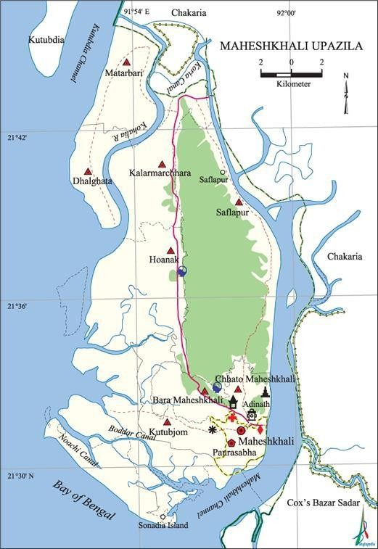

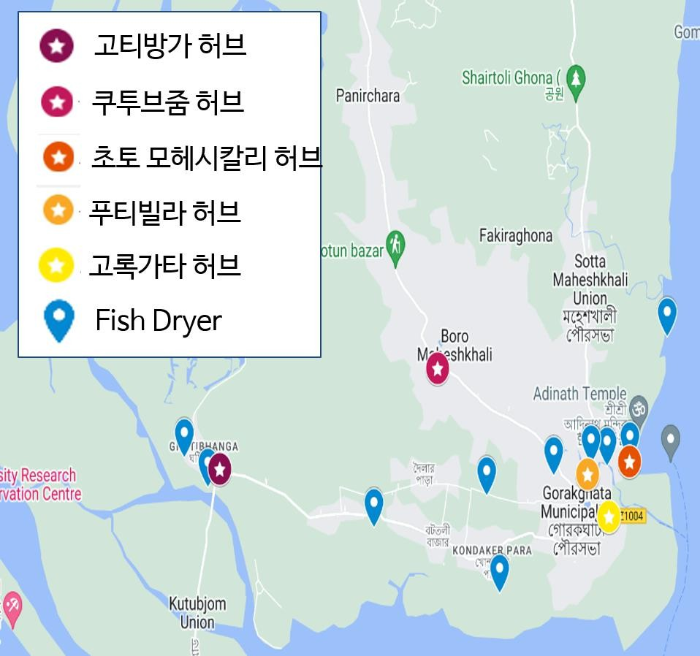

Gorokghata hub

Putibila hub

Choto Moheshkhali hub

Kutubjom hub

Ghotibanga hub

**Project Location**

* One (01) Municipality and Two (02) Unions of Maheshkhali Upazila, Cox’s Bazar District, Chittagong Division, Bangladesh.
  + Maheshkhali Municipality
  + Chota Maheshkhali Union
  + Kutubjum Union

# Target Population Category

* + All Female Entrepreneurs under CEVM project from Maheshkhali
  + All Male Entrepreneurs under CEVM project from Maheshkhali
  + All Female Producers under CEVM project from Maheshkhali
  + All Male Producers under CEVM project from Maheshkhali

**Proposed approach and Methodology** The end line study should be carried out using mixed methods, combining quantitative and qualitative approaches with both primary and secondary data collections. Given the total targeted beneficiaries of 340 individuals, a census approach will be used, and no sampling is required for this quantitative survey study.

The consultancy firm/consultant will design a detailed methodology encompassing the following components:

* Method and Criteria: Define the specific methods to be used for data collection, ensuring they are aligned with the evaluation objectives.
* List of Personnel/Institutions: Identify and list the key personnel and institutions to be interviewed, ensuring comprehensive coverage and representation.
* Participatory Methodology: Develop a detailed participatory methodology that includes Key Informant Interviews (KII), Focus Group Discussions (FGD), and other relevant techniques to ensure inclusivity and representation (considering gender, disability, urban and rural participation, ethnicity, religion, etc.).
* Questionnaires and Tools: Design questionnaires and other data collection tools that are tailored to gather the necessary information to answer the evaluation questions.
* Work Plan: Prepare a detailed work plan outlining the timeline and key activities for the study.

The successful consultant must design an overall qualitative study approach to collect qualitative data, incorporating a variety of primary data collection methods, including:

* Key Informant Interviews (KII): Conduct interviews with key stakeholders to gain in-depth insights and perspectives.
* Focus Group Discussions (FGD): Facilitate group discussions to capture diverse viewpoints and experiences from different beneficiary groups.
* Pictures and Observations: Use visual documentation and direct observations to complement and enrich the data collected.
* Case Stories: Document detailed case stories to illustrate the impact of the project on individual beneficiaries.

 

# Population distribution in the community

|  |  |  |  |  |  |  |  |  |
| --- | --- | --- | --- | --- | --- | --- | --- | --- |
| **Upazilla** | **Union** | | **Ent** | **repreneur** |  |  | **Producer** | |
| **Female** | **Male** | **Tota l** | **Female** | **Male** | **Total** |
| Maheshkhali  Municipality | | | **11** | **25** | **36** | **12** | **88** | **100** |
| **Maheshkhali** | | Chota  Maheshkhali | **11** | **7** | **18** | **40** | **10** | **50** |
| Kutubjum | **11** | **25** | **36** | **39** | **61** | **100** |
| **Total** | | | **33** | **57** | **90** | **91** | **159** | **250** |

**Duties and Responsibilities**

* + **Duties and Responsibilities of Consultancy firm/consultant**: The consultant/ firm will consult and report to Project Manager / Sector Lead – FSL of BRCR, WV Bangladesh.
  + **Duties and Responsibilities of WV Bangladesh**: WV Bangladesh will follow up the filed activities as per schedule, provide feed-back to the consultant/firm/ review the report etc.

# Deliverables

The following major tasks/deliverables should be presented by the consultant;

1. **Inception report** – The report includes initial feasible work plan and proposal for the evaluation survey outlining the evaluation methodology, survey tools, process of data collection and analysis, as well as final set of data-collection tools for all indicators in the log frame. The quality assurance protocols to minimize the bias and errors as well as outlining the limitations. A clear matrix mapping in details the data collection and analysis for each of the indicators need to be developed and be part of the inception report.
2. **Analysis and Summary Survey findings:** Summary report on the main quantitative findings of the evaluation will be shared within a week after the finalization of field level data collection.
3. **Draft report** shared with World Vision and other relevant stakeholders for comments and feedback, done two weeks after the presentation of findings to stakeholders.
4. **Final report**, the final report should be presented to World Vision in electronic format – both MS Word and PDF formats – together with quantitative dataset (including raw data for survey questionnaires) and consolidated qualitative data, two weeks after presentation feedback from WV. The final report should be no longer than 50 pages, inclusive of annexes, and other supporting documents.

 

The report should contain (but not be limited to) the following sections:

* + Executive Summary presenting the major findings and recommendations.
  + A short description of the design and methodology used.
  + Limitations.
  + A short description of the evaluation context and process including its constraints and challenges.
  + Detailed findings based on the study, including annexes of all the evaluation data/information from all communities, pictures, case studies and any quotations.
  + Analysis of the findings.
  + Program Accountability, focusing on the existing accountability system, barriers to existing systems suggested means of overcoming barriers to information provision, participation, consultation and providing and receiving feedback.
  + Analysis about project relevance, coherence, effectiveness, efficiency, impact and sustainability

# Required Qualification and Experience of the Consultancy firm/Consultant

The consultant/consulting team should demonstrate expertise in conducting those study (s) in humanitarian settings. The consultant must show in-depth analytical skills on report compilation and presenting findings in a manner simple and clear to understand. The team leader should have a solid background on e-commerce, education & livelihood issues.

Team leader/consultant qualification must have;

* + A post-graduate degree (program evaluation, statistics, anthropology, applied research, organizational development, sociology and/or organizational change)
  + Proven knowledge in carrying out evaluations using mixed approach in data gathering in different contexts for humanitarian intervention particularly
  + Knowledge and experience in developing and understanding conceptual frameworks
  + Excellent analytical, writing, and communication skills.

 

# Responsibilities of the evaluation consultant/team leader

* Lead and organize the overall evaluation process
* Ensure all data collection
* Monitor data collection and provide support for the team
* Ensure a thorough review and analysis of project’s primary and secondary data
* Provide direction on evaluation methods, tool contents and quality
* Work closely with project staff and stakeholder’s validation of results collected
* Design specific questions within the evaluation tools to capture lessons and best practices

# Team member qualifications:

* Knowledgeable with both quantitative of qualitative research especially on e-commerce, education & livelihood sector
* Extensive practical experience in one of the following areas (with all areas needing to be covered by the collective team) in e-commerce, education & livelihood.
* A graduate degree.
* Local dialect will be given preferencees

# Team member responsibilities:

* Lead the data collection and analysis of primary and secondary data related to his/her field(s) of expertise
* Provide all required support for data collection team in ground
* Monitor and supervise data collection team during data collection
* Ensure the quality and quantity of data collection both quantitative and qualitative as per plan
* Compile precise findings for sharing with stakeholders

# The consultant/ firm must be suitably qualified and experienced, and should include:

* A strong track record in undertaking assessment /evaluations of programs, ideally for agro-fishery market system projects.
* At least 5 years of demonstrable experience of conducting end line assessment/ study in value chain, and market system projects.; value will be added the entities having experience in e-commerce projects.
* Must have a Enumerator pool of local persons who are skilled on local dialect

# Proposal Submission

The consultant/consultancy firm can submit a proposal for the end line study. Expressions of Interest (EOIs) should be submitted, detailing the consultant(s) proposed approach to conducting the end line study, the proposed budget (including an itemized budget proposal with consultancy fees, operational costs, and all associated costs such as VAT and tax), and the proposed methodologies. Additionally, the EOIs should outline how the requirements in the ToR will be met.

Proposals must be accompanied by:

* Relevant CVs of the personnel to be involved in the study.

 

* At least two previous reports of other relevant studies conducted by the consultant/consultancy firm.

This submission should provide a comprehensive understanding of the consultant's capability to deliver a thorough and effective end line evaluation, meeting all outlined requirements and ensuring the successful completion of the study.

# Payment Schedule:

* **1st instalment 35%-** confirmed deliverable will be detailed **Methodology Report** Align with IMT and completion of data collection both qualitative & quantitative
* **2nd Instalment 35%-** Confirmed deliverables are Data analysis & summary report
* **3rd Instalment 30%**- Confirmed deliverables is Detailed narrative report including addressing review feedback of relevant stakeholders.

# Selection Criteria

EOI should be submitted by the deadline and with relevant documents, will be reviewed and scored according to the below criteria and weightages:

|  |  |  |  |
| --- | --- | --- | --- |
| Sl. # | Particulars | Points | Remarks |
| 1 | Technical Proposal | 30 | Approach and Methodology |
| 2 | Financial Proposal | 30 | Competitive budget will get  preferable. |
| 3 | Experience and CV of Key personnel | 20 | More than 10 years’  experience on Baseline & End- line Evaluation Study. |

|  |  |  |  |
| --- | --- | --- | --- |
| 4 | CV of Key personnel | 10 |  |
| 5 | Sample of reports | 10 | Specially on KOICA, USAID  funded projects. |

# Scheduling Time Frame

World Vision pay the consultant full amount as per agreement of the study, in this regard and other costs related to the study logistics will be covered and managed by consultancy firm. The World Vision KOICA team will provide all the support to assist the consultant to carry out the study without any major hassles. The evaluation should be carried out within the 31th July to 04th week of Nov 2024 as shown below:

|  |  |
| --- | --- |
| **Key deliverables** | **Timeline** |
| Consultants’ profile and proposal evaluation | 2nd week of August 2024 |
| Preliminary contact with consultant | 3rd week of August 2024 |
| Recruit consultant/finalize contract | 4th week of August 2024 |
| Submission of Inception Report, proposed  methodology and tools development | 1st and 2nd Week of Sep 2024 |
| Enumerator recruitment and orientation (including field testing and finalization of tools) | 3rd week of Sep 2024 |
| Data Collection, Entry and Analysis | 4th Week of Sep and 1st week of  Oct 2024 |
| Data cleaning, analysis and reporting summary findings | 2nd to 4th Week of Oct 2024 |
| 1st Draft report writing, presentation, and submission for feedback . | 2nd Week of Nov 2024 |
| Final draft report with addressing feedback on 1st draft ,  and submission for further feedback | 3rd week Nov 2024 |
| Final report of End line Evaluation and submission | 4th week of Nov 2024 |

# Application process

Each application package should include the following:

* + A one-page application letter of expression of interest
  + Company or Consultant profile, providing financial solvency, recent audit report
  + Detailed Technical-narrative proposal with clearly outlined methodology, approach and techniques, and tools to be employed for the evaluation (as outlined above in respective sections)
  + Detailed comprehensive budget catering for the evaluation cost, where the financial component will be scored according to clarity and close budget estimates to the tasks identified
  + WVB will not cater for any other costs-solely the responsibility of the firm to give full work costs in the budget.
  + A sample of at least 2 recently written report of similar assignments.
  + Updated CV of the consultant/team members for the survey team including relevant work experience and qualifications.
  + Contact details for three references.

# Standards of Ethics and Safeguarding

The study team will ensure that data collection and analysis approaches are designed to mitigate child protection risks, and protect participants’ privacy and wellbeing by establishing and following credible ethical evaluation principles. The study team will ensure all members of the evaluation team have been oriented in the ethical considerations to be employed in the evaluation. Ethical principles will include the following:

Voluntarism, confidentiality and anonymity of participants: All participation in interviews will be voluntary, and their anonymity and confidentiality will be protected. Voluntary, informed consent will be assured by a scripted verbal explanation of the survey or interview being conducted. The script will inform respondents that they may opt out of the survey, or choose to not respond to certain questions, and may end the survey at any time.

**Do No Harm:** Project and evaluation themes will be screened for topics and questions that may cause distress to some interviewees. Mitigating approaches and referral options will be developed accordingly.

**Integrity:** Data from participants will be presented honestly and proportionately in the report, such as the authoritativeness, extent-shared and intensity of testimonies in the target population. Quotes will be in context to the evaluative themes intended by the informant. AS much as possible, all observations will be triangulated with other forms of data to gauge significance, especially unexpected or contentious findings.

**Participant perspective:** To the extent possible, given logistical limitations of the spread of locations, preliminary findings should be shared with representatives of project stakeholders to invite their reactions and interpretations. These will be recorded and added to the final report.

**Child Protection:** If children (under the age of 18) are to be interviewed, it will be in the presence of a responsible adult from the child’s family or other implied guardian from the community. Children will not be exposed to questions of a highly personal, sensitive, potentially distressing or embarrassing nature.

If children are to be interviewed, child protection reporting protocols will be established. All staff will be made aware of when and how to report any issues that arise from data collection.

Survey Team members will be signed to review, sign, and adhere to a child protection code of conduct