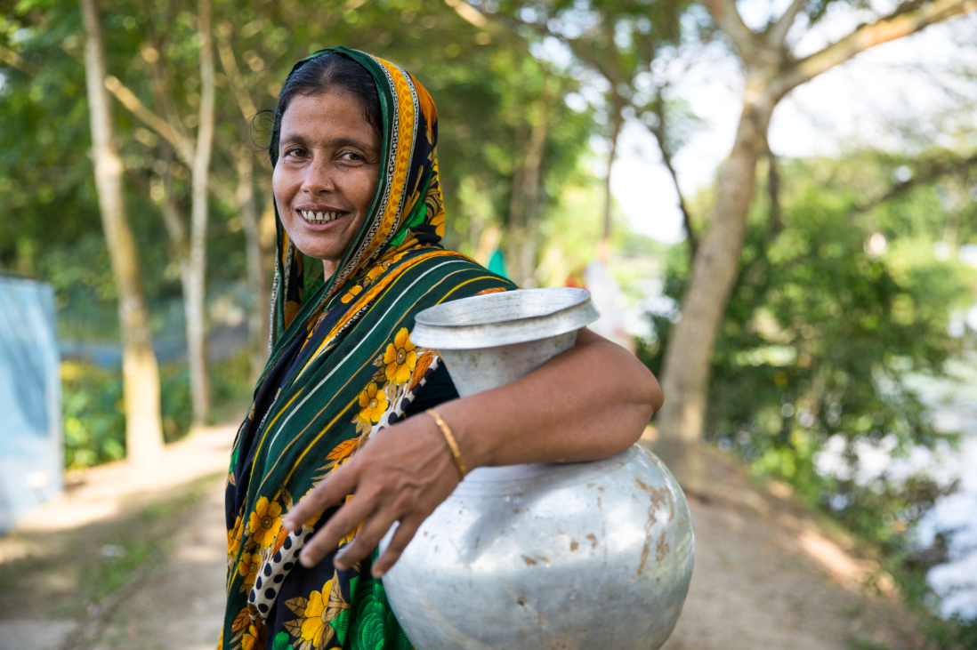

**Job description**

Communications Officer – Media and Outreach

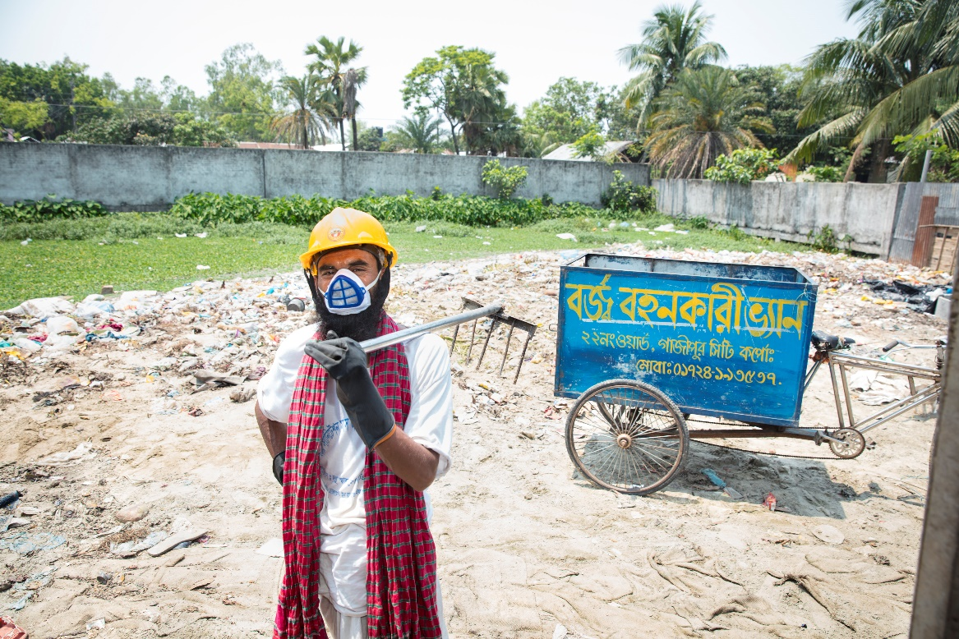



**Report to:**  Manager, Advocacy and Communications

**Work station:** Dhaka.

**Working hours:** Full time (05 days a week with minimum 37.5 hours per week)

**Salary & benefits:** Attractive salary package with admissible benefits

**Duration:** Initially 01 year with a possibility of extension subject to funding and performance.

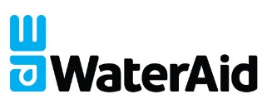



**Accountability**

**Job purpose**

The purpose of this role is to manage and coordinate communications and media engagement project. S/he will also contribute to promote effective knowledge management and learning for the country.

The Communications Officer will have strong working relationships across the country and the regional team and UK team and coordinate with other WaterAid departments.

**Key Responsibilities:**

1. Develop and maintain strong media relationships on behalf of WaterAid to ensure increased visibility of WaterAid’s activities to wider audiences
2. Plan, design and coordinate public events and activations to maximise WaterAid’s external visibility
3. Develop and execute creative campaign and contents for social media ensuring online engagement and promotion
4. Ensure both external and internal communication activities are planned and implemented in line with WaterAid’s mission, vision, values and branding guideline
5. Take initiative in strengthening WaterAid’s documentation and internal communications processes, drives, achieve and maintain agreed quality and standard
6. Maintain key contact databased
7. Undertake specific work as assigned by the line manager and or WAB authority as per need of the organization.

Responsibilities will be reviewed with the line manager from time to time.

**Person Specification**

**Essential**

* Masters preferably in Communications, Business Administration, Social Science, Development Studies.
* Demonstrable experience of managing campaigns, communications, media engagement across different programme, project and areas
* Demonstrable, practical experience of strong communication in development and private sector partnership context.
* Strong communication skills including oral, written and audio-visual skills including the production of communications materials for different audiences
* Strong IT and digital capability.
* Ability to provide effective support and to collaborate and coordinate across different teams from diverse background.
* Excellent time management and ability to prioritize multiple competing tasks and blisteringly urgent deadlines.
* Self-driven and ability to work independently or with minimum supervision
* Demonstrate respect for gender, diversity, organizational cultural and promote safeguarding and uphold organizational values
* Fully committed to WaterAid's vision, mission and values and a way of working that demonstrates this, with the ability to communicate this enthusiasm to others.

**Desirable**

* An understanding of WASH, development and target audience from various backgrounds
* Experience of developing and implementing knowledge management processes and systems
* Experience in media engagement, large scale multi partner involved communications projects
* Capable to work under pressure, manage urgent and conflicting priorities and deadlines.

**Experience**

At least 03 years’ experience in communications field or work.

**Key Contacts/Relationship**

Work closely with other colleagues of Policy-Advocacy and Communications unit on a day to day basis. Keep in strong relations with programme and finance team and relevant WaterAid colleagues.

**Working conditions**

This is a country office-based position (usually based in Dhaka) with access to official vehicle (during field visit and official travel) computer, internet, relevant software and telecommunication including mobile phone network. The position entails working under timelines and in a collaborative process. Willingness to travel on a regular basis to remote areas of Bangladesh is required. 20-40% time should be dedicated to filed-visits.

