Terms of Reference (ToR)
Hiring Consultant or Firm for External Final Evaluation of Sports for Protection, Resilience, and Transformation (SPiRiT)
Terre des hommes (Tdh) Foundation Bangladesh delegation in Dhaka is seeking to contract an expert to conduct the final evaluation of the Sports for Protection, Resilience, and Transformation (SPiRiT) project. SPiRiT objectives are to enhance the physical, mental, and psychosocial well-being of adolescent boys and girls and young people from vulnerable communities by promoting access to safe sports and giving them knowledge and skills that will benefit them long term.

Presentation of Terre des hommes
Tdh is the leading Swiss organization focusing on child rights, based in Lausanne (Switzerland). It provides direct and indirect assistance to over four million children and their families in more than 30 countries each year. Founded in 1960, Tdh is an independent, neutral and impartial Swiss organization committed to bringing meaningful and lasting change to the lives of children and youth, especially to those most exposed to risks. It strives to improve their well-being and ensure the effective application of their rights as defined by the Convention on the Rights of the Child and other relevant human rights instruments. To make a difference, Tdh focuses on the areas of maternal and child health, children and youth migration, and access to justice. Tdh aims to empower children and youth through active participation. Tdh advocates for the respect of children’s rights, supporting them in voicing their needs and interests. Tdh works in fragile and conflict settings, as well as in stable environments.
Tdh has been present and active in Bangladesh since 1974 and focuses its work on Migration, tackling Child Labor, Health, Child Protection, Water, Sanitation and Hygiene (WASH), Access to Justice, and Climate Change in the context of development and humanitarian Aid. Tdh is currently working in Dhaka, Rajbari, Cox’s Bazar (Ukhiya & Teknaf), Kurigram and Satkhira.

Project Context
Bangladesh faces significant challenges due to climate change, including frequent natural disasters that lead to internal displacement. Adolescents and youth in these contexts are particularly vulnerable to various risks, including exploitation and psychosocial distress. The SPiRiT project, implemented by Tdh Foundation, was designed to address these challenges by:
- Providing safe spaces for sports activities to improve psychosocial well-being.
- Enhancing knowledge on leadership, migration, and climate-induced vulnerabilities.
- Engaging sports actors at various levels to create an enabling environment for safe sports participation and referral.
The project aims to enhance the psychosocial well-being and resilience of adolescents and youth affected by climate-induced displacement. The project has been implemented in Kurigram and Dhaka, providing structured sports activities, leadership training, and community engagement to address vulnerabilities. The SPiRiT initiative aligns with global best practices in using sports as a tool for protection and empowerment, ensuring inclusivity and accessibility for marginalized youth. The project also emphasized inclusivity by integrating gender-sensitive approaches, addressing women's participation barriers, and ensuring access for individuals with disabilities and third gender community. The final evaluation for the first three years of the project will evaluate the project's outcomes and lesson learned, challenges, and sustainability prospects to inform future programming and policy development.

Project Summary:
Project title | Sports for Protection, Resilience, and Transformation (SPiRiT)
Project period | April 2022 to June 2025
Project location | Kurigram (Chilmari, Ulipur, and Sadar Upazila), and Dhaka (Pallabai Thana)
Project general objective | To promote the inclusion and empowerment of adolescents and youth who are displaced or at risk of climate-induced displacement in Kurigram district and Dhaka slums.
Project specific objectives | - To enhance the physical, mental, and psychosocial wellbeing of adolescents and youths already displaced or at risk of displacement from vulnerable communities by promoting their access to safe sports  - To engage displaced or at risk of displacement adolescents and youth to advance their knowledge and skills on leadership, migration, displacement, and climate-induced vulnerabilities and promote sustainable local solutions through youth-led initiatives  - To enhance the role of sports actors at local, district, and national levels to contribute to creating an enabling environment for safe sports participation for displaced and at risk of displacement adolescents and youth in Dhaka and Kurigram
Project expected results | Impact: Promote the inclusion and empowerment of adolescents and youth who are displaced or at risk of climate-induced displacement in Kurigram district and Dhaka slums.  Outcome 1: Adolescents and youth (10-24) displaced or at risk of displacement from vulnerable communities have meaningful access to safe sports activities to enhance their physical, mental, and psychosocial well-being and participate in sports activities regularly.  Output 1.1: Coaches and teachers have a better understanding of safe sports for protecting and ensure the well-being of vulnerable adolescent girls and youth.  - Contextualize Tdh's 'sports for protection toolkit' in the local context and design sensitization on the use of sports for youth development, protection, and wellbeing.  - Train sports coaches, teachers, and project staff on approaches to the power of sports and important prerequisites for the use of sports for protection.  - On-job support and regular coaching to community sports coaches through field visits by master coaches.  Output 1.2: Increased participation of adolescents and youth in safe sports and community-level activities.  - Strengthen and establish adolescent and youth groups (including girls' clubs) and equip them with necessary resources for practicing sports in the communities.  - Regular sessions with the local actors (e.g. parents, guardians, religious leaders, sports teachers) to facilitate the participation of girls and boys in sports of their choice.  - Identify youth champions who act as change makers to take community actions. Conduct regular sports sessions with the adolescents and youths (separately for girls and boys) in the communities.  - Support adolescent and youth champions to organize regular, annual and other special day tournaments involving their peers.  Outcome 2: Adolescents and youth displaced or at risk of displacement participating in Sports for Protection and related activities have contributed to sustainable local solutions through youth-led initiatives.  Output 2.1: Improved capacity of adolescents and youth on leadership development, climate change, and mitigation of unsafe migration and displacement-related risks.  - Conduct vulnerability mapping through the Vulnerability Assessment tool to identify adolescents and youth at risk of/affected by unsafe migration and displacement.  - Strengthen youth’s leadership skills through the Sport for Protection methodology (ENGAGE skills) but also through the contextualization and implementation of Participatory action research approaches, based on the Tdh curriculum and Methodologies (MOVE ON & ENGAGE).  - Organize youth-led sessions, to share information and awareness on the impact of climate change and promote the mitigation of migration and displacement-related risks, among other community change actions.  - Youth organize sessions to discuss local problems and ways of dealing with them through participative action research approaches together with their peers and with other stakeholders.  Output 2.2: Strengthen relationships with the communities and forge proper linkages with relevant service providers for the empowerment of vulnerable adolescent and youth.  - Map relevant organizations/service providers working on adolescent and youth empowerment in Kurigram and Dhaka.  - Create linkages and establish referral pathways with the government, private, and non-government service providers for accessing vocational training, entrepreneurship and support.  Outcome 3: Sports actors at local, district, and national levels contribute to creating an enabling environment for safe sports participation for youth and adolescents in Dhaka and Kurigram.  Output 3.1: National and District level sports actors support the implementation of sports for protection initiatives in Bangladesh.  - Project launch at the national level with relevant stakeholders including Ministry of Youth and Sports (MoYD), Ministry of Women and Children Affairs (MoWCA), Ministry of Social Welfare (MoSW), Ministry of Education (MoE), city corporations, sports federations, sports associations, development partners, INGOs, NGOs and other relevant actors.  - Project Inception with district and upazila authority, district sports associations, and actors and agree on the work plan for collaborative actions.  - Regular meetings with the relevant stakeholders and sharing of the learning and progress of the project with authorities and sports associations for their updates and further suggestions.  - Develop a sustainability and exit strategy along with the sports actors and local partners.
Project Theory of Change (ToC) | The SPiRiT project aims to enhance the physical, mental, and psychosocial well-being of displaced and at-risk youth, particularly those impacted by climate change and migration. By providing access to sports, skill development, and leadership opportunities, the project empowers youth to address local challenges, promote social change, and challenge gender norms. It focuses on creating safe spaces, strengthening resilience, and supporting marginalized groups, including girls and those with disabilities. The project is grounded in the Social Ecological Model and draws on successful experiences such as Tdh’s Sports for Protection programs. For further details, including the Theory of Change, pathways, and assumptions, please see Annex One.

Objective of the Evaluation
The general objective of this evaluation is to assess the relevance, coherence, effectiveness, efficiency, impact, and sustainability of the first three years of the SPiRiT project in targeted areas (Chilmari, Ulipur, Sadar Upazilas in Kurigram District, and Beguntila and Bauniabadh slums in Dhaka city), with a focus on the project's contributions to youth empowerment, social inclusion, resilience, and protection outcomes through sports.

This evaluation will compare the findings with previous assessments, including the baseline, in-depth vulnerability assessment, and post-assessment from the first phase, to measure progress and generate lessons learned. This evaluation will be conducted across the entire targeted geographic areas with the specific objectives below:

- Assess Effectiveness: Evaluate how well the project achieved its intended outcomes related to psychosocial resilience and empowerment, applying Rowlands' Empowerment Framework. This includes:
- Number of adolescents and youth accessing safe sports activities
- Improvements in participants' psychosocial well-being
- Enhanced knowledge and skills related to leadership, migration, psychosocial resilience, and climate-induced vulnerabilities
- Evaluate Efficiency: Measure how well financial, technical, and human resources were used to achieve results while ensuring gender and social inclusion.
- Determine Impact: Identify the project's contribution to impact on targeted youth, communities, and local institutions, particularly in empowerment and resilience, including both intended and unintended positive and negative effects.
- Assess Sustainability: Analyze indicators that suggest the potential for the project’s empowerment and resilience outcomes to continue beyond the project period focusing on identifying key factors and how local stakeholders (government, sports federations, and community partners) will support long-term sustainability.
- Examine Relevance: Assess how well the project addressed the needs and priorities of the target population, stakeholders, and its alignment with national policies (e.g., National Youth Policy 2017, National Sports Policy 1998, SDGs, Eighth Five-Year Plan).
- Identify Lessons Learned & Best Practices: Provide practical, evidence-based recommendations for future programs on how empowerment strategies can be effectively integrated to enhance long-term psychosocial resilience and social inclusion.
This evaluation will generate strategic insights into the project's contributions to improving participants' well-being, life skills, and resilience, as well as its effectiveness in engaging local stakeholders in promoting safe sports environments. It will apply a gender and inclusion lens to ensure a comprehensive understanding of the project's reach and contributions. Altogether, the evaluation will provide strategic recommendations for enhancing future interventions and replicating successful approaches.

Intended Users of the Evaluation
The evaluation findings will inform best practices, lessons learned, and evidence-based recommendations for future program design and advocacy efforts. The key users include:
- Tdh Foundation – To refine program strategies, enhance decision-making, and strengthen donor reporting.
- Local Partners & Stakeholders – To improve collaboration and adapt local policies supporting youth protection and resilience.
- Donors & Funding Agencies – To assess project effectiveness and design and guide funding decisions.
- Policy Makers & Advocacy Groups – To contribute to the evidence base and support advocacy efforts on policies related to youth empowerment, climate-induced displacement, and protection of vulnerable populations.

Evaluation Criteria and Key Questions
The final evaluation will apply the OECD-DAC criteria with a focus on exploring the questions below, but this will not limit the evaluation team to coming up with other important critical questions that may be appropriate for this evaluation.
- Relevance:
  - How well did the project align with the needs and priorities of climate-displaced adolescents and youth, including girls, youth with disabilities, and other marginalized groups?
  - Were the activities appropriate in addressing protection risks, social inclusion, and resilience through sports for all youth, including girls and youth with disabilities?
- Coherence
  - To what extent did the project connect with other youth development, protection, and climate adaptation programs, ensuring marginalized youth were included?
  - To what extent was the project aligned with national policies and strategies, such as the National Youth Policy 2017, National Sports Policy 1998, SDGs, and the Eighth Five-Year Plan?
- Effectiveness:
  - To what extent did the project achieve its intended outcomes for youth resilience, social inclusion, and psychosocial well-being through sports, including for girls and youth with disabilities?
  - To what extent did the project contribute to improving the capacity of adolescents and youth for leadership development, climate change, and mitigation of unsafe migration and displacement-related risks?
  - What barriers did youth—especially girls and youth with disabilities—face in accessing project activities, and what helped them participate?
  - How effectively were youth, families, and communities engaged in participation processes (using Lundy’s model as an analytical framework)? Was their participation meaningful and safe?
- Efficiency:
  - Were project resources (funds, expertise, time) effectively utilized to achieve results while ensuring gender and social inclusion? How well the project was managed?
- Impact:
  - What positive and unintended changes (social, economic, and protection-related) resulted from the project, particularly regarding youth empowerment and community attitudes toward gender and inclusion?
  - How did participation in sports influence youth’s wellbeing, leadership skills, and ability to understand and cope with climate-induced displacement, particularly among girls and youth from marginalized backgrounds?
- Sustainability:
  - How likely are key stakeholders (youth, local partners, government bodies, sports federations) to sustain and institutionalize project initiatives, ensuring long-term gender and social inclusion?
  - Are youth, especially those from marginalized backgrounds, prepared with the skills, confidence, and leadership to continue sports and community activities in the long run?

Methodology
The evaluation will cover all components of the SPiRiT project from its inception (April 2022) to its conclusion (June 2025), assessing outcomes at individual, community, and institutional levels. A participatory approach will be prioritized, ensuring meaningful engagement with beneficiaries, stakeholders, and staff. The consultant will collaborate with the project team to co-design and refine the methodology, ensuring quality, contextual relevance and alignment with the project’s goals on youth empowerment and psychosocial resilience. Key tasks will be included:
- Document & Literature Review: Analyze key project documents (proposal, MEAL plan, baseline, post-assessment, log frame) and relevant secondary literature on youth protection, gender, climate-induced displacement, empowerment, and psychosocial resilience. Special attention will be paid to integrating theoretical frameworks, such as Rowlands’ Empowerment Framework, Lundy’s Model, Tdh’s Five Well-Being Pillars, and the Psychosocial Resilience (PSR)Theory of Change.
- Evaluation Design & Execution: Develop a mixed-method approach (qualitative focus), ensuring ethical, inclusive, and gender-sensitive data collection in either English or Bangla to ensure accessibility. Ensure data disaggregation (age, gender, disability) and methodological rigor. The evaluation will explore empowerment processes and psychosocial well-being, with a specific focus on measuring youth agency, empowerment in leadership, and resilience outcomes related to climate displacement and migration.
- Stakeholder Engagement & Data Collection: Coordinate with project teams and engage relevant stakeholders (youth, community representatives, local authorities, NGO partners). Maintain data integrity, ethical compliance, and safeguarding protocols.
- Collaboration & Learning: Work closely with the SPiRiT project team to ensure participatory evaluation, incorporating feedback and learning from stakeholders throughout the evaluation cycle. This will include ongoing reflection on the empowerment and resilience-building outcomes of the project and adjustments to the methodology where necessary.
The consultant will propose a detailed methodology in dialogue with the project team, ensuring adaptability to field realities and alignment with project objectives.

Deliverables
The consultant will provide deliverables on time and in an electronic format. Key deliverables will be:
1) Inception report (by no later than 10th April):
In the inception report, the consultant will describe the design of the situation analysis considering each primary objective and elaborate on how data will be collected and analyzed. This will include-
- Relevant background and context analysis
- Synthesis of literature review – to support the evaluation issues, methodology, and data collection instruments. Incorporate a review of literature around empowerment theory (such as Rowlands’ empowerment framework) and PSR theory of change as key concepts in shaping the project’s objectives.
- Methodology – including the evaluation matrix (in line with evaluation objectives), evaluation participants, brief about the data collection methods, distribution of data source, data collection, and quality assurance technique, and data analysis tools and processes. Clarify how the evaluation will integrate empowerment theory in both qualitative and quantitative methodologies, ensuring that empowerment and agency are measured as key outcomes of the intervention.
- Draft data collection tools and guides
- Detailed activity/work plan, including the number and type of people and sites to be visited
- Risks and limitations analysis, and mitigation plan
- Detail table of contents of the report
- List of literature– to be reviewed further and analyzed for report preparation
- Research ethics and quality assurance:
  - Ethical Considerations: This includes ensuring informed consent, confidentiality, and anonymity for all participants, especially considering the vulnerability of the target population (e.g., youth, marginalized groups). The evaluation will also prioritize the protection of vulnerable groups such as girls and youth with disabilities.
  - Quality Assurance: To ensure the reliability and validity of the data, quality assurance protocols will be incorporated at each stage of the evaluation, from data collection to analysis. This will include pilot tool testing, regular fieldwork monitoring, and triangulation to cross-check data from different sources and methods.
The use of a data collection planning worksheet or a similar tool is required at the inception phase. 30% of the total contract amount shall be paid upon the delivery of the final inception report.
3) Presentation Slides (by no later than 25th May):
The consultant will prepare a slide deck (25-30 slides) summarizing the key findings and recommendations from the evaluation. The presentation will include:
  - A brief introduction to the evaluation objectives, methodology, and context.
  - A concise summary of the key findings according to the evaluation questions, supported by data visualizations such as graphs, charts, and qualitative insights.
  - Lessons learned and good practices identified during the evaluation.
  - Conclusions and actionable recommendations for future interventions or program improvements.
The slides need to be clear, visually appealing, and designed for both internal and external stakeholders. The consultant will ensure that the slides are professional and follow the agreed format.
3) Draft Report (by no later than 8th June) and Final Report (by no later than 23rd June):
- Executive summary (max. 3-4 pages) focused on the brief introduction, methodology, findings according to the main evaluation questions, a brief mention of how empowerment theory shaped the evaluation, conclusions, and relevant recommendations (not more than 2 pages)
- Table of contents
- List of annexes, abbreviations, tables, figures, pictures, etc
- Introduction
- Literature review
- Objectives of the evaluation
- Presentation of the methodology, scope, and limitations
- Findings of the evaluation according to the evaluation questions, including lessons learned
- A two-page analysis on empowerment, applying Rowlands’ Empowerment Framework to the SPiRiT project. This analysis should explore the theory of empowerment, assessing Power Within, Power With, Power To, and Power Over. This analysis should be separate from the full report but can be integrated as a key section in the final delivery.
- 1 summary table with the main conclusions and recommendations (separate short, medium and long term) and the lessons learned.
- Annexes (ToR, data collection tools, outline of the empowerment theory analysis, survey protocols and questionnaires, updated work plan and list of people interviewed, as summary on key stakeholders’ feedback, case studies, evaluation matrix, transcripts of interviews, focus groups, observation.)
Reports must be provided in MS Word format with pages numbered (max 30-40 pages). All reports need to be submitted in English. Reports should be written for a general audience using clear and accessible language. They should be easy to read and technical jargon should be avoided and if used, appropriate footnotes need to be used. The full evaluation report will provide ‘evidence-based’ conclusions. This evidence needs to be clearly illustrated to support the findings in the report. The findings and recommendations of the draft and final report have to be structured according to the evaluation questions. Remaining 70% of the total contract amount shall be paid upon the delivery of the final report.
4) Cleaned Data and Field Notes:
The consultant will submit to Tdh clean raw data, field notes, and relevant documents in an electronic format. The data should be thoroughly reviewed for accuracy, consistency, and completeness. Quantitative data needs to be provided in a digital format (e.g., Excel), and qualitative data (e.g., interview transcripts, field notes) should be presented in a clear, anonymized format.
All documents should be well-organized and labeled according to the prescribed format, ensuring easy access and clarity for analysis. The consultant will ensure that all data complies with ethical standards, including confidentiality and informed consent.
All documentation related to the assignment shall remain the sole and exclusive property of Tdh.

Chronogram
The final evaluation is expected to begin by April 2025 and shall be accomplished no later than June 2025. The consultant should provide a work plan detailing the number of working days required for the final evaluation. The consultant will be expected to meet weekly with Tdh management staff to provide updates on the progress of their work. This can be done virtually or in person.

Roles and Responsibilities:
Tdh team will provide support to the consultant in terms of
- Providing access to key reference documents and responding to questions about the task
- Briefing on child protection and safeguarding
- Briefing about Security conditions
- Facilitating contact with/gathering staff and people to be interviewed
- Providing equipment/space needed for a kick-off meeting and debriefing session in the Tdh office
- Reviewing and commenting on deliverables (inception report, draft report)
- Thoroughly review the quality of deliverables (e.g., inception report, instrument, draft report, presentation slides, final report)
The consultant will be responsible for
- Leading the final evaluation
- Consulting with Tdh for any questions
- Ensuring that the consultancy team is aware of security conditions as per the Tdh briefing
- Behaving in a cultural, gender, and child-sensitive manner
- Abiding by ethical principles when collecting data from the respondents, in particular from children and women (informed consent, confidentiality)
- Developing, submitting, and reviewing the inception report that includes work plans outlining the proposed methodology, evaluation tools, process of data collection, and analysis
- Developing the data collection tools, testing them, and reviewing them upon Tdh recommendation,
- Data collection, data quality assurance, and analysis
- Preparing quality reports and delivering them as planned in the activity/work plan and schedule
- Managing all travel and logistics for their team
- Provide raw data/script during the field assessment for a random check of the data quality by the Tdh assigned team.
- Follow the technical guidance of Tdh in analyzing the evaluation findings, while preparing the report and presentation.

General Terms and Conditions
After completion of the assignment and submission of the final output/deliverables, the concerned project/unit shall make the final payment. Tdh reserves the right to deduct tax dues at the prescribed rates from the remuneration for all consultancy works irrespective of the remuneration. In the event of any change in the tax regulations is announced by Government of Bangladesh, then the consultant must agree with the changes accordingly.
Besides, the below mentioned clauses also applicable for the hired consultancies:
- Payment shall be made through straight to Bank.
- Tdh reserves the right to accept or reject the entire or part of the offer.
- Terrorists: Tdh will not do any business with any known terrorist group or company involved in any way with terrorists.
- In all cases, the decision of the Tdh Management will be final.
- The hired consultancy will fully agree with the Tdh Child and Adult Safeguarding Behaviors Protocol.

Policies
As a condition of entering into a consultancy agreement the consultant must sign Tdh’s Child Safeguarding Policy, PSEA, Do No Harm Policy, Code of Conduct, Good Business Practice, and abide by the terms and conditions thereof.

Evaluator
The evaluation of proposals will be conducted in two stages: Technical Evaluation and Financial Evaluation. Proposals must meet the minimum required score in the technical evaluation to proceed to the financial evaluation stage. The final selection will be based on a combined score of the technical and financial evaluations, as per the weighting specified below:
The details technical criteria or technical evaluation weights are furnished below:

Technical criteria (80% weightage)
The technical and financial proposals will be assessed together. The shortlisted bidding agencies may be asked to give a presentation prior to the final selection.
Technical Evaluation Criteria, | Points
- Technical proposal (Demonstrated understanding, objective, and completeness of the assignment) | 20
- Methodology and implementation plan  - Details and quality (adequacy) of methodology proposed for the assignment including the evaluation framework  - Detailed implementation plan indicating time frame | 20
- Proposed Team  - Detailed description of the proposed team and their skillset  - Position with the firm with CVs (not more than three pages for each CV) of the proposed Team Leader and other key team members  - Gender-balanced team for data collection  - Technical capacity of consultant to do this kind of work | 15
4. Organisation  - Profile (including administrative and logistics facilities available)  - Experience in similar assignments in the last 5 years, client list, management control system  - Exposure to working with UN, International Donor, and development agencies as well as donor-funded programs/project | 15
5. Presentation  (Top five technical scorer will be invited for presentation session) | 10
Total | 80

Commercial Criteria

Cost factor-pricing (20 % weightage)
Commercial weight will be wave for relevant work/ Services in that case service provider will be based on obtain score of Technical Criteria. In that case, full score of technical criteria will be consider (80/20 weight) for scoring and position.

Required Experience and Skills
The proposed evaluation expert should be able to comply with the following list of required qualifications, competencies, and experience:
  - The consultant team/firm should have post-graduate degree in Social Sciences, International Development, Social Work, Monitoring and Evaluation, or related fields.
  - Prior 2 years’ experience working in climate-affected communities and slum populations.
  - Proven experience in conducting evaluations of child protection, empowerment, participation, social inclusion, particularly in development or climate change-related contexts.
  - Understanding of gender-sensitive, disability-inclusive, and child-friendly evaluation approaches.
  - Strong knowledge of participatory evaluation methodologies, including both qualitative and quantitative methods (e.g., Focus Group Discussions, Key Informant Interviews, Surveys, Case Studies)
  - Project evaluation experience using OECD-DAC criteria, and experience on the relevant studies.
  - Extensive knowledge of local government units and structures, programmes, and social care services in Bangladesh.
  - Proven skills in communication and consultation techniques and report writing in English.
  - Have very good planning and time management skills.

Budget
The applicant is requested to submit the detailed budget in both USD and BDT including VAT and Tax and all cost associated with this assignment.

Application Procedures
Interested candidates should present:
16.1 Technical proposal comprising (10 to 12 pages: Calibri – Font size-11)
- Understanding of the assignment and the Terms of Reference (ToR): 1-2 pages.
- Detailed methodology of the evaluation: 4-5 pages
- Details action plan for the realization of each of the evaluation phases: 1 page
- Brief description/bio with relevant expertise and experience of the key team members and their role in this assessment: 2 pages
- Organization profile – which should include relevant work experience and expertise: 1-2 pages.
- Annexes of technical proposal:
  - Updated CV of the key team members (3 pages maximum of each CV)
  - Organization profile
  - Sample reports of at least 2 similar evaluation studies (conducted following DAC criteria, and similar studies)
  - References (three references related to the previous consultancy with contact detail, phone and email)
16.2 Financial proposal: Detail financial proposal (VAT and taxes included)
- Annexes with financial proposal
- Tax registration certificate
- VAT certificate
- Bill must be submitted with Musak 6.3.
- A statement of availability and commitment to undertake and complete the consultancy within the indicated time frame will be required.
Selection of the Provider will be based on:
- How well the application meets the technical requirements set out in the Terms of Reference
- Relevant previous experience in similar work
- Financial offer
- Vat and Tax registration
Duration of the Assignment
The period of assignment will be between April 2025 to June 2025 and will be finalized in consultation with Tdh. The possibility of an extended period adds no extra cost unless otherwise discussed and agreed by Tdh.

Proposal submission
Please submit the technical and financial proposals as mentioned in “Section 16” along with the other documents electronically to the specified email address: bgd.tenders@tdh.ch with the title “Proposals for External Final Evaluation of Sports for Protection, Resilience, and Transformation (SPiRiT)”.
For any queries please send us email to bgd.tenders@tdh.ch
Submission date and time: by 25th March; before 4:00PM

Reference documents and annexes
The selected consultant must read the following documents. Tdh will provide the following documents:
- Project proposal
- Logframe of the Project
- Baseline report
- Relevant Assessment (In-depth situation analysis, post-assessment of the first phase, etc.) and Learning Reports
- Relevant documents on theory and frameworks
- Sport for Protection (S4P) and Relevant Toolkits/Modules
- Relevant child protection and safeguarding policies

Annex One: Project Theory of Change (TOC)
The activities in the SPiRiT project are designed to address the needs of displaced or at risk of displacement adolescents and youth, especially to the impacts of climate change and migration. The Theory of Change provides a roadmap for how these activities contribute to the overall goal of enhancing the physical, mental, and psychosocial well-being of youth, as well as empowering them to contribute to sustainable local solutions.
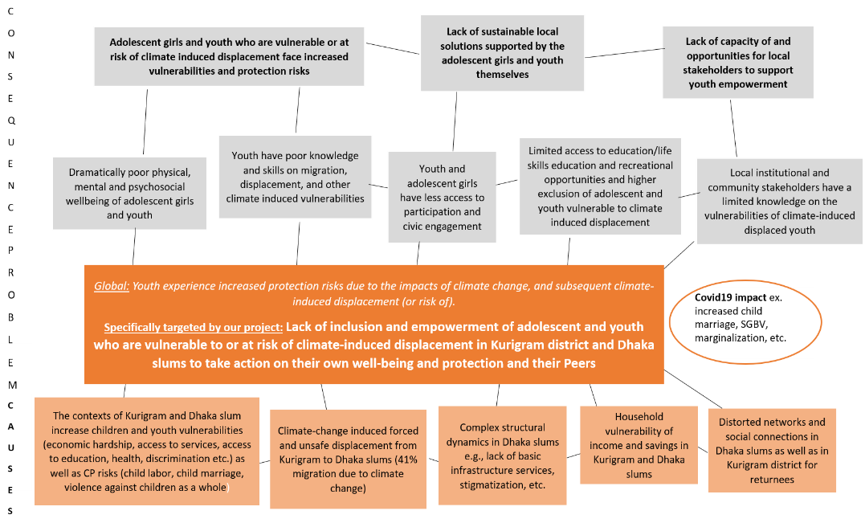
Picture 1: The Problem Tree
The Theory of Change highlights five key challenges that the SPiRiT project targets:
- Displacement and Education: Displaced adolescents who have dropped out of school will gain opportunities for physical, psychosocial, and mental development through sports, enhancing their livelihood prospects.
- Early Marriage and Empowerment of Girls: Girls facing early marriage will be encouraged to participate in social activities and sports, empowering them to continue their studies or pursue professional development.
- Child Labor Awareness and Support: Migrant youth engaged in the worst forms of child labor will be educated about health risks and offered support and skills to mitigate these challenges.
- Gender-Based Violence and Protection: Girls at risk of gender-based violence will receive support through established care and referral pathways.
- Youth Drug Addiction: The project will empower youth affected by drug addiction through sports, providing hope and opportunities for the future.

Pathways of Change:
The project, grounded in the Social Ecological Model, addresses the vulnerabilities of climate-induced displaced or at-risk adolescents and youth in Kurigram and Dhaka. It creates safe spaces where these individuals build resilience through activities that enhance knowledge, life skills, leadership, and adaptive coping mechanisms, based on Tdh’s resilience framework with its five well-being pillars. These pillars focus on physical, emotional, social, economic, and psychological well-being, strengthening their ability to adapt and transform in challenging environments.
By ensuring informed participation, the project empowers adolescents and youth to identify and address local issues, particularly related to unplanned mobility, promoting social change. It also challenges gender norms and supports the inclusion of marginalized groups, including those with disabilities and third genders. Engaging local decision-makers, sports actors, and teachers raises visibility and promotes rights, while partnerships with the Bangladesh National Olympic Association (NOA) and key ministries create an enabling environment for displaced youth in both districts.
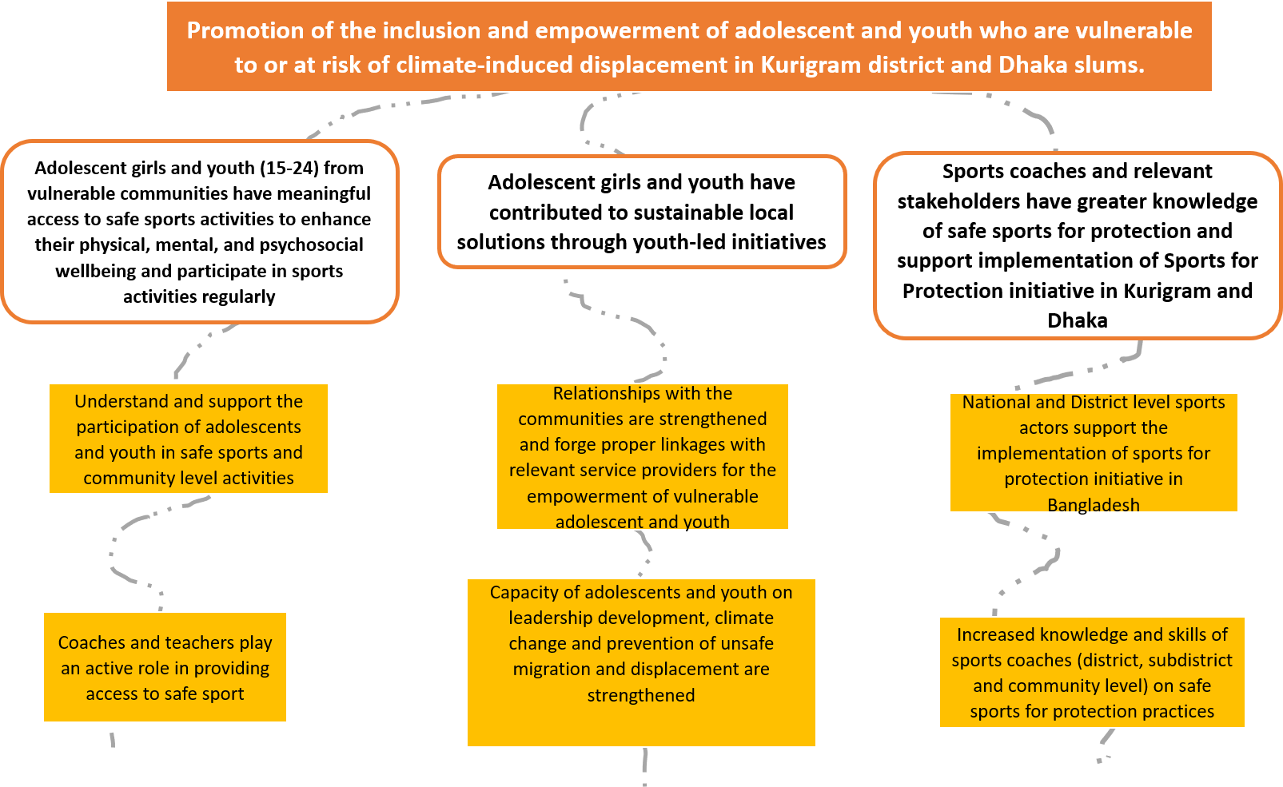
Picture 2: The Pathways of Change
How Activities Contribute to Results:
- Access to Safe Sports: Vulnerable youth have meaningful and regular access to sports activities that enhance their physical, mental, and psychosocial well-being.
- Skill Development and Leadership: Youth gain knowledge on sustainable solutions for migration and displacement, and they have opportunities to develop leadership skills.
- Stakeholder Capacity Building: Sports coaches, social workers, and other relevant stakeholders have received training on using sports to promote youth well-being, protection, and leadership development.
- Youth Empowerment: Local actors, sports federations, and youth clubs have started to work together to promote “safe sports” as a tool for community development and sustainable empowerment.
Selection of Sports:
Preliminary assessments indicated that Football, Cricket, and Handball are popular among both boys and girls in the community. However, the final selection has been made through consultations with local youth, parents, and sports actors, ensuring cultural and social norms are respected. The principle of the best interest of the child and do no harm has guided this process.
Key Assumptions:
- Safe spaces for girls are available.
- Adolescents are interested in participating in sports.
- Sports coaches are ready and committed to the project.
- Parents, faith leaders, and local elites are supportive of youth participation in sports.
- Political stability and the COVID-19 situation permit the continuation of activities.
- Natural or human-made disasters do not significantly disrupt the project.
- Working on gender stereotype is accepted by men and boys.
- Adolescents and youth with disabilities benefit from the inclusive approach.
External Factors:
- The government's focus on sports for youth development presents a strong opportunity.
- Political unrest or violence may inhibit participation, particularly among girls.
Evidence Supporting the Intervention:
- Tdh’s global and regional experience with sports for protection, including successful projects like Kabaddi in India and the Sports for Protection Toolkit in Cox’s Bazar, provides a strong foundation for this intervention.
- Stakeholder consultations have shown strong interest and willingness to participate in the initiative.
- Local implementing partners have the experience and readiness to collaborate with Tdh to deliver project activities in the proposed locations.

