Terms of Reference (ToR)
FOR DIGITAL CONTENT PROVIDER, ASTHA

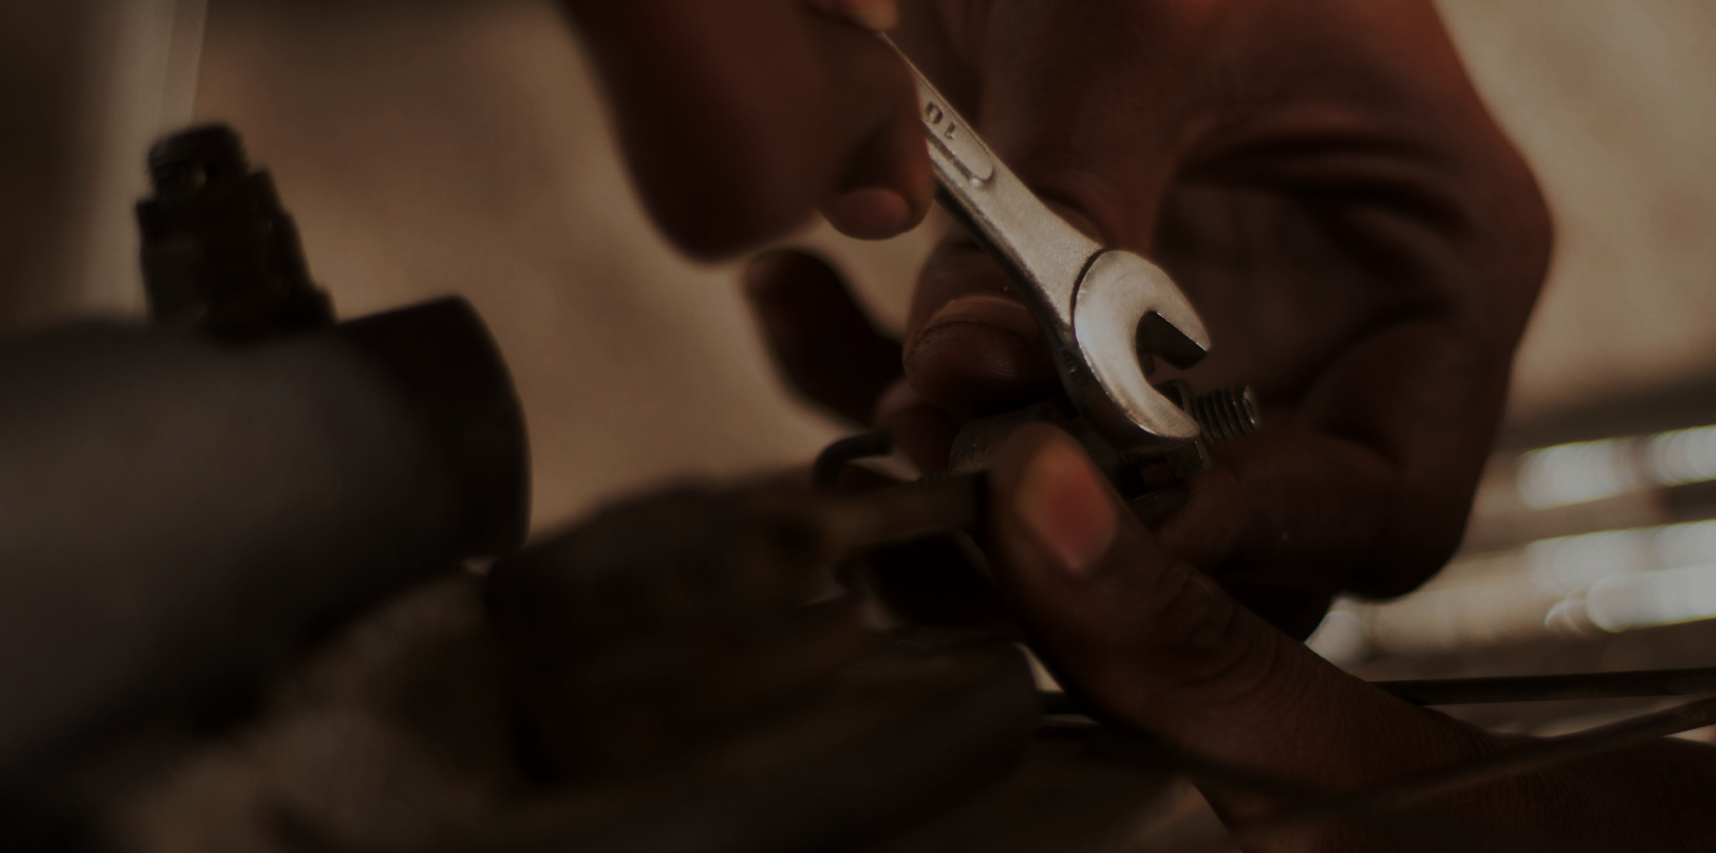

We are a leading organisation for the implementation of international development
projects. We promote inclusive economic, social, and ecological development to make an effective contribution towards sustainable and widespread prosperity in developing and emerging economies.

Background
Swisscontact, Swiss Foundation for Technical Cooperation, headquartered in Zurich and was founded in 1959 by Swiss private sector and academia for sustainable development cooperation. Swisscontact promotes economic, social and ecological development by supporting people to successfully integrate into local commercial life. We create opportunities for people to improve their living conditions as a result of their own efforts. The focus of our systemic interventions in the private sector is the strengthening of local and global value chains. Through its projects, Swisscontact enables access to professional training, promotes local entrepreneurship, creates access to local financial service providers and supports the efficient use of resources with the goal of successfully promoting employment and income generation.

As an initiative to support Bangladesh in reaching the target of ensuring quality healthcare services at rural communities, Swisscontact, in association with Novartis, Swiss Agency for Development and Cooperation (SDC) and Julius Baer Foundation, is implementing the ASTHA (Achieving Sustainability Towards Healthcare Access) project. The project facilitates the development and integration of Community Paramedic services in rural Bangladesh. Its focus is to increase healthcare outreach in the rural inaccessible pocket areas, with special attention to Maternal and Child Health (MCH), Family Planning (FP) and Basic Primary Healthcare Services.

‘Community Paramedic’ is a two-year full-time course, designed by the Ministry of Health and Family Welfare (MoH&FW) where students acquire and develop skills on Maternal and Child Health, Reproductive Health, Family Planning and Primary Healthcare services. Training institutes affiliated with the Bangladesh Nursing and Midwifery Council (BNMC) are conducting this course to develop trained Community Paramedics for rural communities of Bangladesh. After completion of 2 years’ training, students must sit for a final exam organized by BNMC and BNMC also provides practice registration among qualified Community Paramedics. Qualified Community Paramedics are eligible to do self-practice at the grassroots.

ASTHA is currently in its Phase II (January 2019 to December 2022) which will emphasize on business viability of Community Paramedic Training Institutes (CPTIs) and Community Paramedics (CPs) and on acquiring important partnerships for nationwide scaling up and sustainability. The project operates in seven districts, namely, Sylhet, Sunamganj, Barguna, Lalmonirhat, Rangpur, Nilphamari and Patuakhali.
The project is working in the following strategic areas:

- Strengthening CP Programme
- Enhancing the capacity and service provision of CPs
- Sensitising and involving public and private scale agents to promote CP service nationwide.
- Creating mass awareness about CP profession and quality CP services.

Objective of the assignment
Develop The 3D models and 2D medical illustrations with accurate labelling which are a part of the community paramedic curriculum must be integrated into the Moodle based open-source E-Learning Platform.

The scope of work is as follows:

- Development of a prototype of both 3D and 2D models compatible with Moodle platform and their approval through project stakeholders.
- Communicating, defining and documenting stakeholder’s requirements in a systematic manner.
- This also includes requirements workshops, user interviews, and other requirements of the project to understand and to clearly define the scope.
- Compiling the requirements into a detailed scope document and its sign off.
- Quality check and compatibility testing of 2D medical illustrations and 3D models.
- Conduct Minimum three trainings in the first year and one refresher training for the next two years for the users.
Specifications:
Providing Technical Support:

- Share information and requirements with ASTHA.
- Finalize the method, frequency, and focal person for communication among all the stakeholders.
- Formalize the acceptance of the deliverables. This step entails the acceptance of the deliverables by Swisscontact and other stakeholders as required.

- Developing 3D Models:

Deliver four 3D models that:
- Are compatible to be integrated into the open-source E-Learning Platform.
- Are rotatable into the platform.
- Are possible to zoom in and zoom out.
- Are labelled correctly which does not rotate with the model.
- Has texts as description of the 3D model in Bengali Unicode.
- Has clear and realistic colour.
- Satisfies all the design specifications of the stakeholders as defined in the requirement document.

- Developing 2D Medical Illustrations:

Construct fifteen 2D medical illustrations that are:
- Size: small, medium and large
- Resolution: High, medium and optimized
- Possible to zoom in and zoom out
- Labelled clearly.
- Satisfies design specifications of the stakeholders which can be uploaded on the platform

Please refer to annex-1 for the list of 3D models and 2D illustrations.

- Deployment, Retraining and Quality Assurance:

All the 3D models and 2D illustrations must be integrated with the current open-source E-Learning Platform where:
- All the 3D models and 2D illustrations must get integrated into the existing open-source E-learning Platform.
- Quality control: Integration with the E-Learning Platform, display, colour, labelling, rotation, compatibility with different devices like desktop, laptop, mobile.
- Complete all the models and illustrations and hold a final inspection with the stakeholders before the delivery.
- Clear plan of continuous and regular communication with stakeholders during all the stages of the project to avoid any delays or discrepancy.
- Minimum three trainings in the first year and one refresher training for the next two years for the users.

- Deliverables:

- Requirement documents with clear project plan, activity and timeline.
- 3D Models integrated into Open-Source E-Learning Platform
- 2D Illustrated Drawings integrated into Open-Source E-Learning Platform
- Training and refresher trainings
- User Manual.
- Report on each deliverable.

Submission Details
Interested bidders should submit both the hard and soft copies of technical and only hard copy of financial proposals by 13 August, 2022 before 5:00 pm. Soft copies should be emailed to the following address:
bd.procurement@swisscontact.org

Please mention in the subject line “ToR for digital content provider, ASTHA”

Hard copies should be submitted to the address below:

Senior Officer - Procurement
Swisscontact Bangladesh
House 28, Road 43, Gulshan-2, Dhaka 1212, Bangladesh
For more information, please e‐mail to bd.procurement@swisscontact.org

Annex-1: List of 2D Illustrations and 3D Models:

2D Illustrations | - Perineal Tears  - 4 Types of fractures  - Contraceptive Implant  - IUD Insertion  - Urethral Discharge  - Inguinal Bubo  - Injection Techniques  - Breast abscess  - Genital Ulcer  - Scrotal Swelling  - Cervical Cancer  - Types of Blood cells  - Types of Bactria  - Neuron structure  - Anatomical structure of brain
3D Models | - Nervous System  - Eye  - Ear  - Tooth

