Terms of Reference
Photographic Documentation of BYETS Project’s Activities

- Background
Swisscontact was established in 1959 as an independent foundation by notable figures from the worlds of commerce and science in Switzerland. It is exclusively involved in international development cooperation and has carried out its mandated projects since 1961. Based in Zurich, Swisscontact currently manages 133 projects in 41 countries on behalf of public and private funding partners.

The Building Youth Employability Through Skills (BYETS) project implemented by Swisscontact and funded by the Embassy of the Kingdom of the Netherlands will empower 25,000 Bangladeshi youth with improved technical, employability and entrepreneurial skills, and connect them to income-generating opportunities: jobs and self-employment. The project aims to support youths by providing training in three sectors: Readymade Garments (RMG), Agro-processing (AP), and Information and Communication Technology (ICT) across four divisions (Dhaka, Khulna, Chattogram and Rajshahi). The project will address the existing constraints in developing the skills of the youth and support to establish a systemic approach to provide market-driven training specifically by:
- Building the capacity of 20 Training Service Providers (TSPs) to design and implement quality training and job placement support services.
- Collaborating with 50 private sector employers in improving existing workplace-based training (WBT) systems or setting up new ones to upskill and reskill workers.

As part of the project's communication strategy, high-quality visual documentation is important to effectively showcase project activities and outcomes. To capture high-quality photographs of beneficiaries and intervention activities, the BYETS project team is seeking to hire a pool of experienced photographers.
- Objective
The objective of this assignment is to capture high-quality photographs and record photographic documentation of the BYETS project’s intervention phase during the training programs in TSPs and factories for upskilling and reskilling the trainees and workers till June 2026. The contracted service providers also be responsible for covering events under the BYETS project throughout the contract period.

This framework contract is developed to engage a pool of professional photographers to provide photography services aligned with Swisscontact's communication guidelines for the BYETS project.

- Key Audiences
The selected photographs will be used in various reports, websites, documents, IEC/BCC materials, brochures, banners, newsletters, and other communication materials. Primary audiences will include development partner (funding agency), private sector partners, trainees, workers, and employers. Secondary audiences will be project partners and consultants, government bodies and ministries, associations, and other stakeholders.

- Scope of work
Assignment | Role of the photographer | Role of BYETS team
- Understanding the task/assignment | The photographer may gather the necessary information to construct a work plan to execute the assignment. | Provide a brief on the overall project and define the requirements of the assignment. The team may also show sample pictures (if available), communication materials, and communication guidelines.
- Travel to location | Carrying the camera and other supporting equipment. | Arrange transportation to and from the selected locations.
- Arranging accommodation at the selected locations (four divisions- Dhaka, Khulna, Chattogram and Rajshahi) | Request for transportation and accommodation.  Bear all the cost of the Photographer’s assistant (if any) | Arrange all the travel and accommodation (however, no food or per diem will be provided) for the assignments outside Dhaka
- Capturing raw images | Pictures captured need to be taken following the guidelines and specifications provided by the project team. | Provide guidelines and feedback.
- Event Photography | Attending project events, workshops, training sessions, and field activities to capture visual content. | Provide a brief about the event and detail the objective of the assignment. The team will let the photographer know about the assignment at least 5 days before the assignment starts. The team will advise locations and beneficiaries for photo documentation.
- Submission of deliverables | Incorporate feedback provided by the BYETS team and submit the deliverables (edited pictures and all raw photos) within the timeframe requested. | Provide feedback and finalize the deliverables.

- Time Frame
The framework contract with the expert photographers will have validity till the end of the project which is June 2026. The assignment will require photographer involvement for a total of a maximum of sixty working days (as per project requirement) during the contract period. The photographer will be notified at least 5 working days before an event and will be given a minimum of five working days to submit the photographs. Please note that the time frame for deliverables may vary depending on the understanding reached and prior discussions held between the photographer and BYETS members.

- Deliverables
The photographer will have to submit a minimum of 30 high-quality photos (per assignment or event) of print size 300 dpi (inches) in TIFF and JPEG versions on DVDs and USB flash drives. Photographs will have to be marked or organised by sector, factory name, and beneficiaries. The photographer will have to capture the scenarios in the three sectors the BYETS project is working on, specifically, RMG, AP, and ICT under each work order.
Activities | Location | Types of pictures required
- Workers performing their tasks in factories (portraying visuals of work-based training) | RMG and AP Factories | Pictures will be close-ups of a focused subject matter. For example, zoomed-in photos of their hand operating the machine or studying.  Pictures will focus on the core sector activities and portray people in their typical working environments. Pictures will have a broad view of a non-detailed environment: wide perspective landscape views with people from our target populations working in the background.
- Trainers and workers attending workplace-based training in factories (in factories) | RMG and AP factories | Pictures will be close-ups of a focused subject matter. For example, a close-up of their hand operating the machine or studying.  Pictures will focus on the core sector activities and portray people in their typical working environments.  Pictures will have a broad view of a non-detailed environment: a wide perspective landscape of the factory or classroom.
- Youth attending training classes at training centres and trainers taking classes (in TSPs)- | ICT and AP Training centres | Pictures will focus on the core sector activities and portray people in their typical working environments, such as portrait pictures of the trainees working, studying, or smiling at the camera.  Pictures will have a broad view of a non-detailed environment: for example, wide perspective landscape views of the classroom with trainees
- Capturing activities in the event | Project locations across four divisions- Dhaka, Khulna, Chattogram and Rajshahi) | A minimum of twenty events should be covered over the framework period. These events requiring photographic documentation may include seminars, workshops, orientations, networking events, etc.
*More details are listed at the end of the document
- Guideline on Photography
Every picture should tell a story. Create suspense in the composition of the pictures by using contrasts (small/large, close/far, bright/dark, etc.), special angles, or an unusual focus. Do not use symbolic images. Only portray authentic perspectives, panoramic views, or real-life working environments.

The photographic style is divided into three categories:

- Mission
A broad view of a non-detailed environment; wide perspective landscape views with people from our target populations working in the background.
Mission photographs can be used in the following collateral: Posters, greeting cards, annual report covers, website homepage, PowerPoint presentation covers, title slides, and job advertisements.

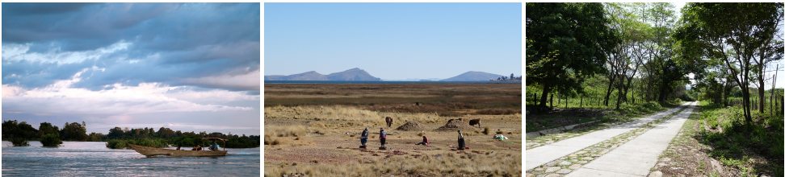

- What we do
These photographs focus on the core sector activities and portray people in their typical working environments. Compositions are interesting and focus on the technical aspect of the work.
What-we-do photographs can be used in the following collateral: Banners, greeting cards for projects, covers and contents of brochures, leaflets, fact sheets, website content, PowerPoint presentation content slides, event invitations and advertisements.

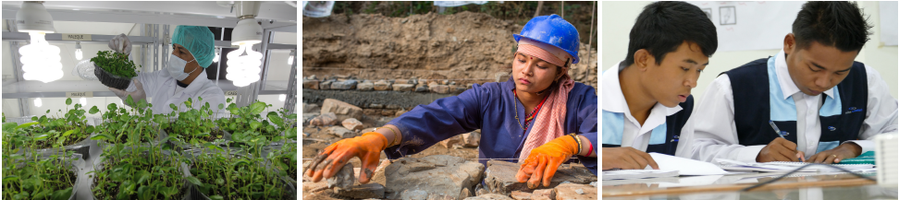

- Results
Close-up of a focused subject matter, such as products and plants relating to specific projects.
Result photographs can be used in the following collateral: Contents of brochures, leaflets, fact sheets, greeting card projects, website content and PowerPoint presentation content slides.

- Required Documents
- A brief technical proposal (maximum 5 pages) that outlines the understanding of the ToR. The technical proposal should summarise the firm’s/consultant's previous experiences and profile that would be useful for the assignment. The proposal may also contain a clear outline of the process of how the firm/consultant may accomplish the task listed in the ToR and quality of the camera and other logistics that will be used.
- Samples of similar work done in the last three years, especially with INGOs and other development organisations.
- Scan copies of documents proving the legal entity of the agency (e.g., trade license, VAT certificate, TIN certificate).
- A Financial proposal that will be submitted at a later stage must be submitted in terms of Bangladeshi Taka (BDT) including the VAT and other additional costs.

- Evaluation Process

Given that this is a selection process based on quality and cost-based consideration, the initial step involves the evaluation of the technical proposal. Only those service providers scoring a minimum of 50% in the technical proposal evaluation will be shortlisted for the next phase of submitting their financial proposals.
During the financial proposal evaluation, the highest marks will be allocated to the lowest bidder, and other scores will be proportionally adjusted. From this combined evaluation of technical and financial proposals, the final selection will be made.

The following criteria will be applicable for the evaluation of proposals.

SL | Particular | Marks allocated
1 | Technical proposal  - Photography samples of similar work done  - Understanding the assignment | 70
2 | Financial Proposal | 30

- Submission Details

The technical proposal must be submitted both physically and online (via email provided below). We kindly ask interested parties to provide all necessary documents. In the case of physical submissions, it is recommended to use envelopes for the technical proposal. Please ensure that the technical proposal bears the title "Technical Proposal for Photographic Documentation of BYETS Project’s Activities”. The bidders are requested to provide the legal documents with the technical proposal.
After the evaluation of the technical proposal, only the shortlisted bidders will be requested to provide the financial proposal.
The email and technical proposal should be submitted to the following address by May 05, 2024, before 5:00 pm. Your adherence to these instructions is greatly appreciated.
The envelope must be addressed:
Manager, Business Administration, BYETS
Swisscontact
SWISS FOUNDATION FOR TECHNICAL COOPERATION
House 20, Road 68, Gulshan 2, Dhaka 1212, Bangladesh

and email to bd.byets@swisscontact.org

*No late submission will be accepted
*Swisscontact reserves the right to accept or reject any or all proposals without assigning any reason

