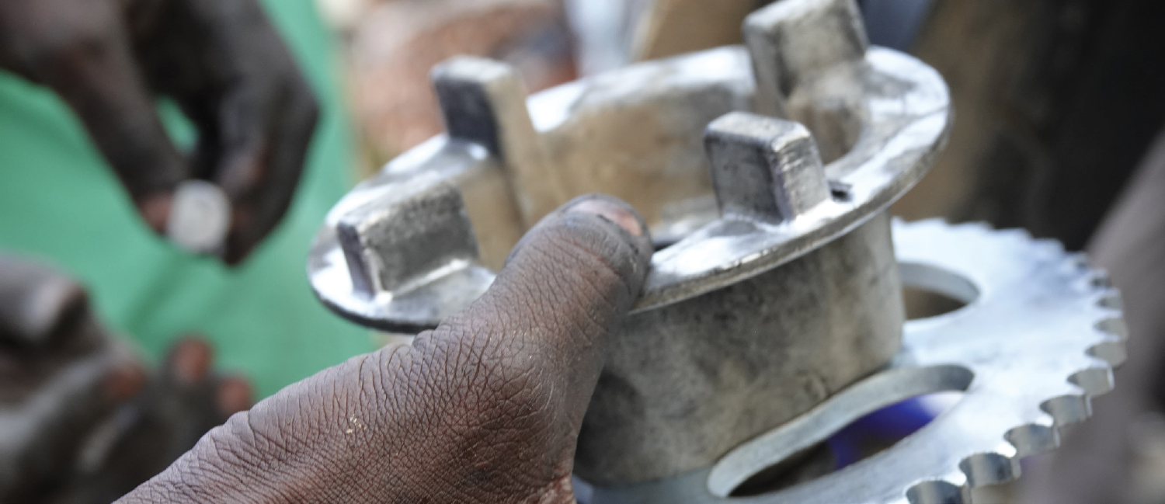
RfP for Teaching Equipment and Furniture for Advanced Welding Trade of Uttoron project

We are a leading organisation for the implementation of international development
projects. We promote inclusive economic, social, and ecological development to make an effective contribution towards sustainable and widespread prosperity in developing and emerging economies.

Swisscontact is a business-oriented independent foundation for international development cooperation. Represented in 39 countries with over 1,400 employees, it promotes - since 1959 - economic, social, and environmental development. The focus of systemic interventions in the private sector is strengthening of local and global value chains. The organization is based in Zurich. Swisscontact Bangladesh is registered as an International NGO under NGO Affairs Bureau of Bangladesh. For more information, please refer to www.swisscontact.org/en/countries/bangladesh
Uttoron - Skills for better life is a skills development project, funded by Chevron under Bangladesh Partnership Initiative (BPI) and implemented by Swisscontact. The first phase of the project continued from 2016-2019 and provided skills training to 1400 community youth in Sylhet division. Uttoron phase II has expanded its work and consist of three components, details been stated in annex.
Time frame and delivery location: Must be delivered to Khulna Shipyard by 23 October 2022
Objective: Under component 3 of Uttoron project a partnership agreement was signed with Khulna Shipyard TTC to upgrade the existing facilities of the training institute to introduce internationally standardized advanced welding training in Bangladesh and imparting training to fifty (50) Uttoron selected applicants. As a part of the agreement, the Uttoron project is going to provide all the necessary teaching & training equipment and furniture for the establishment of the to be upgraded workshop as well as the classroom. Now, it needs to be purchased the necessary teaching equipment and furniture for the theoretical classroom. The specification of the mentioned item is given in Annex 2.

Task and specific deliverables: The bidder will perform the following tasks:
- Share actual picture with specification/catalog of each product
- Get approval of Uttoron team on the product quality and quantity.
- Ensure proper branding (by project-related logos) of all the items as per project requirement
- Incorporate feedbacks, if any, and get approval from Uttoron on the final samples
- Ensure proper quality of the equipment and furniture
- Deliver the product as per agreed quality and amount within the decided timeframe.
Required document and eligibility criteria :
- Produce all required legal documents (tax, registration, vat related document and - trade license etc.)
- Previous work experience in similar type of work will be a plus point.
Submission guideline
Interested candidates are requested to submit a) technical proposal and cover letter, b) sample/catalog for item, and c) Financial Proposal. All three documents (hardcopy) with sample/catalog need to be submitted mentioning the subject line RfP for Teaching Equipment and Furniture for Advanced Welding Trade of Uttoron project by 03 October, 2022 before 5:00 PM, no late and only hard copy proposal will be accepted to the following address.
To
Sr. Officer – Procurement
Swisscontact, Bangladesh
House#28, Road# 43, Gulshan 2, Dhaka 1212

Scoring criteria for technical and financial proposals
Mentioned in the annex

Annex 1: Project overview Objective Component-1: Skills training for community youths Component-2: Facilitate establishment of a sustainable training centre at Sylhet Component-3: Upgradation of a welding training institute To support community youths from the selected areas within Sylhet division in securing gainful employment by equipping them with market-demanded skills. To facilitate establishment of a skills training center for the community youths at Sylhet with an aim that the center will run beyond the project period. To support upgrading a national level training institute to offer training in advanced welding skill.
Annex 2: List of the teaching equipment and furniture: Sl. No. Name of item Specification Quantity 1. Classroom Chair Classroom Armed Chair (stylish and contemporary), Wooden with metal stand 45 Pcs. 2. Classroom Table Executive Table (Size: 2’.4”X2’.6”X4’), Wooden 2 Pcs. 3. Executive Chair Executive Chair (stylish and contemporary) 2 Pcs 4 White board White board, size 6 x 4 feet, nonmagnetic, standing option 1Pc 5 Multimedia Projector EPSON EB-X41 3600 MULTIMEDIA PROJECTOR, 3LCD Technology and RGB liquid crystal shutter 1Pc
Annex 3: Scoring criteria for technical and financial proposals Scoring criteria Score Ttechnical proposal Sample/Catalog as per specification 30 Financial Proposal Financial score 70 Total Score 100 N.B.: Swisscontact reserves the right to reject or cancel any offer.

