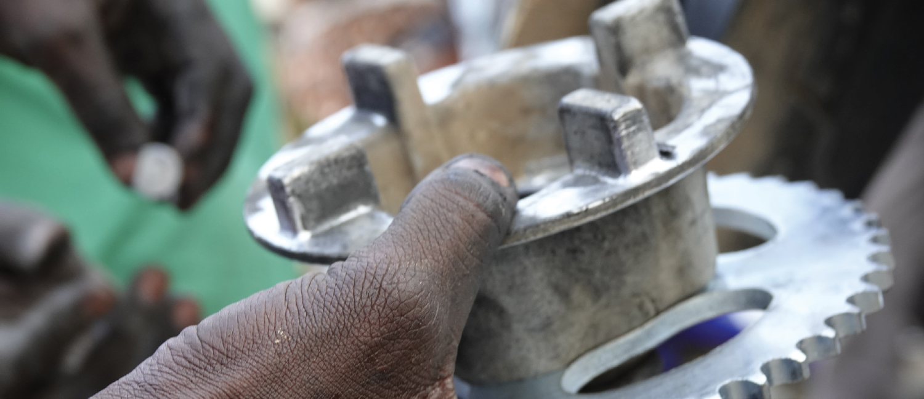
RfP for Personal Protective Equipment (PPE) for Uttoron project

We are a leading organisation for the implementation of international development
projects. We promote inclusive economic, social, and ecological development to make an effective contribution towards sustainable and widespread prosperity in developing and emerging economies.

Swisscontact is a business-oriented independent foundation for international development cooperation. Represented in 38 countries with over 1,400 employees, it promotes - since 1959 - economic, social, and environmental development. The focus of systemic interventions in the private sector is strengthening of local and global value chains. The organization is based in Zurich. Swisscontact Bangladesh is registered as an International NGO under NGO Affairs Bureau of Bangladesh. For more information, please refer to www.swisscontact.org/en/countries/bangladesh
Uttoron - Skills for better life is a skills development project, funded by Chevron under Bangladesh Partnership Initiative (BPI) and implemented by Swisscontact. The first phase of the project continued from 2016-2019 and provided skills training to 1400 community youth in Sylhet division. Uttoron phase II has expanded its work and consist of three components, details been stated in annex.
Time frame: All items must be delivered to Uttoron Sylhet Office by 20 January 2022
Objective: Uttoron project in partnership with Sylhet City Corporation is establishing a permanent training center at Sylhet City. The training center will provide vocational training on electrician, welding, plumbing pipe fitting and housekeeping trade. To ensure safety standards during training Uttoron will be providing all necessary Personal Protective Equipment (PPE). The list and specification of the equipment is given in Annex 2.

Task and specific deliverables: The consultant will perform the following tasks:
- Share sample (if possible multiple for each item)
- Get approval of Uttoron team on material design, colour and quality.
- Incorporate feedbacks, if any, and get approval from Uttoron on the final samples
- Ensure proper branding of all the material as per project requirement
- Ensure proper quality of the material
- Deliver the all the material as per agreed quality and amount within the decided timeframe.
- Deliver the items at Uttoron Sylhet Office
Required document and eligibility criteria :
- Produce all required legal documents (tax, registration, vat related document)
- Experience with producing material following branding guidelines.
- Previous work experience in developing similar type of material will be a plus.
Submission guideline

Interested candidates are requested to submit a) technical proposal and cover letter, b) sample for items, and c) Financial Proposal.

All three documents need to be received at

Swisscontact Bangladesh
House 28, Road 43, Gulshan-2, Dhaka 1212, Bangladesh mentioning “RfP for PPE equipment for Uttoron project” in subject line by 12 December 2021, 5:00 PM, no late submissions will be accepted.
Scoring criteria for technical and financial proposals
Mentioned in the annex

Annex 1: Project overview Objective Component-1: Skills training for community youths Component-2: Facilitate establishment of a sustainable training centre at Sylhet Component-3: Upgradation of a welding training institute To support community youths from the selected areas within Sylhet division in securing gainful employment by equipping them with market-demanded skills To facilitate establishment of a skills training center for the community youths at Sylhet with an aim that the center will run beyond the project period To support upgrading a national level training institute to offer training in advanced welding skill
Annex 2: Specification of Personal Protective Equipment by trade Sl. No. Name of PPE Quantity Remarks 1. Hard Helmet 50 For electrical and plumbing and pipe fitting trades 2. Welding Helmet 25 For welding trade 3. Leather welding gloves 25 For welding trade 4. Rubber Safety Gloves 25 For electrical trade 5. Cotton Safety Gloves 25 For plumbing and pipe fitting trade 6. High-Visibility Vest 50 For electrical and plumbing and pipe fitting trades 7. Leather Apron 25 For Welding trade 8. Cloth Apron (cotton/white color) 25 For housekeeping trade 9. Safety Goggles/Eyewear 75 For electrical, welding and plumbing and pipe fitting trades 10. Safety Shoes (Rubber boots) 50 For Electrical and plumbing and pipe fitting trades 11. Safety Shoes (Steel toe shoes/boots) 25 For welding trade
Annex 3: Scoring criteria for technical and financial proposals Scoring criteria Score Ttechnical proposal Company profile and legal documents 20 Samples as per specification 40 Financial Proposal Financial score 40 Total Score 100 N.B.: Swisscontact reserves the right to reject or cancel any offer

