Expression of Interest (EOI) Template
for
“WATER TECHNOLOGY PROVIDER FOR ESTABLISHING WATER ENTERPRISES”
Swisscontact Bangladesh has initiated a project aiming to create access to safe drinking water for the severe drinking water crisis-prone low-income communities of Bangladesh. The current project will onboard water technology providers for establishing two water enterprises in Satkhira Sadar and Shyamnagar.
The Water Technology Providers are requested to provide the information as per the Expression of Interest (EOI) template below:
EOI Application Template
 | Registered name of the company with complete postal address, telephone/mobile number, fax number and e-mail address for the purpose of correspondence
 | Year of the establishment (# of years in operation)
 | Mention three unique selling points (USPs) of your company/technology over other existing market competitors
 | Do you have experience working with water ATMs and online dashboard management systems?
 | How many days would you require to establish a water treatment plant with an ATM booth facility in Shyamnagar Upazila of Satkhira District? (Mention in # of workdays required)
 | Water treatment plant installation plan with a timeline |  |  |  | Attach the work plan in a separate file
We request you to offer the most efficient combination of equipment, considering the variety of available machinery (based on quality, brand, longevity, country of origin, etc.), where the RO membrane has a lifetime of at least 3 years.
If you are proposing any technology other than the RO, please follow the following template and align your detailed specification with the price accordingly.
* Please use the attached water quality parameter when estimating costs for the water treatment plant.
*Try not to skip any fields and fill in as much information as you can
SL | Name of the equipment | Units Required | Specification | Lifetime (years of functionality) |  | Brand & Origin Country | Price offered (BDT)
 | 500 litres/hour capacity RO set-up (frame, feed pump, electric panel, membrane, etc.)
 | Vessel-1
 | Vessel-2
 | Vessel-3
 | Micron cartridge
 | Ultra-violate filter
 | Ozone generator
 | Water ATM (Card & Coin based)
 | Raw Water Tank_5000 litre
 | SS Tank for purified water_2000 litre
 | Pipe fittings and others
 | Solar setup for full RO plant operation**
 | Solar setup for ATM operation**
 | Pre-treatment for pond/rainwater like, adding extra vessels, PSF setup or sand filtration***
Accessories (Photos are attached below for reference)
 | Motorized Delivery Van
 | 20-Litre White Jerry Can
 | 20-Litre Blue Jar (normal without handle)
 | Plastic Dispenser
Total Budget
VAT @15%
Total Budget (incl. Tax and VAT)
*Please add or delete additional items/rows if needed.
**Please add detailed specifications mentioning the components and unit price as an annexe to this EOI application.
***If the raw water is pre-treated before the main treatment-RO, the quality of the water gets better. This practice helps to increase the lifetime of the RO membrane. As an operating cost-cutting mechanism, the CapEx of the preferable pre-treatment process is contextually essential for this EOI.
Proposed water quality parameter for the water treatment plant: Water Quality Parameter for quotation
Sl. | Parameter | Unit | Bangladesh drinking water standard | Results (DTW) | Method
1 | pH |  | 6.50-8.50 | 7.23 | Membrane Electrode
2 | TDS | mg/L | 1000 | 1110 | Conductivity
3 | Salinity | g/L | 1 | 2.7 | Conductivity
4 | Turbidity | NTU | 10 | <1 | Attenuated Radiation
5 | Chloride | mg/L | 600-1000 | 650 | Mohr’s
6 | Total Hardness | mg/L | 500 | 655 | EDTA
7 | Arsenic (As) | mg/L | 0.05 | 0.357 | HG-AAS
8 | Iron (Fe) | mg/L | 0.30-1.00 | 6.15 | Flame AAS
9 | Manganese (Mn) | mg/L | 0.1 | 0.4 | Flame-AAS
10 | E. Coli | cfu/100ml | 0 | 0 | Membrane Filtration
11 | Fecal Coliform | cfu/100ml | 0 | 45 | Membrane Filtration
12 | Total Coliform | cfu/100ml | 0 | 69 | Membrane Filtration

Signature and seal of the responsible Personnel

Photos of the proposed accessories for the water treatment plant:
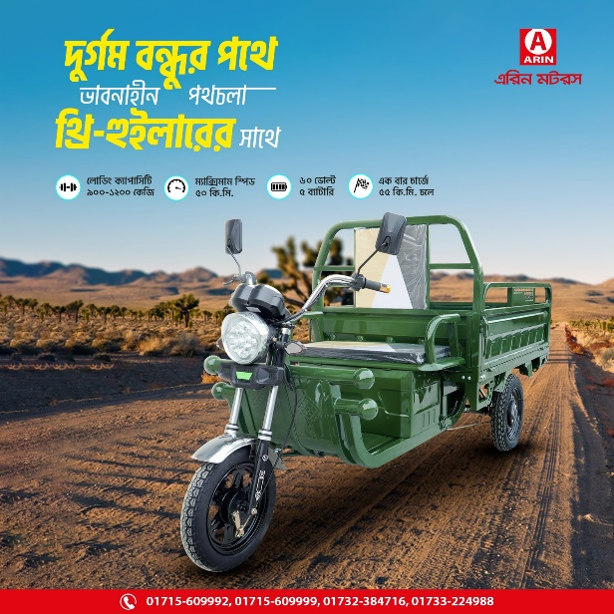  Figure 1 Motorized Delivery Van | 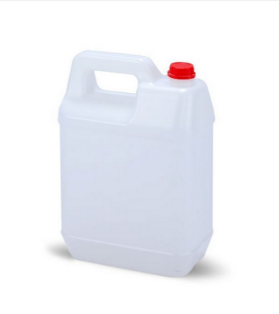  Figure 2 20-Litre White Jerry Can
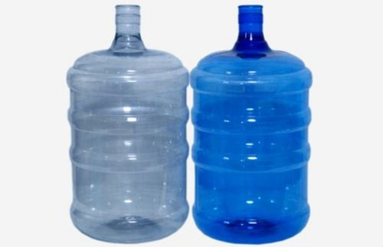  Figure 3 20-Litre Blue Jar (normal without handle) | 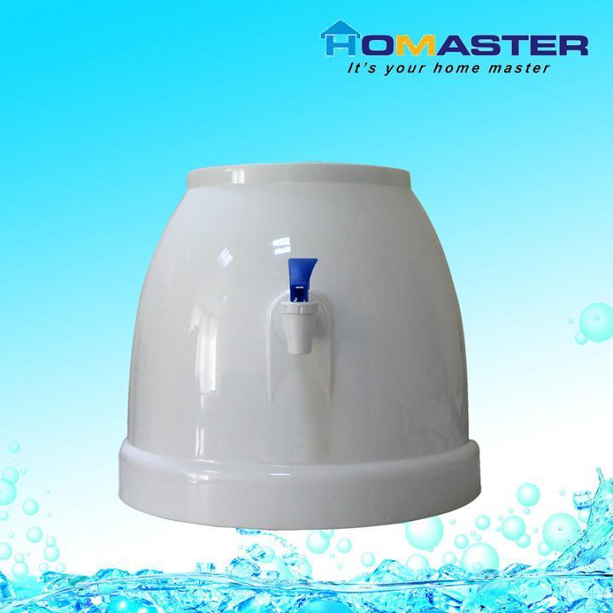  Figure 4 Plastic Dispenser

