Terms of Reference for (ToR)
Producing shop signage for Community Paramedic service outlets

Background
Swisscontact promotes economic, social and ecological development by supporting people to successfully integrate into local commercial life. We create opportunities for people to improve their living conditions as a result of their own efforts. The focus of our systemic interventions in the private sector is the strengthening of local and global value chains. Through its projects, Swisscontact enables access to professional training, promotes local entrepreneurship, creates access to local financial service providers and supports the efficient use of resources with the goal of successfully promoting employment and income generation.
Swisscontact, Swiss Foundation for Technical Cooperation, is headquartered in Zurich and was founded in 1959 by Swiss private sector and academia for sustainable development cooperation. The Swisscontact Bangladesh (SCBD) office is located in Dhaka. SCBD has the mandate to develop and maintain Swisscontact’s portfolio of development projects in Bangladesh.
The Terms of Reference (ToR) relates to one such project within SCBD portfolio that focuses on improving healthcare access of rural communities through creation of skilled community health workers. The project is branded as ASTHA. To support the interventions of the project, ASTHA will appoint a supplier to print and produce Signage that will be placed on top of the service outlet of Community Paramedic.

Objective
The objective of the assignment is to produce shop signage for Community Paramedic service outlets.

Scope of Work
- Specifications
Materials | Quantity (pcs) | Specification
Signage | 120 pcs | Size: 6’ X 3’ (with frame) = 18 sq feet (80 pcs)  Board: 12 mm PVC Board  Print: Single side 4 colour vinyl sticker print  Frame: 0.6 ‘’ metal (ss/aluminium) frame will be placed surrounding the board (see the photo below)

- Sample of the Signage

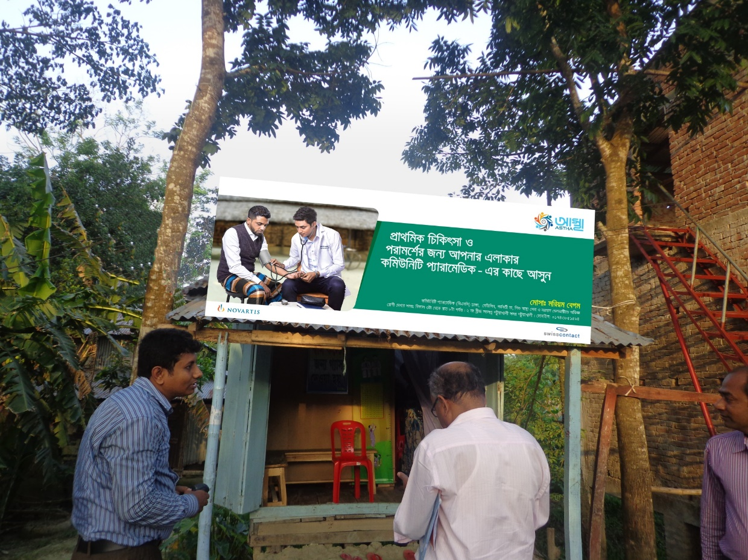

- Delivery Points:

 | Delivery Location | Quantity
1 | Rangpur: RDRS office Building, Rangpur | 40 pcs
2 | Patuakhali: Sarekha vila, Munsef para, Sadar, Patuakhali) | 40 pcs
3 | Sylhet: Flat 4/C, House 12, Road 07, Block A, Shahjalal Upashahar, Sylhet | 40 pcs
Total |  | 120 pcs *
*Quantity by delivery place may very upon the priority. But the total amount (120 pcs) will remain unchanged.
- Role of the service provider
The vendor will be responsible for production of the mentioned item.
- Task of the service provider
- The vendor will submit the price quotation along with the sample of the materials e.g. PVC board, metal frame and printing sample (bidding stage)
- The vendor will require getting final approval of the sample from Swisscontact before going for the full production.
- The vendor will make sure the free delivery of the materials to Sylhet, Rangpur and Patuakhali districts.
- Role of Swisscontact
- Swisscontact will provide the soft copy of master design.
- Swisscontact will provide name and addresses of 120 Community Paramedics that will be printed on the signage
- Swisscontact will approve the sample
- Swisscontact will bear all costs (as per approved budget)

Required documentation
- It is mandatory for bidding organisations to submit documentary evidence demonstrating their legal, taxation and financial status. This includes:
- A certificate of incorporation (for individual companies, a trade license);
- Joint stock registration certificate (if applicable)
- An organisational organogram of key personnel, inclusive of the names of such personnel;
- Tax Identification Number (TIN);
- VAT registration number;
- Proof of a segregated account (providing the name and address of such an account);
- Other valid papers (Provided by Government institutions)
- The vendor must bear all Annual Income tax (AIT)
- Percentage of VAT and total amount of VAT should be mentioned in the proposal.
- Financial offer should be sent in a separate envelope

Evaluation criteria:
Value for money upon accepted samples

- Evaluation Criteria:
Particular | Score
Technical | 50
Financial | 50
Total | 100

Submission Details
Interested parties should submit the price quotation along with samples by 27 October 2021 before 4:00 pm to the address mentioned below:
Senior Officer-Procurement, Swisscontact Bangladesh
House 28, Road 43, Gulshan 2, Dhaka 1212, Bangladesh
For more information, please email at: samaun.bhuiyan@swisscontact.org

