Sesame Workshop Bangladesh

TERMS OF REFERENCE (TOR)

Install “Sisimpur Book Corner" in Non-government Primary Schools
at Moulvibazar and Habiganj Districts

Project Name
USAID’s Promoting Education for Early Learners Activity

Release Date: May 19, 2022
Agency Briefing: May 23, 2022
Proposal Submission Deadline: May 31, 2022

ABOUT SESAME WORKSHOP BANGLADESH

Sesame Workshop Bangladesh (SWB), the country office of Sesame Workshop, produces Sisimpur, the local version of world-famous kids’ television program Sesame Street in Bangladesh. Sisimpur has been made possible in Bangladesh with the generous support from USAID. The TV show has been airing since 2005 with a view to making early childhood education delightful and enjoyable for Bangladeshi kids. This program has been developed to address educational needs of kids between the ages of 3 and 8. Along with the kids, parents, care givers and teachers are involved in Sisimpur through different school and community-based intervention. SWB undertakes different school and community-based intervention to reinforce the messages aired through TV program. It develops and distributes school based educational materials, train teachers, monitors classroom activities and provides technical assistance for using them in the classroom along with community engagement and outreach programs. Since its inception, Sisimpur has been a tremendous success in Bangladesh and within a very short time, it became the most famous television program for kids as well as their caregivers.
Further information can be found at www.Sisimpur.org.bd and www.sesameworkshop.org/

ABOUT THE TOR

To improve the learning outcomes of marginalized children, Sesame Workshop Bangladesh (SWB) has started a new project titled ‘USAID’s Promoting Education for Early Learners Activity’ in Moulvibazar and Habiganj districts. This project will cover 250 non-government primary schools where SWB will reach the students of early grades from Pre-primary, Grade I and Grade II. For achieving the project objective, SWB will deliver a holistic, multi-media initiative to reach marginalized children in Bangladesh, specifically children with disabilities and girls, with engaging educational content through school and community-based interventions and teacher training. Besides different initiatives, one of the key activities under this project is to install Sisimpur Library/Book Corner at non-government primary schools.

This ToR is specifically written to hire an agency who will install Sisimpur Book Corner/Library in 250 non-government primary schools in three sub-districts named Kulaura, Rajnagar and Sadar of Moulvibazar district and two sub-districts named Chunarughat and Madhabpur of Habiganj district. The detailed Scope of Work is given below.

SCOPE OF WORK

To understand the present scenario of project schools, the agency will make a feasibility visit to the project schools before starting the installation process. The agency will produce bookshelves as per real measurement, print backdrop stickers, and install them in 250 schools following the branding guideline of SWB. As 1st phase, Sisimpur Book Corners will be installed in 100 schools of Moulvibazar district by June 2022 and rest of schools will be covered in 2nd phase.
3.1 MAJOR COMPONENTS
3.1.1 As mentioned, the major four components are:
- Feasibility visits in schools as sample basis at Moulvibazar district for ensuring actual measurement and other requirements of Sisimpur Book Corner set-up.
- Production of Sisimpur bookshelves following the design approved by SWB
- Printing backdrop as sticker for Sisimpur Book Corner
- Installation of Sisimpur Book Corner in the selected classroom/s of project Schools

    - Bookshelves Size and Measurement with specification (Follow the image Annex-1):
- Type one: Bookshelves: Size 4ft (Height) X 6ft (Width)X 1ft (Depth)
- Type two: Bookshelves: Size 4ft (Height) X 3ft (Width)X 1ft (Depth)

Bookshelf speciation:
- 18mm MDF Board for Structure
- 18mm Gorjon plywood (Partex board) for basement
- Duco Paint as per provided color and design
- Rectangular Bookshelf
- Hardware Materials high quality for making and assembling

    - Backdrop Sticker Size and Measurement with specification (Follow the image Annex-2):
- Type one: Backdrop Sticker: Size 8ft (H) X 10ft (W)
- Type two: Backdrop Sticker: Size 8ft (H) X 7ft (W)

Backdrop Sticker speciation:
- 5mm PVC board (partex board) for pasting on wall
- Inkjet Sticker Eco print with Matt Lamination that will be pasted on PVC board
- Fevicol Solution Adhesive and 1/1.5-inch screw are both will be used for PVC board pasting
- Inkjet sticker is pasted with PVC sheet on the wall according to design and size will be measure by square feet.

    - 1st Phase Requirement: 1st phase will cover 100 schools
- Type one Bookshelves: 36 pcs with type one backdrop strikers for 36 schools (one book package for each school).
- Type two Bookshelves: 128 (64X2) pcs with type two backdrop strikers for 64 schools (2 book corner package for each school).

N.B. Agency will take school wise HD video footages and still pictures of book corner set-up for documentation.

    - 2nd Phase Requirement: 2nd phase will cover 150 schools as well as Bookshelf and Backdrop Strikers size, measurement and specification will be same as 1st phase. Number of type one and two of Bookshelf and Backdrop Strikers will vary as per field level information.

N.B. The below annex is for your understanding. We will share the final design on the agency briefing season.

LIST OF DELIVERABLES

- Workplan
- Sample Book Corner install in two schools (01 set type one and 01 set type Two)
- Install Sisimpur Book Corner Package at 100 Schools in 1st phase and at 150 Schools in 2nd phase
- Work completion report along with below documents:
  - School wise still pictures of book corner installation
  - School wise assignment completion letter from Head of Institution with recommendation of quality work
  - Sample basis HD video footages (all category and about 5% schools)

SUCCESS INDICATORS

- Proper installation of Sample Book Corners in two schools
- Proper installation of Sisimpur Book Corner package as per requirement
- Product materials quality
- Product printing and finishing quality
- Recommendation letter from Head of Institution

PROPOSAL Component
The proposal must submit both technical and financial plan following the below aspects like-
For Technical Proposal-
- Understanding of the project
- Previous relevant working experience
- Detail installation plan
- Product specification and quality

For Financial Proposal-
- Budget summary
- Detail budget with unit and unit rate
- Legal documents (including individual, agency or organization’s registration paper/NID, Tax/TIN certificate, VAT certificate and bank detail).

Evaluation criteria
The proposals will be evaluated as per below evaluation criteria:
Section | Weightage
Chapter 1: Understanding of the project | 10%
Chapter 2: Previous relevant working experience | 30%
Chapter 3: Detail installation plan | 20%
Chapter 4: Product specification and quality | 10%
Budget | 30%
Total Weightage | 100%

DEADLINES

Activities | Deadline
ToR Publish | May 19, 2022
Agency Briefing | May 23, 2022 (SWB office at 03:30 PM)
Feasibility Audit to schools | May 24-26, 2022
Proposal Submission | May 31, 2022
Award declaration | June 02, 2022
Work order | June 05, 2022
Sample Book Corner set-up in two schools | June 09, 2022
Book Corner Set-up | June 11-25, 2022
Bill submission to SWB | June 26, 2022

POINT OF CONTACT
Name: Md. Khalilur Rahman
Designation: Senior Manager- Outreach
Phone: +8801712067984
Email: Khallur.Rahman@sesame.org

HOW TO SUBMIT THE PROPOSAL
Please submit your proposal with legal documents via email to Mr. Mozammel Khokon at Mozammel.Khokon@sesame.org

Sesame Workshop Bangladesh Office Address
2nd Floor, House- 85, Road- 03, Block- F
Banani, Dhaka- 1213, Bangladesh
Tel: +8802 02-222270670/222270671
Annexure-1: Bookshelf Prototype:

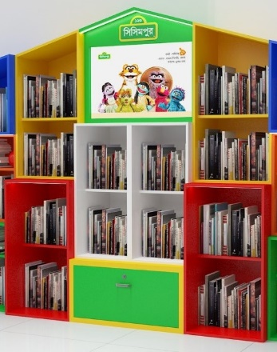
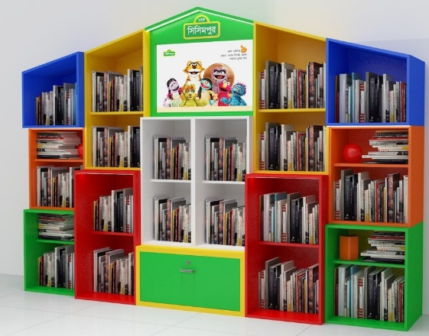
Image-1: Type one bookshelf size 4ftX6ftX1ft Image-2: Type two bookshelf size 4ftX3ftX1ft

Annexure-2: Backdrop Sticker Prototype:
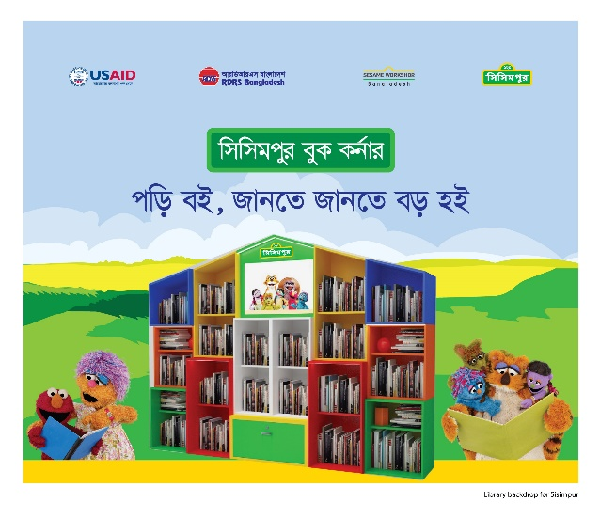
Image-1: Type one backdrop sticker size 8ftX10ft with type one bookshelf
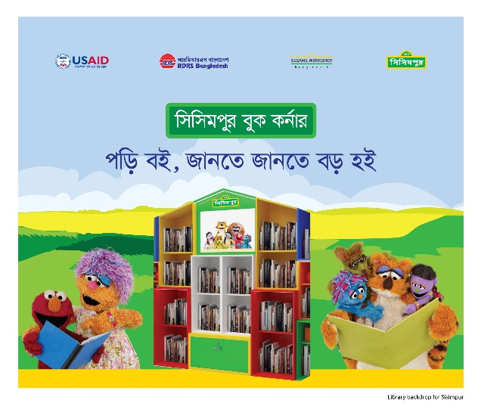

Image-2: Type two backdrop sticker size 8ftX7ft with type two bookshelf

Wear glasses, use crutch/wheelchair/stick, use hearing aids and children with autism etc.

