Project Manager-LEAP
(Based at Cox's Bazar)

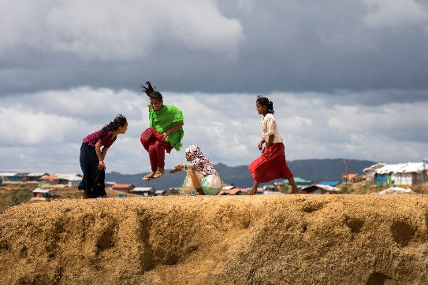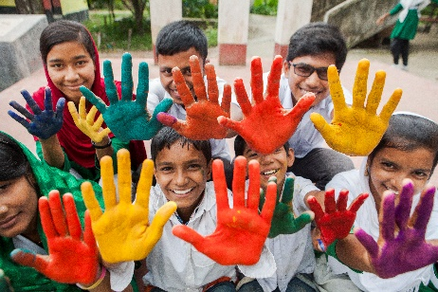

We believe in the power and potential of every child. Globally we have committed ourselves to the ambitious target of reaching 100 million girls to ensure that they can learn, lead, decide and thrive. Plan International Bangladesh (PIB) is transforming itself to meet the enormous challenge everywhere we work to successfully deliver on our global ambitions and significantly impact children’s rights and gender equality in Bangladesh.
Plan has been working in Cox Bazar to respond to the Rohingya refugee influx since 24 September 2017 implementing the following key objectives: 1. Ensure girls and boys affected by the crisis are protected from violence, abuse, neglect and exploitation through appropriate prevention and response interventions in line with minimum standards. 2. Reduce the transmission of disease from faces to mouth through the promotion of good hygiene practice and the reduction of health risks related to poor sanitation 3. Restore and increase access to safe quality and inclusive educational opportunities for refugee children and adolescents (girls and boys) affected by the Rohingya crisis.
We are dedicated and responsible to act on our core values and advance our organisational purpose- Advancing Children’s Rights and Equality for Girls demonstrate our commitments to stand for what is right. We value and embrace diversity of skills, backgrounds and perspectives. We recognize that our work is best achieved by reinforcing our capacity in partnership.
At the country level in Bangladesh, the project will be led by the Plan International Bangladesh and Project Manager will lead the consortium project, supporting Plan International Bangladesh and partners to implement a high-quality project, support project integration, shared learning and other activities with a focus on expanding capacity in inclusion, gender and safeguarding. S/he will be responsible for overall project management, reporting and linkages with Plan Canada, Bangladesh governmental actors and stakeholders and partner organizations (PHD, SKUS, Mukti Cox’s Bazar and HOPE Foundation). As well as establish rigorous project management processes that support high quality and safe programming.

The role:
- The Project Manager being a Consortium lead will be responsible for overall project management, reporting and linkages with Plan Canada, Bangladesh governmental actors and stakeholders and partner organizations (PHD, SKUS, Mukti Cox’s Bazar and HOPE Foundation) as per the signed agreement.
- S/he will be responsible for coordinating and overseeing partners for the quality of the implementation focused on GARI, SRHR, SGBV and MHPSS of the project, providing overall strategic leadership and managerial oversight of the administrative, phonematic, technical and operational aspects.
- S/he will oversee the day-to-day implementation of the project, including the teams in the field as per the organigram.
- S/he will be accountable for the timely and quality implementation of SRHR & GBV activities, compliance with donor rules and regulations and effective stakeholder relationship management.
- S/he will also be responsible for developing and maintaining strong working relationships with the donor, Governments and Consortium members in Cox’s Bazar, Bangladesh, acting as the primary liaison and project representative.
- Most importantly, s/he will be responsible for the overarching leadership and governance of the project, ensuring that the partners work together effectively and efficiently, that there is transparent and active communication amongst stakeholders and that there is a clear ‘value add’ from Plan International Bangladesh involvement in this Consortium.
- S/he will also be responsible for the overall management of areas related to finance, budgetary management and oversight, and partner management, as well as other operational and administrative duties required by the project.

What we’re looking for:

Minimum Masters level educational qualification in public health (MPH) or development studies, social studies or any relevant subject. Minimum 5 years work experience in Consortium / project management, implementation of project with partners. Where 3 years proven experience in humanitarian responses specially in Rohingya responses. Proven experience in partnership project operations and dealing with Government of Bangladesh, civil societies, media and NGO/ CBO. Highly developed relationship building, influencing, negotiating and inter-personal skills. Ability to analyse strategic trends and develop appropriate plans and responses to manage risks. Previous experience in managing complex and multiyear and focused like SRHR & GBV, multi-stakeholder programmes. Solid experience in implementation in complex and insecure environments. Proven experience in establishing information management and finance systems related to programme management. Experience in gender-sensitive programming and at least an understanding of the importance of MHPSS and inclusion in I/NGO programming. Ability to work both in an advisory and a hands-on implementation capacity. Proven capacity to supervise, train, mentor and coach staff. Experience leading on the coordination and writing of donor reports as the lead of a consortium. Politically and culturally sensitive, with qualities of patience, tact and diplomacy. A high level of written and spoken English. The capacity and willingness to be flexible and accommodating in difficult and sometimes insecure working circumstances.

About Plan International:

Plan International is an independent development and humanitarian organization that advances children’s rights and equality for girls. Plan International envisages a world in which all children and young people realise their full potential, a vision now shared by the 193 Heads of State and Government who adopted the 2030 Agenda for Sustainable Development in September 2015.

We believe in the power and potential of every child. This is often suppressed by poverty, violence, exclusion and discrimination. Its girls who are most affected. Plan International’s new Global Strategy aims to transform the lives of 100 million girls by implementing an integrated programme and influence approach.

How to apply:

To find out more details and apply visit: Career Opportunities: Project Manager LEAP

Plan International Bangladesh is committed to ending gender inequality, and achieving a gender balanced workforce. Women are strongly encouraged to apply.

We promote competitive salary, female friendly workplace, outstanding co-workers (who are respectful, professional, unbiased and easy to work with); equal opportunity that mean equal access to promotion, leadership role or incentive programme.

Salary Package for this role will be as per policy of Plan International Bangladesh. Along with other benefits i.e., hospitalization benefit for spouse and children, contributory provident fund, Festival Bonus, leave, group insurance and yearly medical check-up for employee.

Closing Date: 15th April 2022. This project duration is 30th month and selected candidate will get initially one-year contract. Highly possibility for extension base on employee performance. Early submission is strongly encouraged as application collection and selection process will go simultaneously. Only short-listed candidates will be communicated for interview. Any form of persuasion in the selection process will automatically disqualify the candidacy. Selected candidates must be willing to join within very short notice.

Plan follows an equal opportunity policy and actively encourages diversity welcoming applications from all especially women and people living with disability.

-Caution-

All Plan International Bangladesh’s job notifications are published and Plan International does not ask for or ever accept applications fees.

