Request for Quotation (RFQ)
PIBD-DHK-RFQ-FY21-36
QUESTION AND ANSWERS

- According to RFP, we have to follow the Annex 1 for Text, Graphics and Cover Design. But we cannot find any Annex 1 to download. Please, provide the Annex 1.

Pathfinder International Response: Annex-1 was not included with the published RFP. Annex-1 (Soft Copy of the Manual which will be printed) will be provided at the time of issuance of the purchase order.

- Who will make the design? Do we have to only print the manual?

Pathfinder International Response: Pathfinder International has the design of FP Manual. The selected vendor will work on the change of colors and other editing which shall be shared with Pathfinder and approved for printing.

- We are not an enlisted vendor in your organization, can we participate in this RFQ. If not please tell us what the process is to enlist our company as a vendor for your organization.

Pathfinder International Response: No enlistment is required to submit a quote in response to this RFQ. This is a full and open competition, therefore, anyone who meets the required criteria can submit quotes.

- We did not find annex-2 and cost template attachment with this RFQ regarding Delivery point. Please provide it.

Pathfinder International Response: Annex-2 is the included in the BDjobs advertisement to download. The RFP, Annex-2 and Annex-2 have separate download links as shown below. You can click on this link to download these documents.

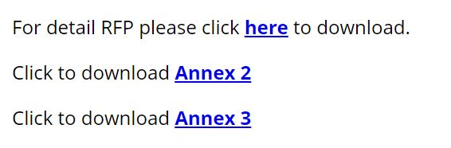

- Price Quotation Template Annex -3" & " Annex-2 Delivery Location" is not clear in RFQ Sheet.

Pathfinder International Response: Please see response for question 4 above.

- Can we use multiple courier services available in Bangladesh for delivery?

Pathfinder International Response: Yes.

- Is it necessary to submit only the booking slip as a delivery document in case of delivery by courier service? Or do you have to submit the receipt copy with the signature of the recipient?

Pathfinder International Response: Pathfinder International will require receipt copy with the signature of the recipient.
- What kind of activities do you have to ensure that 100% delivery is confirmed to all recipients?

Pathfinder International Response: Please see answer to question no. 7 above.

- Designing is our part, or you give design & we execute it? In our part, we need concepts/ previous manuals for base work.

Pathfinder International Response: Please see answer to question no. 2 above.

- 60 days start from which date? after finalized design?

Pathfinder International Response: 60 days will start after signing of the Purchase Order.

- In what quantity a vendor will be awarded if Pathfinder choose more than
one vendor for this assignment. The price will very significantly if the materials quantity is not go above 15-20 thousand.

Pathfinder International Response: Pathfinder International will make the determination of the award upon receiving quotes.

- Will you share receiver's phone number with final delivery details?

Pathfinder International Response: Point of contact and mobile no. will be provided at the time of issuance of the purchase order or before the delivery.

- Is it ok if we deliver through courier service and submit the CHALLAN of
courier service? OR, do you want receiver's signature on vendor challan copy

Pathfinder International Response: Please see answer to question no. 7 above.

- Which format are given design and contents of the family planning manual?

Pathfinder International Response: Both in PDF and illustrated copy but the selected vendor will require to do some additional work as mentioned in this document and the RFP.

