TERMS OF REFERENCE

Title: | Establishment and Technical support for community-based biogas including vermicompost plant.
Description: | Practical Action is looking for a firm that has a strong history of working with international or national NGOs and is known for being professional and delivering work on time. The selected firm/supplier/vendor will provide all the required inputs, construction, commissioning and technical support to operationalize community-based biogas including vermicompost plant in selected place of unions of Dacope, Khulna.
Duration of the Assignment: | 31 March 2026
Fee Rate and Total Fees: | The bidding agency must provide the rate and fees with a detailed budget breakdown, Post set up service following the deliverables with a work plan after site visit.

Who We Are
We are an international development organisation helping people in poverty create lasting change in their lives. We work with communities to find smart, locally led solutions to big challenges, like climate change, gender inequality, farming, clean energy, water, and waste management. We test what works and share it widely so small ideas can grow into big impact.

Our global team includes problem solvers, knowledge sharers, and technical experts. Together, we aim to build a fairer, more sustainable world, where practical action leads to a future free from poverty. To learn more, please visit: https://practicalaction.org.

- Background and Purpose of the procurement

The UK Foreign, Commonwealth and Development Office (FCDO) has selected a CARE Bangladesh led consortium to implement the project titled ‘Nature Based Adaptation towards Prosperous and Adept Lives & Livelihoods in Bangladesh (NABAPALLAB/ নবপল্লব)’ in two Ecologically Critical Areas (ECA) – Sundarbans and Hakaluki Haor. The other consortium members are CNRS, CordAid, C3ER-BRAC University, Dushtha Shasthya Kendra (DSK), Friendship, Humanity & Inclusion (HI) and iDE. It is a key component of the Bangladesh-UK Accord on Climate Change and will deliver the adaptation outcome of the FCDO’s flagship Bangladesh Climate and Environment Programme (BCEP). The programme will make a significant contribution in Bangladesh to progress against GoB’s policies and priorities e.g., National Adaptation Plan (NAP), Nationally Determined Contribution (NDC), commitments to biodiversity conservation, ongoing 8th Five Year Plan, etc. And it will also contribute to UK’s commitment to International Climate Finance (ICF).
The component of the project is to facilitate solar based 3 husking, 3 thresher and 1 dryer. The activities are taken for supporting communities to enhance livelihoods and businesses as well. The project already procured and installed solar based hybrid system husking thresher and dryer to the communities. Earlier the system was procured grid tied system and hybrid system which required electricity support to run the machines. As in coastal areas, disasters disrupt power supply; during extreme weather condition the machine need to run during load-shedding and power disruption.
Hence, we are inviting suitable vendor/company to submit expression of interest (EOI) to discuss the issue related to the community based bio gas plant, its pros & cons, cost, materials, challenges, way out of the challenges, Provision of technical support, payments method etc, submit an associated quotation for materials and service to establish 2 community based biogas plant having vermicompost systems at beneficiary doorsteps at remote locations of Paikgaccha and Koyra.

- Key Deliverables

The selected agency must provide the following deliverables:

2.1 Scope of works

- Interested vendor should submit an EOI letter to procurement.bd@practicalaction.org.bd providing experience, technical strength, post service facilitation and ability to complete work within time limit within the 27 December.
- After EOI submission a pre quotation meeting will be held to clarify the expectation and size of the biogas plant (Arranged by Practical Action in person/online).
- Biogas plant will be made of concrete, Biogas plant should have automated mixer device With Solar System.
- During the construction ground water table of the coastal area should be keep in consideration.
- Average Using 10 family which size may be differ considering the user number.
- Meter required for every household for Gas Measurements.
- After the meeting, the final quotation with work plan will be submitted including required input and materials for 2 community-based biogas plant and vermicompost systems functional.
2.2 Design of the biogas plant

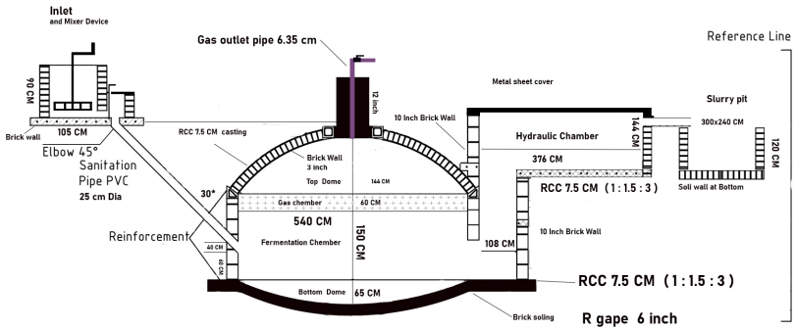

- Role of Practical Action
- Practical Action will provide the technical details with the work order.
- Practical Action will provide all necessary support, directions, and suggestions to the awarded vendor/company in order to complete the tasks mentioned.
- Practical Action will not pay any extra payment to the vendor/company in case of any loss and damage happened.
- Practical Action holds the authority to take any decision at any stage or moment in the work process.
- The service of warranty/guaranty period must be followed by the vendor otherwise Practical Action can take legal action.

- Role of the selected vendor
- Delivery Terms: The items must be delivered to under Practical Action. All deliverables must be reached and set up at beneficiaries’ household level at Dacope, Khulna
- It may need to carry through river transport which should be Considered.
- Services guarantee
- Guarantee the ready availability of the material/goods
- Valid Trade License, VAT, and Tax document (PSR-Proof of Submission Return/Tax Return Certificate).
- The vendor/company must change the materials as mentioned in above until the satisfactions.

- Exclusivity
The vendor cannot share the concept, methodology, content, raw artworks, and the final products with any other party anywhere in the world during at any time, without written consent from Practical Action.

- Ownership and Copyright
Practical Action will own the copyright of all the documents/ products/ materials (in full and every single component) to be generated from this procurement and will preserve the right to share it, if required, with any other party as it might find appropriate. Organization might be allowed to use these products only for non-commercial purpose, subject to written approval from Practical Action.

- Payment
- The payment will be made to the supplier within 30 days upon satisfactory receipt of goods and completion of services by the terms and conditions stated in the Purchase/Work Order after Commissioning, submission, and acceptance of complete set of deliverables e.g., the final handover of the equipment/system to the project site.
- After the successful commissioning 80 % of the total work order value will be provided and remaining 20 % will be paid after one year completion of after sales service period.

Note: Tax and VAT will be deducted at source from the bills payable to the selected vendor.

- Resignation and cancellation/termination of contract:
Penalty Clause – in case of unauthorized delays in the completion of tasks & submission of the document, a 2% penalty will be deducted from the total work order value for each day delayed. The selected firm/team must pay back the total amount of the advance money (if provided) if it fails to submit agreed deliverables and/or withdraws from the contract. The selected vendor/company must notice Practical Action, in writing, if it needs to extend the submission date.

Practical Action in Bangladesh reserves the right to cancel, amend, and defer the contract agreement.

- Required competencies and experience
Minimum 5 years’ experience in relevant sector for government agencies, commercial agencies, I/NGOs;

- Submission process
  - Bidder has to send the EOI letter including experience, bank solvency to procurement.bd@practicalaction.org.bd by 27th December 2025
  - Copies of all required legal documents (Trade license, TIN, BIN, and other documents like experience).

- Important notes for the bidders:
  - Bidders must clearly state the period during which their quoted pricing will remain valid.
  - Bidders must provide a detailed financial proposal
  - Practical Action requires the agency to take all safety measures for its employers to protect the Covid-19 pandemic, especially those who will be involved in this agreement
  - Practical Action will not take any responsibility if any of the members of the selected agency get affected by Covid-19 during / after the procurement
  - Practical Action holds the authority to take any decision at any stage or moment in the work process
  - Practical Action will not compensate for any damages\loss of any equipment
  - Practical Action will not provide any vehicle, accommodation, food to the selected agency
  - The selected agency will directly work with the NABAPALLAB project team of Practical Action
  - Practical Action has got the authority to drop any line item, and accordingly the costs against the line item/s will be deducted.

