TERMS OF REFERENCE

Title: | Poultry rearing coops for household level beneficiaries.
Description: | Practical Action is looking for a firm that has a strong history of working with international or national NGOs and is known for being professional and delivering work on time. The selected firm/supplier/vendor will provide all the required inputs (Poultry coops, water pot and feeding tray) door to door of our selected beneficiaries of all union at Dacope, Paikgaccha and Koyra, Khulna.
Duration of the Assignment: | 30 November 2025
Fee Rate and Total Fees: | The bidding agency must provide the rate and fees with a detailed budget breakdown following the deliverables with a work plan

Who We Are
We are an international development organisation helping people in poverty create lasting change in their lives. We work with communities to find smart, locally led solutions to big challenges, like climate change, gender inequality, farming, clean energy, water, and waste management. We test what works and share it widely so small ideas can grow into big impact.

Our global team includes problem solvers, knowledge sharers, and technical experts. Together, we aim to build a fairer, more sustainable world, where practical action leads to a future free from poverty. To wanted to learn more, please visit: https://practicalaction.org

- Background and Purpose of the procurement

The UK Foreign, Commonwealth and Development Office (FCDO) has selected a CARE Bangladesh led consortium to implement the project titled ‘Nature Based Adaptation towards Prosperous and Adept Lives & Livelihoods in Bangladesh (NABAPALLAB/ নবপল্লব)’ in two Ecologically Critical Areas (ECA) – Sundarbans and Hakaluki Haor. The other consortium members are CNRS, CordAid, C3ER-BRAC University, Dushtha Shasthya Kendra (DSK), Friendship, Humanity & Inclusion (HI) and iDE. It is a key component of the Bangladesh-UK Accord on Climate Change and will deliver the adaptation outcome of the FCDO’s flagship Bangladesh Climate and Environment Programme (BCEP). The programme will make a significant contribution in Bangladesh to progress against GoB’s policies and priorities e.g., National Adaptation Plan (NAP), Nationally Determined Contribution (NDC), commitments to biodiversity conservation, ongoing 8th Five Year Plan, etc. And it will also contribute to UK’s commitment to International Climate Finance (ICF).
The component of the project is to facilitate livestock activities. The activities will support to enhance the beneficiary’s livelihoods and businesses as well. To increase their good livestock production practice by supporting poultry coops, hygiene feeding tray and water pot.
Hence, we are inviting suitable vendor/company to submit a plan and associated quotation to supply at beneficiary doorsteps at remote locations of Dacope, Paikgaccha and Koyra.

- Key Deliverables

The selected agency must provide the following deliverables:

2.1 Deliverable items

ITEM # | DESCRIPTION | UNIT | Quantity
1 | Poultry rearing coops (Length-6 feet * 4 feet width *height 5 feet with two floor and there will be 4 chambers, and two chamber in one floor, Frame use wood and ensure the structure can withstand the weight of roofing materials and external condition) | Pcs | 500
2 | Water pot (4-liter plastic poultry equipment water pot, it can satisfy several chickens to drink at the same time. Colour: Red) RFL product | Pcs | 500
3 | Feeding tray (4-liter plastic poultry equipment feeding tray, it can satisfy several chickens to drink at the same time. Colour: Red) RFL product | Pcs | 500

- Detailed Specifications

Technical Specification of poultry rearing coops and inputs for household level
Items | Description
Main Components of household level Inputs: | Chicken coops, Water pot and Feeding tray.
Poultry rearing Coops | - Length-6 feet * 4 feet width *height 5 feet with two floor and there will be 4 chambers, and two chamber in one floor.  - Size of house posts: Each post will be 2 inches by 2 inches and six posts  - Fence/Slats: Each slat or flat will be 2 inches by 1 inch and there is 1/3 inch gap between two slat or flat in the each ground.  - The fence wood will be 3/4 inch thick in final product  - Frame use wood and ensure the structure can withstand the weight of roofing materials and external condition.  - Plastic net (RFL) will be at the front side and mid portion of the coops for aeration, tin shed will be extended at the front side as if it will be protected the coops from rain.  - Tin-shade house (0.20mm) where wooden frame or structure is wooden, and shade is GCI sheet and will use GI screw with GI Ridge Cap. The roof sheet will be 10-12 inches extended all sides so that the rain water didn’t soak the wall and enter into the chamber.  - Walls will be made by wood. Wood will be of good quality/seasoned. Thickness of the wood will one inch in final product.  - Wood should matured & seasoned Raintree/ Mahogany  - Four chambers have 4 doors and opened in the outside. Ground floor will be 6 inches high from the ground level i.e., Ground clearance will be minimum 6 inch.  - Best quality GI Kobza and steel kora would be used.
Coops (Image) | 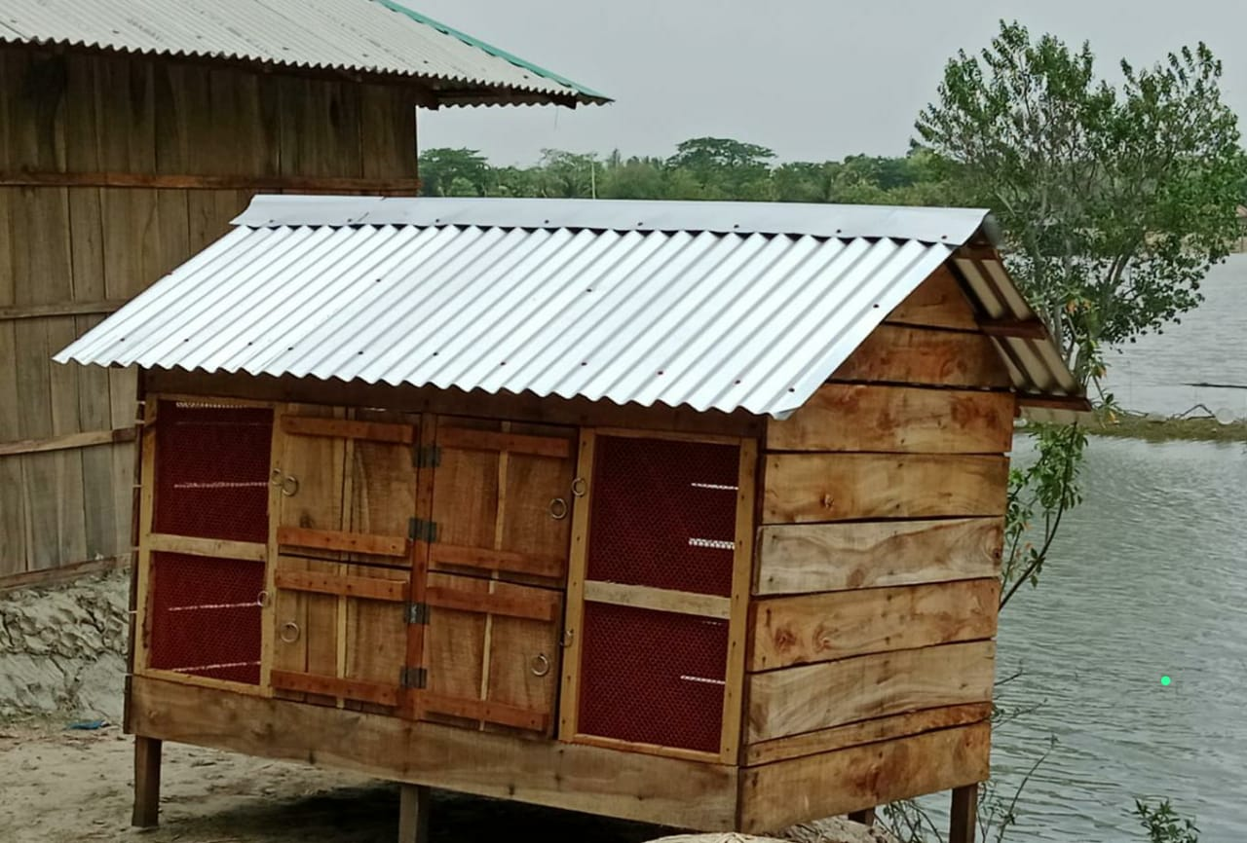
Feeding Tray | - 4 litre plastic poultry equipment feeding tray.  - It can satisfy several chickens to eat at the same time.  - Colour: Red RFL
Water Pot | - 4 litre plastic poultry equipment water pot  - It can satisfy several chickens to drink at the same time.  - Colour: Red RFL

- Role of Practical Action
- Practical Action will provide the technical details with the work order.
- Practical Action will provide all necessary support, directions, and suggestions to the awarded vendor/company in order to complete the tasks mentioned.
- Practical Action will not pay any extra payment to the vendor/company in case of any loss and damage happened.
- Practical Action holds the authority to take any decision at any stage or moment in the work process.
- The service of warranty/guaranty period must be followed by the vendor otherwise Practical Action can take legal action.

- Role of the selected vendor
- Delivery Terms: The items must be delivered to under Practical Action. All deliverables must be reached at beneficiaries’ household level at Dacope, Paikgaccha and Koyra Khulna
- It may need to carry through river transport which should be Considered.
- Services guarantee
- Guarantee the ready availability of the material/goods
- Valid Trade License, VAT, and Tax document (PSR-Proof of Submission Return/Tax Return Certificate).
- The vendor/company must change the materials as mentioned in above until the satisfactions.

- Exclusivity
The vendor cannot share the concept, methodology, content, raw artworks, and the final products with any other party anywhere in the world during at any time, without written consent from Practical Action.

- Ownership and Copyright
Practical Action will own the copyright of all the documents/ products/ materials (in full and every single component) to be generated from this procurement and will preserve the right to share it, if required, with any other party as it might find appropriate. Organization might be allowed to use these products only for non-commercial purpose, subject to written approval from Practical Action.

- Payment
The payment will be made to the supplier within 30 days upon satisfactory receipt of goods and completion of services by the terms and conditions stated in the Purchase/Work Order after Commissioning, submission, and acceptance of complete set of deliverables e.g., the final handover of the equipment/system to the project site.

Note: Tax and VAT will be deducted at source from the bills payable to the selected vendor.

- Resignation and cancellation/termination of contract:
Penalty Clause – in case of unauthorized delays in the completion of tasks & submission of the document, a 2% penalty will be deducted from the total work order value for each day delayed. The selected firm/team must pay back the total amount of the advance money (if provided) if it fails to submit agreed deliverables and/or withdraws from the contract. The selected vendor/company must notice Practical Action, in writing, if it needs to extend the submission date.

Practical Action in Bangladesh reserves the right to cancel, amend, and defer the contract agreement.

- Required competencies and experience
Minimum 5 years’ experience in relevant sector for government agencies, commercial agencies, I/NGOs;

- Submission process
  - Bidder has to send the technical and financial proposal to procurement.bd@practicalaction.org.bd by 30th August 2025
  - Copies of all required legal documents (Trade license, TIN, BIN, and other documents).

- Important notes for the bidders:
  - Bidders must clearly state the period of time during which their quoted pricing will remain valid.
  - Bidders must provide a detailed financial proposal
  - Practical Action requires the agency to take all safety measures for its employers to protect the Covid-19 pandemic, especially those who will be involved in this agreement
  - Practical Action will not take any responsibility if any of the members of the selected agency get affected by Covid-19 during / after the procurement
  - Practical Action holds the authority to take any decision at any stage or moment in the work process
  - Practical Action will not compensate for any damages\loss of any equipment
  - Practical Action will not provide any vehicle, accommodation, food to the selected agency
  - The selected agency will directly work with the NABAPALLAB project team of Practical Action
  - Practical Action has got the authority to drop any line item, and accordingly the costs against the line item/s will be deducted.

