TERMS OF REFERENCE

Title: | Procurement of Agricultural Inputs (Agricultural tools and organic solutions) for NABAPALLAB Project.
Description: | Practical Action is looking for a firm that has a strong history of working with international or national NGOs and is known for being professional and delivering work on time. The selected firm will supply mentioned Agricultural Inputs (Agricultural tools and organic solutions) with respective user guidelines/manual.
Duration of the Assignment: | 30 September 2025
Fee Rate and Total Fees: | The bidding agency must provide the rate and fees with a detailed Budget Breakdown following the deliverables (SL-2) with a work plan.

Who We Are
We are an international development organisation putting ingenious ideas to work so people in poverty can change their lives. We help people find solutions to some of the world’s toughest problems. Challenges made worse by catastrophic climate change and persistent gender inequality. We work with communities to develop ingenious, lasting and locally owned solutions for agriculture, water and waste management, climate resilience and clean energy. And we share what works with others, so answers that start small can grow big.

We’re a global change-making group of problem solvers, knowledge mobilisers and expert advisors. We work together to multiply our impact and help shape a world that works better for everyone. The group consists of a UK registered charity with community projects in Africa, Asia and Latin America, an independent development publishing company and a technical consulting service. Want to learn more, please visit: https://practicalaction.org

- Background and Purpose of the procurement

Practical Action is an innovative international development organization that puts ingenious ideas to work to change the lives of people living in poverty. We help people find solutions to some of the world's toughest problems, namely catastrophic climate change, and persistent gender inequality. Our modality is that to start small can grow big and bring people together in bold collaborations, combining knowledge with innovation to change the systems that keep people poor and vulnerable. We partner with communities to develop ingenious solutions for water and waste management, agriculture, climate resilience, and access to clean energy. We then share what has been proven to work with others so that many more people can change their world, and we also believe in the power of small to change the big picture.
The UK Foreign, Commonwealth and Development Office (FCDO) has selected a CARE Bangladesh led consortium to implement the project titled ‘Nature Based Adaptation towards Prosperous and Adept Lives & Livelihoods in Bangladesh (NABAPALLAB/ নবপল্লব)’ in two Ecologically Critical Areas (ECA) – Sundarbans and Hakaluki Haor. The other consortium members are CNRS, CordAid, C3ER-BRAC University, Dushtha Shasthya Kendra (DSK), Friendship, Humanity & Inclusion (HI), iDE, and Practical Action. It is a key component of the Bangladesh-UK Accord on Climate Change and will deliver the adaptation outcome of the FCDO’s flagship Bangladesh Climate and Environment Programme (BCEP). The programme will make a significant contribution in Bangladesh to progress against GoB’s policies and priorities e.g., National Adaptation Plan (NAP), Nationally Determined Contribution (NDC), commitments to biodiversity conservation, ongoing 8th Five Year Plan, etc. And it will also contribute to UK’s commitment to International Climate Finance (ICF).
One of the components of the project is to facilitate regenerative agriculture. Among two parts of the regenerative agriculture, one is Adaptive Kitchen Garden and other is Small Scale Field Crop farming. For those agricultural intervention we need organic solutions and agricultural tools.
Hence, we are inviting suitable vendor/company to submit a plan and associated quotation to complete whole procurement process including transportation of all inputs to warehouse at Chalna Bazar, Dacope, Khulna.

- Key Deliverables
The selected vendor must provide the following deliverables:

2.1 Deliverable items

ITEM # | DESCRIPTION | UNIT | QUANTITY | UNIT PRICE | AMOUNT (BDT)
1 | Regenerative agricultural inputs for Adaptive Kitchen Garden (According to attached specification)
1.1 | Pheromone lure | pcs | 1870
1.2 | Yellow Sticky Insect Traps | Pcs | 5610
1.3 | CGI tin for pit compost shade | pcs | 1870
1.4 | Geo-grow Bag 7 Gallon | pcs | 4675
1.5 | Organic fertilizer (Vermicompost)-25 kg | Sacks | 935
1.6 | Watering plastic can | pcs | 935
1.7 | Garden tool (Mini iron spade with weeder/tengi)-Local made | pcs | 935
2 | Regenerative agricultural inputs for Small Scale Field Crop (According to attached specification)
2.1 | Pheromone lure | pcs | 1896
2.2 | Yellow Sticky Insect Traps | Pcs | 4108
2.3 | Geo-grow Bag 7 Gallon | pcs | 3160
2.4 | Organic fertilizer (Vermicompost)-25 kg | Sacks | 948
2.5 | Spike Dripper without bottle for Drip Irrigation. | Nos | 3160
2.6 | Garden Hoe Spade with Wooden Handle | pcs | 158
Total Amount with VAT & TAX

- Detailed Specifications
Technical Specification for agricultural inputs:
Sl | Items (with specification) | Unit measure | Total requirements | Indicative images
1. | Watering plastic can 6L-  Brand: RFL,Item Code: 91280, Material: HDPE  Product Type: Watering Jar, Capacity: 6L  Dimension (LxWxH): 38.5X19X25.5 cm  Harmless, safe, and strong pressure resistant. | Piece | 935 | 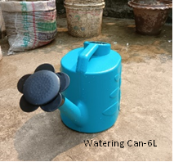
2. | Garden tool (Mini iron spade with weeder/tengi)-Local made | Set | 935 | 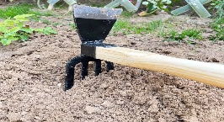
3. | Pheromone lure (Q-phero, Spodo-lure) (2 lure per packet) | Packet | 3766 | 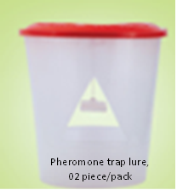
4. | Yellow Sticky Insect Traps (made of PVC material with ultra strong adhesive layer on both side (Made in England) | Piece | 9718 | 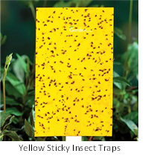
5. | Organic fertilizer (25 KG bag)- Vermicompost | 25 kg/bag | 1883 | 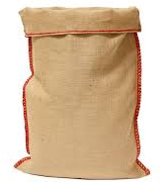
6 | CGI tin for pit compost shade Corrugated Iron Sheet  Height: at least 7 Feet,  Thickness: at least 0.22 mm | Piece | 1870 | 
7 | Geo-grow Bag 7 Gallon Bag Size: Dia-14” & Height-10” Material: Geo Hard Felt Fabric Quality: 600 GSM Color: Grey/white ( Kitchen garden level 5/HH and field crop level 20/HH) | Nos | 7835 | 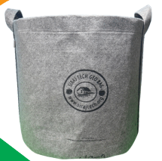
8 | Garden Hoe Spade with Wooden Handle (Wooden handle branded, Steel Spade branded, wooden handle size = 28.5 inch, Steel Spade (Hoe)size = 8 inch, Longlasting) | Piece | 158 | 
9 | Spike Dripper without bottle (Material:PVC, Water flow range: 0-5 L/h, Dripping, speed:0-60s / 1 drip, Dripping lasts:1-10 days, Joint size: 1.1 inch inner diameter, Joint bottle: ½L, 1L, 2L, 5L Bottle) | Piece | 3160 | 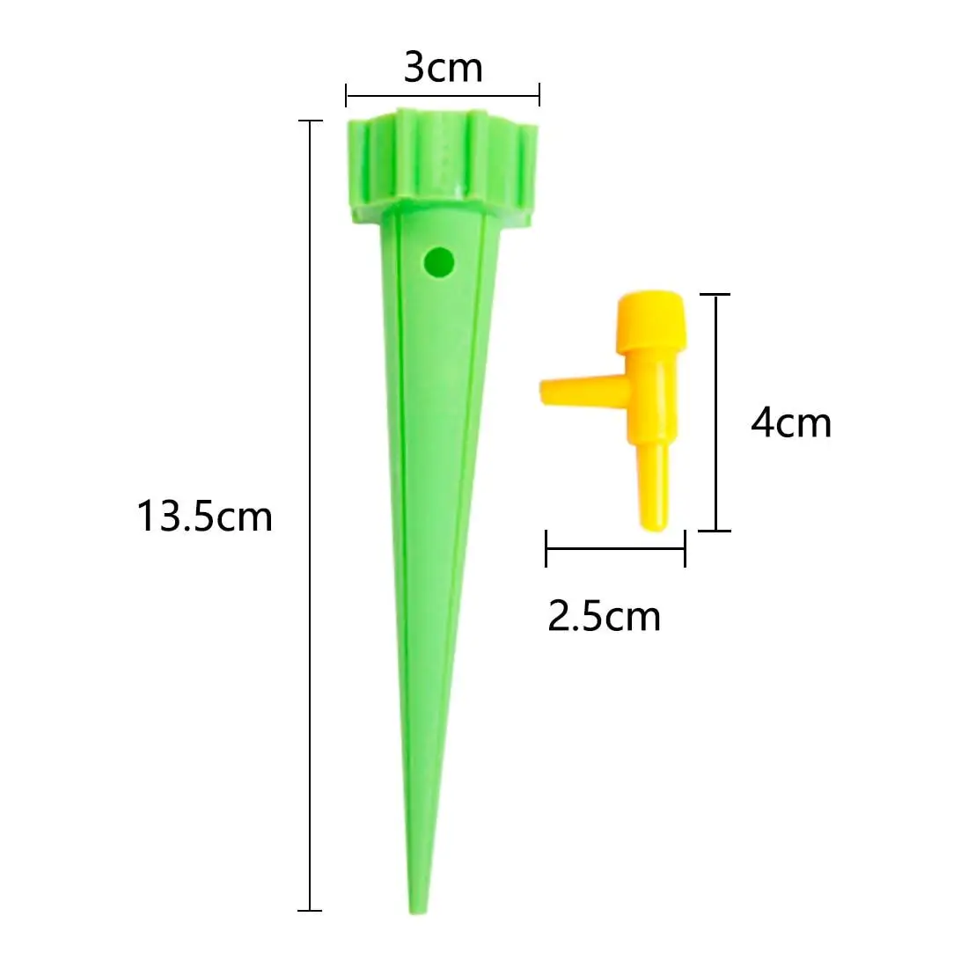

- Role of Practical Action
- Practical Action will provide the technical details with the work order.
- Practical Action will provide all necessary support, directions, and suggestions to the awarded vendor/company in order to complete the tasks mentioned.
- Practical Action will not pay any extra payment to the vendor/company in case of any loss and damage happened.
- Practical Action holds the authority to take any decision at any stage or moment in the work process.
- The service of warranty/guaranty period must be followed by the vendor otherwise Practical Action can take legal action.

- Role of the selected vendor
- The vendor/company is responsible to deliver all the deliverables above mentioned address.
- The vendor/company has to change the tasks as mentioned in above until the satisfactory output comes.
- The vendor will ensure 6 months after sales service which will be counted after delivery.

- Exclusivity
The vendor cannot share the concept, methodology, content, raw artworks, and the final products with any other party anywhere in the world during at any time, without written consent from Practical Action.

- Ownership and Copyright
Practical Action will own the copyright of all the documents/ products/ materials (in full and every single component) to be generated from this procurement and will preserve the right to share it, if required, with any other party as it might find appropriate. Organization might be allowed to use these products only for non-commercial purpose, subject to written approval from Practical Action.

- Payment
The payment will be made to the supplier within 30 days upon satisfactory receipt of goods and completion of services by the terms and conditions stated in the Purchase/Work Order after Commissioning, submission, and acceptance of complete set of deliverables e.g., the final handover of the equipment/system to the project site.

Note: Tax and VAT will be deducted at source from the bills payable to the selected vendor.

- Resignation and cancellation/termination of contract:
Penalty Clause – in case of unauthorized delays in the completion of tasks & submission of the document, a 2% penalty will be deducted from the total work order value for each day delayed. The selected firm/team must pay back the total amount of the advance money (if provided) if it fails to submit agreed deliverables and/or withdraws from the contract. The selected vendor/company must notice Practical Action, in writing, if it needs to extend the submission date.

Practical Action in Bangladesh reserves the right to cancel, amend, and defer the contract agreement.

- Required competencies and experience
- Registered agricultural supplier/vendor with DAE
- Demonstrated experience in supplying Climate-adaptive agricultural inputs
- Compliance with organic farming standards.
- Financial stability and capacity for bulk procurement.
- Must have updated Vat and Tax documentation and record.
- Minimum 5 years’ experience in relevant sector for government agencies, commercial agencies, I/NGOs.

- Submission process
All interested vendor/company are requested to submit a quotation (including VAT and TAX) with the details company profiles including reference of relevant work experience, relevant experience including activities and milestones, BIN, TIN certificate, budget details, time frame and contact details.
Electronic copy of the quotations with budget details duly signed should be submitted to: procurement.bd@practicalaction.org.bd with the subject line: “Agricultural inputs.” by no later than 23 August 2025.

- Important notes for the bidders:
  - Bidders must clearly state the period of time which their quoted pricing will remain valid.
  - Timely delivery of inputs, maintaining visibility, branding and standard.
  - Respective user guidelines for tools and equipment; cultivation procedures; manual; necessary documents for cultivation and practices farmers on sustainable farming practices.
  - Bidders must provide a detailed financial proposal
  - Practical Action requires the agency to take all safety measures for its employers to protect the Covid-19 pandemic, especially those who will be involved in this agreement
  - Practical Action will not take any responsibility if any of the members of the selected agency get affected by Covid-19 during / after the procurement
  - Practical Action holds the authority to take any decision at any stage or moment in the work process
  - Practical Action will not compensate for any damages\loss of any equipment
  - Practical Action will not provide any vehicle, accommodation, food to the selected agency
  - The selected agency will directly work with the NABAPALLAB project team of Practical Action
  - Loading, unloading and transportation cost (if any) will bear by vendor, the entry road to any location must be considered.
  - Any kind of loss such as theft or other loses in vendor warehouse/storage/ transportation need to be recover/fill up properly.
  - Practical Action has got the authority to drop any line item, and accordingly the costs against the line item/s will be deducted.

