## 

Call for Consultants

Training Module Development

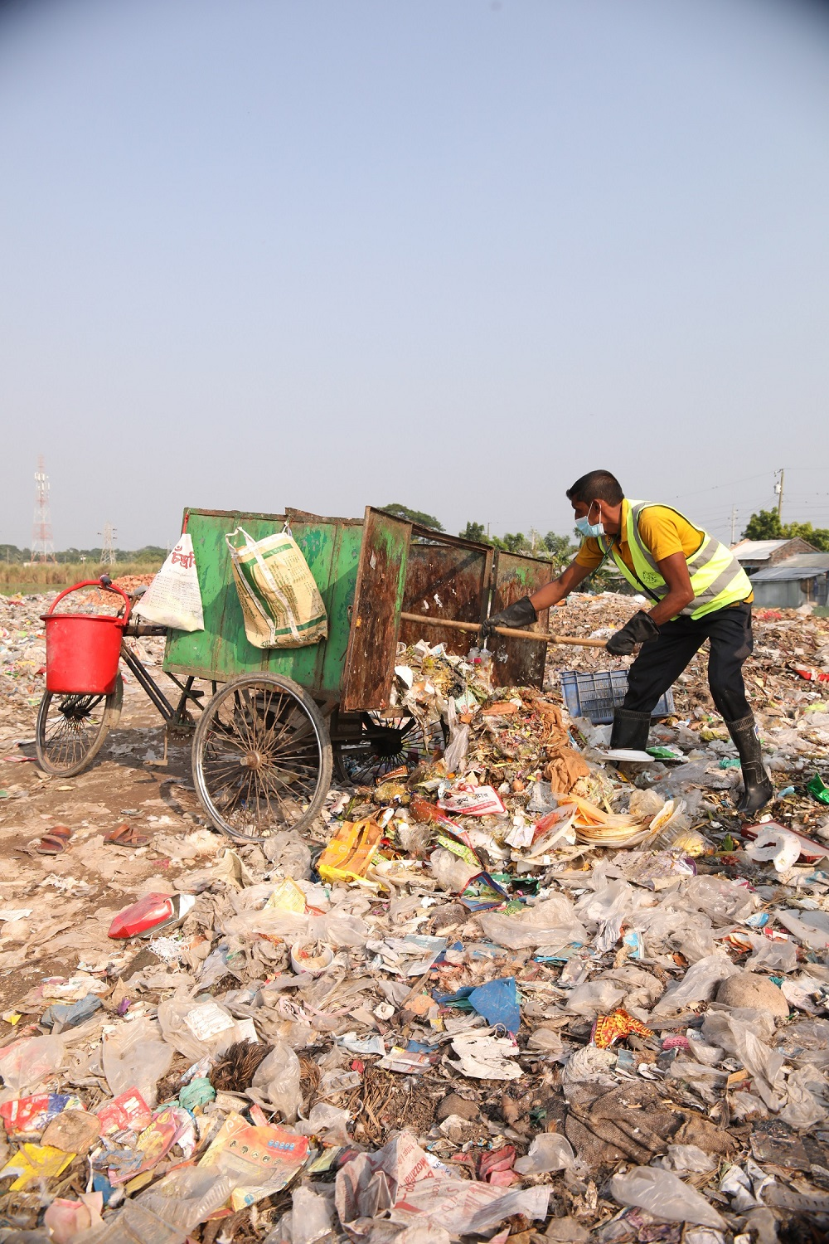

Practical Action

about us

**ABOUT US**

We are an international development organisation putting ingenious ideas to work so people in poverty can change their world.

We help people find solutions to some of the world’s toughest problems. Challenges made worse by catastrophic climate change and persistent gender inequality. We work with communities to develop ingenious, lasting and locally owned solutions for agriculture, water and waste management, climate resilience and clean energy. And we share what works with others, so answers that start small can grow big.

We’re a global change-making group, working with communities who are vulnerable to poverty and climate change to support them to change their world. Together we develop innovative, community powered and locally owned solutions that achieve transformative change in lives and livelihoods. And we work with a range of partners, including governments, business and international organisations to ensure improvements are sustained and scaled and to change the systems that keep people poor and vulnerable.

We were founded in 1969 by radical economist EF Schumacher who challenged the development thinking of the time.  He believed in solutions suited to context, equipping people with the skills and knowledge to change their situation, economic systems that work for all and living within the planets means. This ethos continues to fuel all our work. Schumacher was the author of ‘Small is Beautiful: A study of economics as if people mattered’. In our work we start ‘small’, ensuring we understand what is already working but we aim big focussing on what will deliver the systems change required.

We have over 50 years of experience working across Africa, Asia and Latin America. Our group consists of a UK registered charity with experienced country teams, an expert consulting service and an independent development publishing company. We combine these specialisms to multiply our impact and help shape a world that works better for everyone.

**OUR AIMS**

We work across four thematic areas. Much of our most impactful work combines our expertise across issues to solve complex and interconnected problems such as supporting smallholder farmers with renewable energy to increase yields and open up bigger opportunities for the wider economy.

**Harnessing energy that transforms** for the one billion people without electricity, and the three billion people without clean cooking solutions. We’re bringing together rural communities, displaced people, energy providers and decision makers to put clean energy to work. By 2025, our work with partners will have led to affordable, low-carbon energy access and cleaner cooking for two million people in ‘last mile’ communities and 18 million people through wider systems change.

**Building resilience that protects** for vulnerable people whose lives and livelihoods are threatened by climate-related and natural hazards. We’re working with people threatened by natural and climate related hazards, reducing vulnerability and minimizing the impact on their lives and livelihoods. By 2025, 0ur work with partners will have enhanced risk knowledge systems so that four million people living in hazard-prone, climate-vulnerable communities are better protected.

**Making cities fit for people** for the millions of people living in urban slums and settlements without proper sanitation, clean water and waste services. Our work with communities is making cities in poorer countries cleaner, healthier, fairer places for people to live and work, with clean water for drinking and sewage safely contained, collected and processed. By 2025, our work with partners will have led to improved water, sanitation and waste management services for one million people living in slum communities and a further 2.4 million people through wider systems change.

**Cultivating farming that works** for smallholder farmers struggling to make a sufficient income and adapt to the negative effects of climate change. We’re teaming up with smallholder farmers, many of whom are women, so they can adapt to climate change and achieve a good standard of living. By 2025, our work with partners will have improved food security and incomes for two million people in rural communities and a further one million people through wider systems change.

## **Terms of Reference**

|  |  |
| --- | --- |
| **Assignment title:** | Development and production of training manuals with trainer's guidelines for the capacity building of the Waste and Sanitation Workers on 7 different issues. |

**Background**

Practical Action in Bangladesh has been working on the WASH sector for around 15 years with a special focus on Fecale Sludge and Solid Waste management. We work in collaboration with municipalities to make the cities clean and liveable for everyone. We work closely with the formal and non-formal waste and sanitation workers. Since the beginning of our work, we have been trying to uphold the dignity of waste and sanitation workers. In order to make their lives dignified, along with many different initiatives, we have been trying to make them evolve as entrepreneurs rather than being a mere cleaner. To do this, our activities include transforming manual pit-emptying into mechanical de-sludging; making them competent at using different machines; mobilising the waste and sanitation workers to create their own organisations (cooperatives here) so that they can start their business rounding up their own waste management activities – waste collection, transportation, dumping, treatment, recycling, etc.

Capacity building of waste and sanitation workers, partner NGO staff and municipal authorities is one of the major activities of Practical Action in Bangladesh. In order to build the capacity of our stakeholders, we provide a lot of different training for them. Of the trainings, we have selected seven issues to be reflected as training modules. Therefore, we are launching this ToR to hire a consultant/firm to develop and produce the training modules.

**Details of the Modules to be developed:**

|  |  |  |  |  |
| --- | --- | --- | --- | --- |
| **Name of the Training Module** | **For whom** | **Duration** | **Nature** | **Remarks** |
| Training on how Sanitation Workers can attain customer satisfaction by developing their service quality and overcoming the challenges regarding their market promotion and service delivery. | Faecal and Solid Waste worker/cleaner | 2 days | Residential | Practical Action will provide the zero/basic draft of the module |
| Training on Public Private Partnership (PPP) | Municipal Officer and Faecal Sludge Cleaner | 3 days | Residential | Practical Action will provide the zero/basic draft of the module |
| Training on how to use and maintain equipment and tools that are used for managing Faecal Sludge | Faecal Sludge Cleaner | 2 days | Residential (hands-on) | Practical Action will provide the zero/basic draft of the module |
| Training on Workplace Gender Equality | Municipal Officer and Faecal Sludge Cleaner | 2 days | Residential | Practical Action will provide the zero/basic draft of the module |
| Training on organizational Capacity Building of the cooperatives | Cooperative members of Solid and Faecal Sludge Cleaners | 2 days | Residential | Practical Action will provide the zero/basic draft of the module |
| Training on how to manage accounts of Cooperatives | Cooperative member of Solid and Faecal Sludge Cleaners | 2 days | Residential | Practical Action will provide the zero/basic draft of the module |
| Training on Women’s participation in co-compost production, Small Entrepreneur development & Market Extension | Women and men entrepreneurs: Waste-segregators, compost seller | 2 days | Residential (hands-on) | Practical Action will provide the zero/basic draft of the module |

**Deliverables:**

1. The consultant/firm will deliver a test run of ToT to around 20 trainees from Practical Action, municipal staff and other related government staff in Faridpur. The ToTs will be carried out within 2 consecutive days. The venue and accommodation will be arranged by Practical Action;
2. Upon the feedback of the ToT, the consultant/firm will prepare the final draft of the manuals. All the manuals must contain guidelines for the trainers;
3. The consultant/firm has to deliver seven (7) Training manuals as per the cells above.
4. The language of the modules will be in Bangla (SutonnyMJ font). The consultant/firm has to follow the Bangla Academy rules for spelling.

**Scope of Work:**

The selected consultant/firm will –

1. review the documents (zero-draft manuals) that will be provided by Practical Action;
2. review secondary docs, prepared by other organisations like BTEB (Bangladesh Technical Education Board), MAB (Municipal Association of Bangladesh), ITN-BUET, SNV Netherlands, etc.
3. have review meeting/s with the respective staff of Practical Action;
4. prepare the first drafts and share with the respective staff of Practical Action;
5. upon final feedback, deliver the final versions of the manuals;
6. visit to Faridpur, if needed (do not include the visit cost in the financial proposal, Practical Action will arrange it)

**Role of Practical Action:**

The main responsibility of Practical Action is to:

1. provide support in preparing the itinerary of the assignment, contacting and connecting with relevant stakeholders, if needed;
2. provide technical feedback and support throughout the process;
3. arrange ToT venue and participants.

**Payment**

All applicable taxes will be deducted at source. The release of funds will be made in two instalments:

1. 25% upon signing the contract and completing the work plan;
2. 75% after submission and acceptance of a complete set of deliverables.

**Duration and timing:**

15 working days from the date of signing the contract.

**Minimum Requirements:**

1. For individual consultants: we require the consultant to have a master’s degree in development studies, Journalism or any other subject under Social Science with a minimum of 10 years of experience in developing/producing Training Modules. S/he must have at least 5 years of direct work experience in the WASH sector;
2. For the consulting firms: the firm must be legally registered; we require a reputed and renowned firm in the development field with a minimum of 10 years of experience in developing Training Modules/manuals for national/international NGOs. The firm must have a clear understanding and knowledge of the WASH sector, the life and livelihoods of the waste and sanitation workers and waste management.

**Submission process:**

1. please send your proposal to [procurement.bd@practicalaction.org.bd](mailto:procurement.bd@practicalaction.org.bd) by 31 May 2022;
2. include all related documents at the bottom of the proposal as annexures, make one PDF file and send;

**Resignation and Cancellation/Termination of contract**

Practical Action in Bangladesh reserves the right to cancel, amend, and defer the contract agreement.

**Penalty Clause**

In case of delays in the submission of the document, a 2% penalty will be deducted from the total payment for each day delayed. The selected consultant/firm must pay back the total amount of the advance money if it fails to submit all deliverables and/or withdraws from the contract. The selected agency must notice Practical Action, in writing, if it needs to extend the submission date.

**Intellectual Property Rights**

The video will be considered as Practical Action’s property. However, any of them can be used by media and/or by the selected agency for people’s good with prior written approval from Practical Action, but cannot sell to/reproduce for other entity.

**Important notes:**

1. The consultant/firm must provide a detailed financial proposal, CV of the consultant (for the firm, lead consultant);
2. Practical Action requires the consultant/firm to take all safety measures to protect the Covid-19 pandemic;
3. Practical Action will not take any responsibility if any of the members of the firm and the individual consultant get affected by Covid-19 during/after the assignment;
4. Practical Action will not compensate for any damages/loss of any equipment;
5. Practical Action will not provide any vehicle, accommodation, food to the selected consultant/firm;
6. No spelling error in the modules will be accepted. Please follow the Bangla Academy spelling rule;
7. The consultant/firm has to use the **SutonnyMJ** font.

**Deadline for Application:** 31 May 2022

*Practical Action treat all applications on their merits and do not take into consideration any factors that are not relevant to the assignment such as disability, race, age, caste, religion, gender, gender reassignment or sexual orientation.*

*To ensure that Practical Action meets its legal obligations, appointments with the organisation will be subject to criminal screening, legal tax requirement, professional reference checks and asked to complete safeguarding training. Safeguarding training is delivered through an online training platform.*