**Terms of Reference (ToR) on**

**Conducting Interactive Graffiti Painting on Safe and Informed Migration**

**Background:**

OKUP is a grassroots migrant workers’ organization in Bangladesh. Believing in that the unity of migrant workers enhances their empowerment and contributes to the protection of their rights and dignity, OKUP came up as a platform of returnee migrant workers in 2004. It operates on the principle of human rights first priority, gender justice and non-discrimination. OKUP is registered with NGO Affairs Bureau, under the Primeminister’s office, Peoples Republic of Bangladesh since 2008.

OKUP in partnership with Helvetas Swiss Inter Cooperation Bangladesh has been implenting a project entitled ‘Strengthened and Informative Migration Systems (SIMS) Phase - II’ in Narsingdi district since 2021. Under this project OKUP is seeking service from the bonafied firm/team/. individual to paint grafiti in 30 unions under six upazila of Narsingdi. It is mentioned that the said Graffiti design is already developed (see in annex).

Each year thousands of Bangladeshi migrants go abroad for the overseas job. Despite of having safe migration information many of the migrants are being victimized and or cheated in the migration cycle. People are still depended on the sub agent in the migration cycle. Graffiti is one of the strong media to influence people on awareness raising on specific issue. The grafiti as visual mass awareness media is expected to help raising awareness among community people, migrants and their family members in taking decision either migrate or not.

**Objective of the consultancy:**

* To manage and/ or conduct whole range of labor migration focused Graffiti painting function in selected 30 unions under Narsingdi district.

**Scope of Work:**

|  |  |
| --- | --- |
| **Deliverables** | **Description** |
| 1. Paint interactive graffiti painting at thirty unions under Narsingdi district. | Selected firm/team/individual needs to draw/ paint a total of 65 graffiti on the fixed theme (which is already developed). The team will extract/ draw/ paint the graffiti at thirty unions of six Upazila under Narsingdi district. The same graffiti (theme) will be drawn in thirty unions.  Union name is attached bellow as annex. |

**Timeline of Deliverables:**

|  |  |  |
| --- | --- | --- |
| **Sl. No.** | **Deliverable** | **Timeline** |
| 1. | Sharing the ToR (through bdjobs.com) | 25 March 2025 |
| 2 | EOI/ Proposal submission | 15 April 2025 |
| 3 | Selection of desired team/ individual/firm | 17 April 2025 |
| 4 | Contract signing and orientation about the assignment to the selected team/ individual/firm | 20 April 2025 |
| 5 | Development process start | 22 April 2025 |
| 6 | Start field implementation | 27 April 2025 |
| 7 | Complete all the graffiti painting | 30 May 2025 |

**Payment Modality:**

* 40% installment as advance during the contract signing.
* 60% installment after completion of all graffiti in thirty unions.
* Vat and tax will be applied as per GOV. Rules.

**Terms and Condition:**

* The firm/team/ individual has an expertise in Graffiti painting.
* Experience of developing graffiti on different development issue. Having a minimum two/three years' experience in this field.
* Able to handle multiple team members at the same time to meet the deadline.
* Must have to submit (i) Valid Trade License copy, (ii) TlN certificate copy, (iii) BIN certificate copy (iv) Experience document copy (v) CV of team leader/Profile of the firm (vi) sample of previous work
* **Technical proposal:** covering implementing process, requirement analysis and roll out plan in details.
* **Financial Proposal:** express the budget, and timeline. All types of costs including, transportation, materials, food, accommodation, fee and others will be incurred to the graffiti painting.
* Must have a valid Bank account the name of the firm/ team /individual.

Interested firm/individual are requested to submit a technical and financial proposal with the required documents mentioned in section terms and condition to [procurement.okup@gmail.com](mailto:procurement.okup@gmail.com), or hard copy to OKUP head office ( 466, Sawdagor Garden, Donia, Jatrabari, Dhaka - 1236) **by 15 April, 2025.**

A**nnex: Working Areas:**

|  |  |  |
| --- | --- | --- |
| **District** | **Upazila** | **Unions** |
| Narsingdi | 1.Narsingdi Sadar | Karimpur, Nazorpur, Nuralapur, Paikarchar, Amdia, Kathalia |
| 2.Polash | Gozaria, Charshindur, Dangga, Jinardi |
| 3.Belabo | Belabo, Patuli, Narayanpur, Sollabad, Binnabaid |
| 4.Monohardi | Lebutola, Borochapa, Kachikata, Doulatpur, Charmandalia |
| 5.Raipura | Raipura, Mirzapur, Amirgonj, Sreenogar, Nilokhha |
| 6.Shibpur | Joynagor, Putia, Masimpur, Sadharchar, Joshore |

Annex: Graffiti

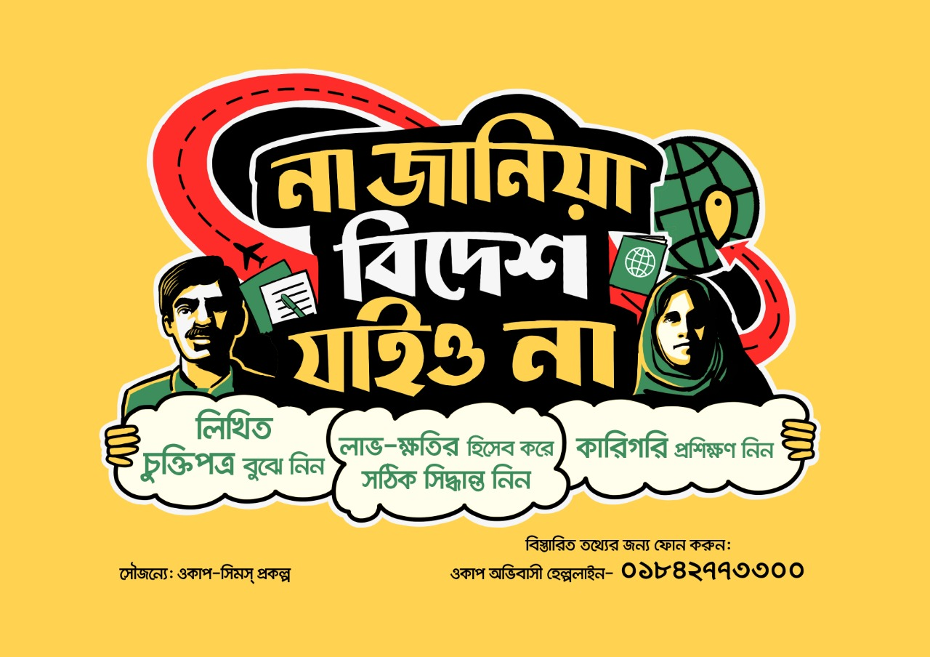

Length – 10 feet (Approximate)

Width – 6 feet (Approximate)