

**Request for Proposal (RfP)**

**for Bakery Sector**

For implementing the project

**Making Markets Work for Youths (M4Y)**

## **1. Introduction and Background of the project**

Muslim Aid (MA) is a UK-based organization founded in 1985 in response to a drought in the Horn of Africa. In Bangladesh for over 25 years, known as MABCO, have adapted their programs to address local community needs in Humanitarian, Livelihood, Education, and Health sectors. With guidance from Muslim Aid Head Quarter (MAHQ), MABCO has executed 15 projects, impacting millions.

Muslim Aid UK Bangladesh Field Office (MABFO) is implementing a three-year project titled, ‘Making Markets Work for Youths (M4Y)’. Initially the project is designed focusing sector-based approach and Market System Development (MSD). M4Y is designed focusing multiphase including set; Market Assessment (MA); Review and Design (R&D); Test Phase (TP) and Implementation Phase (IP) to capitalize the outcome of each phase for further scale up. M4Y released a comprehensive Market Assessment (MA) aimed at refining the project's scope, analyzing various sub-sectors, and formulating targeted interventions. The MA delves into the intricate dynamics of the informal Agro Processing, Light Engineering, and Electronics and Electrical sectors. The MA identified Agro Processing, highlighting nano sectors i.e., dry fish, banana, and bakery, as the potential nano sectors.

M4Y aims at Inclusive economic empowerment of youth in selected areas through the development of market systems in the pilot phase through providing Business Development Services (BDS) to 350 workers and enterprises. By collaborating with MABCO, BDS providers stand to access opportunities for engagement not only in peri-urban and rural areas but also to broaden their client base beyond major cities. The programme aims to empower participating BDS providers to offer specialized consultancy and management training services tailored to the needs of Small and Medium Enterprises (SMEs). Emphasizing the necessity for customized management solutions, the programme will address critical areas including access to finance, product design, market access, technology advancement, supply-chain management, quality assurance, and the promotion of safe and conducive work environments.

## **2. Purpose of the Request for Proposal (RfP)**

To kickstart its efforts, M4Y initiated a comprehensive market assessment in Dhaka and Chattogram to identify promising nano sectors suitable for the pilot phase. This assessment aims to pinpoint opportunities within the “nano” sector that hold potential for meaningful impact and scalability. Thus, M4Y project is geared towards empowering young individuals and driving economic development through various nano-sectors, including dry fish, banana, and bakery. Through targeted interventions such as capacity building, input support, market development, and product diversification, the project aims to harness the potential of young entrepreneurs and workers in these nano sectors. By addressing specific challenges like outdated drying technology, post-harvest losses, product quality, and market access barriers, the initiative seeks to create an enabling environment for youth-led enterprises to thrive.

Against this backdrop, M4Y intends to select Business Development Service (BDS) providers for the pilot phase implementation. Initially, the focus will be on Dhaka and Chattogram, with plans to extend operations to Bogura and Sirajganj in implementation phase. Through this strategic expansion, the project aims to amplify its reach and impact, ultimately contributing to broader socio-economic development goals.

## **Objectives and Scope**

Under the programme team supervision, the specific objectives of the assignment are i) engage with enterprises in programme target sector and district; ii) provide need based BDS consultancy support to individual enterprises; iii) provide group training for the management staff and workers of SMEs having similar BDS need i.e., access to market, production process upgradation; and iv) provide input to programme’s Management Information System (MIS) for monitoring and results measurement purposes. BDS will be delivered to SMEs through following models:

**Needs Assessment and Workshop Facilitation:**

* Conduct comprehensive needs assessments or workshops as needed to identify sector-specific challenges and opportunities.
* Gather insights into the unique requirements and hurdles faced by stakeholders in bakery sectors (Dhaka).

**Capacity Building of Young Workers**

* Provide tailored capacity-building support to empower young entrepreneurs and workers in the targeted sectors. Required trainings could be suggested by the specialists of the mentioned sector but here are some probable trainings for Bakery sector, which are:
* Hygienic Practices in Bakery Production
* Quality Control and Food Security in Bakery Manufacturing
* Business Management Skills for Bakery Enterprises
* Equip them with essential skills, knowledge, and resources to enhance their competitiveness and sustainability in the market.

**Input Support Initiatives:**

* Facilitate initiatives to provide crucial input support aimed at boosting productivity and raising quality standards within the sectors.
* Collaborate with supply chain actors to ensure access to quality inputs such as raw materials, equipment, and technology.

**Market Development and Product Diversification:**

* Develop strategies to expand and diversify markets for products within the dry fish, banana, and bakery sectors.
* Explore avenues for introducing new product lines or variations to meet evolving consumer preferences and market demands.

**Advocacy Events and Policy Addressing:**

* Organize advocacy events targeting policymakers and industry stakeholders to address policy barriers hindering sector growth.
* Advocate for measures to improve market access, create a conducive business environment, and foster innovation and entrepreneurship within the sectors.

## **Goal, outcomes, outputs, and activities of the project**

**Project’s Goal**

The goal of this project is to inclusive economic empowerment of youth in selected areas through the development of market systems.

**Project’s Outcome**

* Improved awareness and practices among workers on hygienic production of bakery items
* Increased sales of bakery products
* Workers apply better practices (becoming more capable to fetch higher incomes over time)
* Businesses generate more revenue.
* Workers benefit from higher capacity translating to higher Salaries & Bonus
* More Businesses observe benefit and then crowds in through similar model.

OUTPUT 1:Workers are capable of handling processes and steps to ensure hygienic production.

**Key Activities**

1. Conduct a need assessment of Bakery value chain. Identify, Shortlist and Select **3 Bakery Enterprises** to partner with
2. Training on food Safety ingredient Handling to **150 workers**
3. Provide Personal Protective Equipment (PPE) to **150 workers.**

OUTPUT 2: Businesses source high quality inputs at competitive prices

**Key Activities**

1. Arrange pure water supply and WASH at Business entities to **15 SMEs**.
2. Introduce Chemical Safety practices during production to **150 workers.**
3. Improve ventilation for Heat Stress Management to **10 SMEs**

OUTPUT 3:Businesses market their improved and more hygienic products to the market.

**Key Activities**

1. Organize **01 sensitization workshop** on Regulatory Compliance
2. Organize **01 sensitization workshop** on Inspections and Audits, marketing, and manufacturing process.

## **5. Project period, and location**

**Period:** The project is aiming to start its Test phase in **June and to continue till December,2024.**

**Locations:**

BDS services will deliver by sectors and locations as per the Table 1: Geographic Focus by Sector below:

*Table 1: Sector wise project locations:*

| **Sector** | **Districts** |
| --- | --- |
| Bakery | Dhaka (urban and peri-urban) |

## **Target beneficiary**

The table below provides location-wise and component-wise targeted beneficiaries.

**Table 2: Location-wise beneficiary for different components**

|  |  |
| --- | --- |
| **District and sector wise targeted beneficiaries and enterprises** | |
| **District** | **Target** |
| **Beneficiaries** |
| Dhaka | 150 workers* |

Note: the numbers of SME will be determined in consultation with BDS provider(s).

## **Preparation of proposal**

Attached template should be used to prepare the proposal. The proposal should not be more than 25 pages. The proposal must be written in English. Interested BDS should also provide an organizational overview. Following guidelines will be applicable in the preparation of the proposal:

* Project will not bear separately any regular travel cost of key staff for field operation, except travel for meeting, workshop, cross visit, monitoring visit, etc.
* Project staff and their salary should be planned realistically without compromising with the quality and skill required.
* Payment from Muslim Aid during project life will be made on monthly/quarterly advance basis as appropriate as per MABCO policy. But payment of last month will be on reimbursement basis based on completion of deliverables.

**With the proposal the interested BDS will submit the following information /documents:**

* + Copy of the registration **(Trade Licenses)**
  + Last three years annual budget highlighting major investment sector/s
  + Proportion of donor and own funding sources
  + List of major donors in last three years
  + A copy of the organizational organogram
  + A copy of the last organizational audit
* Apart from registration, which other registrations /approvals does the BDS have to work for development sector in Bangladesh.

**Financial proposal**

* Prospective BDS provider should submit financial proposal (30 points) as per MABCO template. Financial proposal must elaborate co-financing strategy with MABCO programme and ratio of cash contribution from MSMEs.

## **BDS Selection Criteria**

**Minimum Qualifications and Experience of BDS providers**

* At least 5 years of experience as a business service provider;
* Track record of providing BDS to SMEs, preferably of bakery.
* Experience of implementing similar kind of programmes/projects;
* Have technical resources/propose relevant nano sector experts according to the nano sector.
* Technical expertise in assessing issues of market demand and supply in Bangladesh and the ability to draw strong and valid conclusions;
* Understanding of Bangladesh socio-economic context and nature of informal economy; and
* Familiarity with the development efforts of national and international development partners, INGOs and NGOs.
* Will have all necessary legal documents (registration with legal authority, VAT/Tax registration/certificate etc.)

## **Evaluation criteria for technical proposal (annex 1) will be as follows:**

|  |  |  |  |
| --- | --- | --- | --- |
| **Sl.** | **What to evaluate** | **Description** | **Points** |
| **1.** | CV of BDS Implementation Manager and other proposed positions | To be evaluated as per professional experience requirements | **20** |
| **2.** | Prior experience of providing support to Dry fish sector | To be evaluated as per the BDS provided to Dry fish sector | **10** |
| **3.** | Proposed implementation approach | To be evaluated as per activity timeline and implementation plan | **10** |
| **4** | Beneficiary planning | To be evaluated as per the plan to reach targeted workers (male and female) and enterprises | **10** |
| **5.** | Organization profile and References of previous works | To be evaluated as per organizational experience requirements | 20 |

## **Deliverables**

1. Submit detail activity plan for BDS interventions, after onboarding targeted MSMEs, within one months of contract signing;
2. Submit monthly tracker for monitoring result measurements as per MABCO prescribed format;
3. Submit quarterly progress and project completion narrative reports (template will be provided by MABCO);
4. Submit quarterly financial report (budget vs expenditure, fund utilisation report) with supporting documents (format and template will be provided by MABCO); and

## **Reporting**

The BDS providers will report to the Head of Programmes, MABCO but will work closely with M4Y Project Staff.

## **Submission of proposal**

1. CVs of BDS Implementation Manager as well as proposed staffs must highlight relative experiences in respective fields (CVs should be attached as annex of technical proposal);
2. All technical proposal’s evaluation will be done based on the sectors, locations, and prioritized BDS categories;
3. Technical Proposal should not be more than 25 pages;

* Technical proposal and Financial Proposal should be submitted to the email address: [**bangladeshprocurement@muslimaid.org.bd**](mailto:bangladeshprocurement@muslimaid.org.bd) by **28 May 2024**. Please mention **“Engagement of BDS Provider”** in email subject line. Two different folders i.e. technical and financial should be submitted into one zip folder with a cover letter. The proposals should be submitted in pdf format.

1. **Contact Person:** If the bidders have any queries for the the quality of the proposals, the bidders have to submit those questions by to Akramul Haque Email: [info@muslimaid.org.bd](mailto:info@muslimaid.org.bd) All inquiries shall reference the RFP in the subject line. No phone calls or in-person inquiries will be entertained; all questions and inquiries must be in writing. The questions should be asked to increase the quality of proposals.

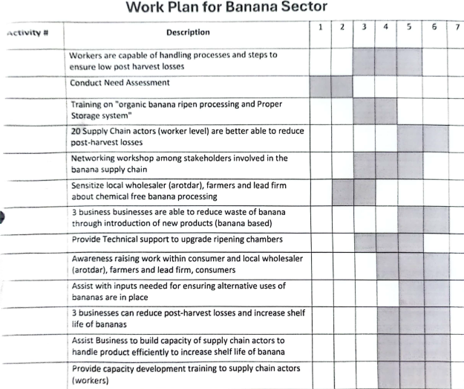

**Financial Proposal**

|  |  |  |  |  |  |  |
| --- | --- | --- | --- | --- | --- | --- |
| **SL** | **Activities** | **Unit** | **Qty** | **unit cost** | **Total amount (BDT)** | **Remarks** |
| **1** | **Activity 1: 150 Workers are capable of handling processes and steps to ensure hygienic production** |  |  |  |  |  |
| 1.1 | Conduct need assessment of Bakery value chain | Nos | 1 |  | - |  |
| 1.2 | Training on food Safety ingredient Handling | Batch |  |  | - | Service Provider will determine the quantity of batch |
| 1.3 | Provide Personal Protective Equipment (PPE) | Persons | 150 |  | - |  |
|  | **Sub Total** |  |  |  | **-** |  |
| **2** | **Activity 2: Businesses source high quality inputs at competitive prices** |  |  |  |  |  |
| 2.1 | Deliver capacity development training for existing workers | SME | 15 |  | - |  |
| 2.2 | Deliver capacity development training for existing workers | Batch |  |  | - | Service Provider will determine the quantity of batch |
| 2.3 | Deliver capacity development training for existing workers | SME | 15 |  | - |  |
|  | **Sub Total** |  |  |  | **-** |  |
| **3** | **Activity 3: Businesses market their improved and more hygienic products to the marke** |  |  |  |  |  |
| 3.1 | Organize sensitization workshop on Regulatory Compliance | Workshop | 1 |  | - |  |
| 3.2 | Organize sensitization workshop on Inspections and Audits, marketing and Organize sensitization workshop on Inspections and Audits, marketing and manufacturing process | Workshop | 1 |  | - |  |
|  |  |  |  |  |  | Service Provider can recommend for additional sub-activities to achieve this activity |
|  |  |  |  |  |  |
|  |  |  |  |  |  |
|  |  |  |  |  |  |
|  | **Sub Total** |  |  |  | **-** |  |
| **4** | **Activity 4: Promotional materials** |  |  |  |  |  |
| 4.1 | Promotional Materials, Banner, Leaflate, festoon, Learning materials | Package |  |  | - | Service Provider will determine the quantity of batch |
|  | **Sub Total** |  |  |  | **-** |  |
| **5** | **BDS operation cost i.e., HR, operaton, admin** |  |  |  |  |  |
| 5.1 | Human resource 1 | Day |  |  |  | Service Provider will determine the quantity of batch |
| 5.2 | Human resource 2 | Day |  |  |  | Service Provider will determine the quantity of batch |
| 5.3 | Human resource 3 | Day |  |  |  | Service Provider will determine the quantity of batch |
| 5.4 | Human resource 4 | Day |  |  |  | Service Provider will determine the quantity of batch |
| 5.5 | Specialist | Day |  |  |  | Service Provider will determine the quantity of batch |
|  | **Sub Total** |  |  |  | **-** |  |
| **6** | **Total direct cost** |  |  |  | **-** |  |
| **7** | **overhead cost** |  | **7%** |  | **-** |  |
|  |  |  |  |  | **-** |  |

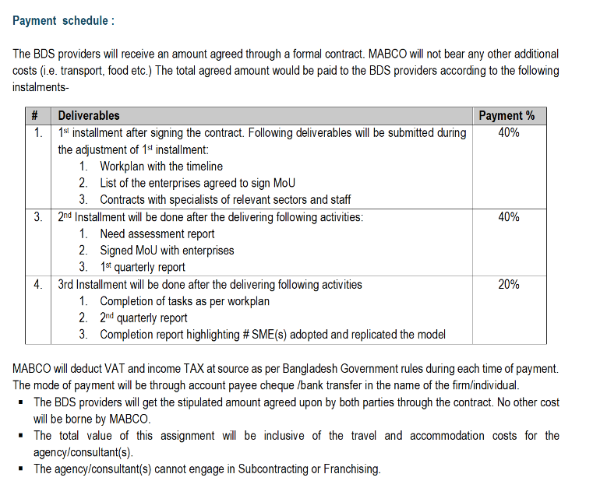

**Earnest Money:**

An earnest money 2.5% on quoted amount (Earnest money will be refunded to the respective vendors/suppliers/agency within 30 working days after finalizing procurement process.)

Name of Account: Muslim Aid-UK Bangladesh Field Office

Account Number: 20501020202091912

Name of Bank: Islamic Bangladesh Limited (IBBL)

Branch: Local Office, Motijheel, Dhaka

It would be **Pay Order** not **Account Cheque**

|  |  |
| --- | --- |
| **INFORMATION FOR APPLICANT** | |
| Eligibility of Applicant | 1. Must have **valid Trade License (2023-2024) Financial Year Update copy)** 2. Must have **Income Tax Certificate (Financial Year Update copy)** 3. Must have **VAT Registration Certificate (Financial Year Update copy)** 4. Must have **Bank Account** 5. Must have Valid Office Address, Telephone/Mobile & Email |

**Cover Letter Format**

(Please use letterhead pad)

[*Location, Date*]

Dr. Zareen Khair

Country Director

Muslim Aid UK Bangladesh Bangladesh

House 13, Road 27, Block J

Banani, Dhaka 1213

Dear Sir:

In response to your RfP for the project titled **Making Markets Work for youth Project, Test Phase** we are hereby submitting our proposal, which includes this Technical Proposal and a Financial Proposal.

If negotiations are held during the period of validity of the proposal, before May 31, 2024 we undertake to negotiate on the basis of the proposed staff. Our proposal is binding upon us and subject to the modifications resulting from contract negotiations.

We understand Muslim Aid UK Bangladesh reserves the right to reject all or any proposal without giving any verbal and or written rationale.

Yours sincerely,

Authorized Signature:

Name:

Title:

## **Evaluation criteria for technical proposal (annex 1) will be as follows:**

The selection process will follow the scoring criteria detailed below:

**Criteria, sub-criteria and point system for the evaluation of the Technical Proposals are:**

|  |  |
| --- | --- |
| i) Experience & Reference  Experience with similar Field/Sector  Prior experience of providing support to Dry fish sector  References of previous works . Sub-total | 10  7  3  **20** |
| (ii) Approach, Methodology, and Work Plan  Understanding of comments on the ToR/Proposal  Technical approach and methodology  Work plan  Sub-total | 10  10  20  **40** |
| (iii) Qualification of Experts, including their Experience in the Field of Assignment  Team Leader / Manager / Senior Survey Specialist  Others Colleagues  Sub-total  Total 100 | 10  10  **20** |
| (iv) Financial part &Legal documents  Quotation submits as per following point 07 (Total Including VAT & AIT)  Legal Documents (Update Licenses, Tin, Bin, Business Account)  Sub-total  Total Number - 100 | 10  10  **20** |

Questions from bidders

If the bidders have any queries for the Feed the Future Bangladesh Horticulture Activity regarding improving the quality of the proposals, the bidders have to submit those questions by to Shafinaj Rahman, MEL Director, Email: shrahman@chemonics.com. All inquiries shall reference the RFP in the subject line. No phone calls or in-person inquiries will be entertained; all questions and inquiries must be in writing. The questions should be asked to increase the quality of proposals. Typically, a relevant question asked about the proposal will be responded by the Feed the Future Bangladesh Horticulture Activity within seven days of receipt. While the bidders will be able to send questions individually to the specified Activity email (mentioned above), without copying the other bidders, in response the Activity will copy all the bidders with the answer to the question asked, without identifying which bidder has

asked the question.