Terms of Reference
Endline Study
- Organizational Background
iDE is an international NGO with over 37 years of experience in designing and delivering market-based anti-poverty programs in 14 countries. We are a world leader in making markets work for the poor as well as the longest established market development specialist NGO in Bangladesh. iDE believes that markets can be a powerful force for improving smallholder prosperity by creating income and livelihood opportunities for poor rural households. iDE Bangladesh currently has eight projects in agricultural markets, water, sanitation and hygiene (WASH), and access to finance with a focus on women’s economic empowerment and climate-smart technologies.
- Project Background
Uddokta - empowering entrepreneurs - is a three-year (2020-2022) project co-funded by Chevron and the Swiss Agency for Development and Cooperation (SDC) and implemented by iDE. Under Chevron’s Bangladesh Partnership Initiative (BPI) and SDC’s COVID-19 Relief Emergency Grant, Uddokta seeks to improve income and livelihoods, and promote inclusive and non-discriminative society and employment opportunities of the poor and disadvantaged people through enterprise development and strengthening market systems in the Sylhet Division (Northeast of Bangladesh). The first objective of the project is to increase the income of 1,100 micro, small and medium enterprises (MSMEs) and the second objective is to ensure 1,500 out-of-job youths who have been affected by COVID-19 have full-time equivalent jobs in high-growth sectors. Uddokta is being implemented in 4 districts in the Sylhet division: Sylhet, Moulvibazar, Habiganj, and Sunamganj.
- Project Objective
The primary goal of the project under Switzerland co-investment is to ensure that 1,500 out of job youths (aged 18-35, 30% of them are women) have full time equivalent (FTE) jobs as a result of the project leading to a 25% increase in their household income. The project will select out-of-job youths with a focus on women target groups ensuring that at least 30% of the entrepreneurs are women. The achievement of this goal is manifested through 3 key results pathways and one crosscutting result area, these are:
- Results Pathway 1: The 1st Results pathway is focused on supporting 1,500 vulnerable and marginalized youths to start full time jobs/enterprises and benefit from alternative income-generating activities in a sustainable manner and make them resilient to economic shocks in the future.
- Results Pathway 2: The 2nd Results pathway wants to empower youths to make independent business decisions affecting their livelihoods and create a supportive community around them;
- Results Pathway 3: The 3rd Results pathway aims to accelerate the SME ecosystem in the selected areas by attracting at least USD 1.5 million in external investments through trade, financial services and partnerships between SMEs and private sector actors.
- Cross-cutting Results Area: The cross-cutting results area is to promote climate smart and clean energy technologies, business model, products and services leading to sustained climate-resilient livelihood. (Please see the ToC in Annex 1)
Uddokta’s interventions contain three main growth sectors and a couple of sub-sectors. The growth sectors and sub sectors are in below:
- Growth Sector 1:
  - Agriculture and Aquaculture,
  - Agri-mechanization and
  - Livestock and Poultry
- Growth Sector 2: Climate-Smart Sector
  - Clean and Renewable Energy,
  - Sustainable Waste Management,
  - Regenerative Agriculture
- Growth Sector 3:
  - Labor Market/Off-Farm
  - Last mile retail agents
- About the Assignment
iDE is looking to hire a qualified firm to conduct the endline study for the Uddokta project in its targeted areas following specific instructions. Uddokta has clearly defined its targets and indicators in its project proposal and previously conducted a baseline study in 2021 with baseline indicators and data for each of the target sets. These indicators and data represent guiding pillars to measure project’s achievements and outputs until the end and also guide the programme team to plan effectively and coherently in materializing the project goal in a systematic way.
In addition, since 2021 the programme has been collecting quantitative data of the outputs through its Information Management System (MIS) regularly. Uddokta has considered outcome monitoring as one of the most important MRM (Monitoring and Results Measurement) activities to assess the outcomes of the programme and review the approaches both quantitatively and qualitatively. Thus, the programme has been coordinating studies in both the targeted sectors with the aim to assess the progress at outputs and outcome levels against the programme interventions during the programme period. The programme is now in its final year, expected to wrap up in November, 2022, and seeks to do a final assessment of its performance indicators in line with its programme logical framework.
- Objectives of the Assignment
The overall objective of this study is to assess the impact among the youth entrepreneurs and employees in the targeted sectors as a result of the Uddokta supported interventions and provide quantitative and qualitative interpretations on the specific indicators baseline. The study will further produce credible information to assess the level of change brought forth to the livelihoods of the targeted 1,500 youth by the project, and whether it is as was envisaged. In particular, the study will strive to achieve the following objectives:
- To collect and analyze the information of the existing situation of the project’s beneficiaries, service providers, and/or related stakeholders in terms of their income and employment status, sustainability and resilience, independent business decision capacity, increase of trade and investment and expansion and adoption of energy-efficient and eco-friendly tech and all other relevant indicators as outlined in the Uddokta Intervention Results Assessment Plan (IRAP); and
- To measure the positive and/or negative changes/outcomes taking place on relevant indicators at the MSME/employee/household/ community level
The study design must also incorporate measurement of attribution and contribution. One of the essential elements of an impact evaluation is that it not only measures or describes changes that have occurred but also seeks to understand the role of particular interventions (i.e., programs or policies) in producing these changes. The study must thus take this into consideration and identify:
- attributable change that has directly been brought about by the project
- contributable change that has been brought about by the project, but is also influenced by other external factors
The study findings will be primarily used by iDE and its implementing partners in assessing the beneficiaries and comparing their pre and post project status of the market systems and communities with whom it works. The endline information will also be used by the relevant project stakeholders and donors.
- Geographic Area Distribution of the Assignment
The Uddokta project works with the out-of-job youths of 4 Districts and 7 Upazilas under the Sylhet division. The study will be conducted in all 4 districts and 7 Upazilas. The targeted Districts and Upazilas are:
District | Upazila | Upazila Map
Habiganj | Nabiganj | 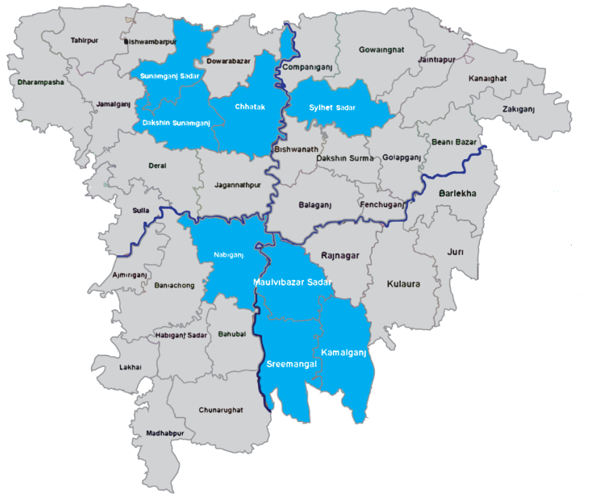
Moulvibazar | Moulvibazar Sadar
 | Kamalganj
 | Sreemangal
Sunamganj | Sunamganj Sadar
 | Dakshin Sunamganj
 | Chhatak
Sylhet | Sylhet Sadar

- Suggested Approaches and Methodologies
Study Methodology
The study will be based on data and information gathered from both primary and secondary sources. Under the secondary sources, the study will include a desk-based review of relevant programme documents such as programme description, logical framework, programme implementation manual, proposed interventions and action plans etc. Other secondary literature should include (but not limited to) sectoral growth reports, policy documents and district-wise available reports and databases.
Under the primary data, the consultant will collect primary data through an appropriate quantitative survey for youths and their families, and qualitative methods such as focus group discussions, in-depth interviews, key informant interviews, and semi-structured questionnaires for other relevant stakeholders such as programme partners, community members, etc. Data collection should preferably be tab/mobile-based, but can be finalized upon discussion regarding the study methodology. To ensure the quality of data, the consultant will have to provide a data quality assurance protocol that will be followed throughout the study. For quantitative data collection, geo-location data of the respondents will be required.
This is the proposed and brief methodology. However, we would appreciate more efficient and detailed methodology from the consultant. The study should follow a mix-method (qualitative and quantitative) approach. A combination of but not limited to (sample) enterprise surveys, key informant interviews (KII), focus group discussion (FGD) and case studies is required. The study will cover all the information based on the outcome indicators of the programme which are already designed in programme monitoring and evaluation matrix.
As evident from the abridged Theory of Change (ToC), the Uddokta project primarily works to elicit transformation in the following four focus areas:
- Youth-based enterprises (MSMEs) sustainably generate income and are resilient to shocks
- Increase women’s participation in supported enterprises
- Increase investment and trade from key market actors as investment and trade through partnership and market facilitation
- Expand market for more environment-friendly and energy-efficient technology and processes
The consultant is expected to articulate, in their proposal, proposed key research questions addressing these four focus areas, which will guide the development of FGD and KII tools. The study will make sure of the following conditions:

Impact Evaluation
In terms of evaluating the impact, the other influencing forces rather than the project interventions that may have an impact on the beneficiaries need to be considered. The key factors are mentioned below.
- Since the inauguration of the Chevron stream of the Uddokta, the project is seeking to improve incomes and livelihoods of rural communities through enterprise development, creation of local entrepreneurs, and strengthening market systems in Chevron BPI catchment areas of the Sylhet Division: Sylhet, Moulvibazar, and Habiganj, which are also the implementation districts of Swiss Uddokta. Therefore, in the overlapping areas, Chevron Uddokta is working with the enterprises and households from specific VDOs, whereas Swiss Uddokta is working with the out-of-job youth from the same geographic areas, and sometimes from the same VDOs. There’s no overlapping of beneficiaries between the streams, but sometimes both of them create impacts on the same households. In this aspect, on the overlapping households, the impact of the Chevron and Swiss stream can be measured separately.
- Apart from the influence of the Chevron stream, we assume that there might exist some other factors that have an impact on the youth and their households, such as government initiatives, seasonal business opportunities, support from relatives, etc. While conducting the impact evaluation, it’ll be figured out if there were other factors like these or not and if found, those factors will be considered as well. This will help to measure how much impact those factors had on the youth and the households who received no interventions from the project. Considering those impacts, the project’s actual attributable impact can be measured and the difference can be shown.
- There was another project that operated in the region – BRAC’s Jibika project – that has a lot of overlap with Uddokta. Therefore, the impact evaluation for the endline should include three groups: direct households (iDE-only interventions, iDE and BRAC interventions), indirect households (no intervention in non-Jibika VDO households), and a control group (no interventions). BRAC did not work with indirect households, so it would be easier to argue that income changes in those households (as compared to the control group) should be attributed to iDE interventions and not BRAC.
Following the other methodology, Uddokta will take different impact measurement strategies for its project objectives. The impact and outcome objectives, key performance indicators, data collection methods, and the possible data sources are described in the table below.
Evaluation Objective | Method | Relevant Indicators
Goal: Change in youth’s own and HH income | Quantitative: Comparing intervention and control groups, Regression Analysis | ● % of youth reporting increase in income (disaggregated by gender)  ● % of annual income increase of the household
Outcome 1: Youth based enterprises (micro and small) sustainably generate income and are resilient to shocks | Quantitative: Comparing intervention and control groups | ● % of enterprises who feel they are able to cope with shock or stress in the future  ● % of enterprises reporting an increase in savings
Outcome 2. Increased ability for youth, especially women, to make independent business decisions. | Quantitative: Comparing intervention and control groups | ● % youth and women in leadership roles within targeted enterprises  ● % of youth and women can make independent business decisions (i.e. investment, sales, production, etc.)  ● % of enterprises reporting an increase in business relationships with other enterprises  ● % of enterprises reporting an increase in business relationships with input suppliers  ● % of enterprises reporting an increase in business relationships with output buyers
Outcome 3: Increase investment and trade from key market actors through partnership and market facilitation. | Quantitative: Comparing intervention and control groups | ● Value (USD) of additional investments attributable to the Uddokta project  ● # of incubated enterprises that establish a new and innovative business model in financing/ logistics/ retail services
Outcome 4: Expand the market for more energy-efficient and environmentally friendly technologies and processes (Green Growth) | Quantitative: Comparing intervention and control groups | ● # of enterprises adopting energy-efficient and environmentally friendly (climate-smart) technologies and processes  ● Value (USD) of additional investments by the youth on climate-smart enterprises attributable to project  ● # of renewable energy and/or climate-smart technology-based business models are designed, developed inhouse (by Uddokta)  ● % of youth are aware of climate-smart products and services through project activities

A complete reference of the full indicator set, baseline values, targets, definitions, data sources, and data collections are mentioned in the Uddokta IRAP plan. However, a detailed methodology must be prepared before conducting the study.
Population Groups and Sampling Techniques
In order to see the scope of impact and spillover effect of the project’s proposed interventions, it is highly anticipated that the proposed study methodology should include samples from the target beneficiaries and households of mentioned districts and upazilas, as well as indirect household beneficiaries and project-supported growth sectors and sub-sectors.
To conduct the Impact evaluation, Uddokta will consider four groups from the intervention and adjacent areas. The sample size will be calculated based on the population estimates of each group and a random sampling strategy will be followed to select them. The four groups will be:
- Households who received Swiss Uddokta only interventions
- Households who received Chevron Uddokta only interventions
- Households who received both Swiss Uddokta and Chevron Uddokta interventions
- Households who received neither the Swiss Uddokta nor the Chevron Uddokta interventions (Indirect groups)
However, additional population groups might need to be considered based on context while conducting the study.
The consultant should propose a robust sampling methodology, constituting proportionate representation of all geographic locations. The project also works with a number of private and social enterprise partners from the growth sectors and sub-sectors to mobilize their business that need to reflect in the proposed methodology. The detailed methodology and field work schedule will be finalized in consultation with iDE, partner organizations and the consultants.
The study will draw data from all 900 MSMEs in targeted 3 sectors and from a population of 2,932 project beneficiaries and their family members. Based on the provided information, the applicant should provide a thorough sampling methodology. A point to be considered here is that the total figure for youth-led enterprises (900) is not an updated figure, and the total population size will increase once the data for Q2 2022 has been incorporated into the MIS. The most updated data will be shared with the consulting firm at the earliest opportunity once the agreement has been signed. The consultant is expected to devise appropriate tools and study methodology factoring this into their assessment plan.
- Major Responsibilities of the Firm
The composition of the study team is left up to the consultant/organization based on their internal system, ideas and logic. However, iDE recommends that the team comprise one Team Leader (TL) to coordinate/conduct the overall study and liaise with iDE. To collect information from the field, an adequate number of Field Enumerators (FEs) will be deployed in facilitation of iDE's Project Officers at the Districts/Unions. Supervision of the field work and quality (reliability and validity) of the data/information collected from the field is the primary responsibility of the TL. The TL will work closely with the M&E Unit and Project Team. In each step and process, consultation with the Project Manager, E&A/M&E Specialist and District/Upazila Field Teams are vital. The consultancy/consultant team will be primarily responsible to:
- Visit iDE Dhaka and Uddokta project office in Sylhet and hold interactions with E&A Specialist and Uddokta core team to get acquainted with the project, its activities and the proposed work.
- Prepare and share a detailed plan of action/schedule for the endline study, covering orientation to enumerators, field work, data collection, analysis, interpretation, draft and final report preparation with concerned project staff.
- Prepare a detailed methodology for the endline study including sample size calculation, questionnaires for household survey and checklist for group discussion, focus group discussion (if applicable and possible) and key informant interview as per the project document and project log-frame mainly focusing on indicators but also covering other relevant areas.
- Pre-test draft endline questionnaire, incorporate the inputs/feedback and circulate the final version of the questionnaires.
- Develop the questionnaire into a digital data collection platform, i.e. Kobo Toolbox.
- Submit inception report.
- Debrief/discuss with project team about effectiveness of questionnaire, checklists and other tools used in pre-test, collect feedback and finalize them.
- Orient, train and supervise the enumerators and collect the data in an ethical manner for the endline study.
- Ensure the quality of information collected from fields, cross-check the validity of information collected and verify/revise where needed.
- Update progress of the study on a weekly basis to the E&A Specialist .
- Analyze data (using R/SPSS/Excel/other statistical analysis software), submit the analyzed data and analysis code to iDE and prepare quality reports.
- Share draft report and give presentation on the draft report to iDE, and
- Prepare and submit a final report (a compiled version of the report - both hard copy and electronic version in Microsoft Word format) to the project after incorporating the feedback and suggestions from iDE.

**The consulting firm must obtain approval from iDE for all key documents and processes outlined above.
- Major Responsibilities of iDE
iDE will provide the consultant/firm with the necessary support to undertake and implement the assignment and execute the objectives of this assignment. Such responsibilities include the following:
- Provide programme documents and approve the work plan
- Support to finalize the methodology
- Lead the development of research questions, and develop tools and questionnaires
- Supervise data collection, cleaning, and data transcription
- Review and approve the data analysis plan
- Supervise data collection and arrange a presentation on analyzed data
- Approve table of contents and provide feedback on the draft report
- Approve the final report
- Disbursement of payment as per the agreed schedule in the contract
- Tentative Task Schedule
The consultant/firm is expected to start work on or around October 13, 2022. This assignment should be completed within the 8th of December 2022, which includes completion of all tasks in the assignment along with the submission of the deliverables as detailed in Section 11. Based on unavoidable circumstances, the period for conducting the assignment might change. The consultant/firm is expected to be able to accommodate these changes without additional cost. A final detailed work schedule will be determined during the kick-off meeting.
Indicative Work Plan
Activities | Month  1 |  |  |  | Month  2 |  |  |  | Month 3
 | W1 | W2 | W3 | W4 | W1 | W2 | W3 | W4 | W1 | W2
Contract signed
Work plan and methodology submitted and approved
Development of data collection tools and questionnaire
Finalize and approve endline study data collection tool
Training of enumerators & pre-testing of the questionnaire
Data collection for endline study
Data cleaning, processing, and sharing of database
Data analysis and presentation of findings
Submission of draft report
Feedback incorporation and submission of final report

- Deliverables and Schedule of Payment
The financial proposal (format attached) should include expert and data enumerator’s fees and expenses (including travel costs, accommodation & food expenses, etc.). The payment will be made in three installments as follows:
Deliverable | Timeline for Completion | Installment Values
Deliverable 1: Inception Report, including approved work plan, methodology, questionnaire etc. | 13 October 2022 | 25%
Deliverable 2: Dataset of sample beneficiaries and MSMEs selected from the field based on selection criteria for the endline study | 5 November 2022 | 25%
Deliverable 3: Draft endline report including the key findings, final dataset and transcripts | 24 November 2022 | 50%
Deliverable 4: Final Endline Report (both hard and soft copy) | 8 December 2022
Note: Government VAT and tax regulation will be applied, and these costs must be included in the financial proposal.
The following terms and conditions will apply:
- The payment will be made through account payee cheque/ wire transfer (account name, number, type, bank name, and branch name is required for wire transfer);
- As per Government of Bangladesh VAT and tax regulation; International consultants are taxed at 15% VAT (on contract amount) and 20% tax (on contract amount +VAT); National consultants are taxed at 15% VAT and 10% tax;
- Government VAT and tax regulation will be applied and iDE Bangladesh will deduct all relevant VAT and Tax at source as per GoB rule;
- VAT Registration Certificate, TIN and Trade License (if applicable) must be submitted before the agreement is signed;
- In case of failure to deliver the final product in due time, iDE Bangladesh will deduct .05% of the total agreement amount for each day of delay in submitting the report beyond the closing date of the agreement;
- The selected consultant/firm will abide by other terms and conditions of iDE Bangladesh.
- Proprietary Rights
Any document, information or data entrusted to or produced by iDE in connection with this assignment shall be strictly confidential and cannot be used by the contract employee for any other purpose without the written consent of iDE. This provision shall remain valid even after the completion of this assignment. iDE reserves the right to terminate this agreement at any time with the consultation of the contracted individual/firm.
- Guidelines for Submission of the Proposal
These guidelines shall ensure uniformity of proposals submitted by all applicants and transparency of the evaluation process.
- Eligibility Criteria
Eligible applicants are research organizations with an appropriate setup (fully equipped with physical facilities and competent team members) to conduct this task. The applicant must meet the following criteria.
- The consultancy firm must have 10 years of experience in undertaking impact evaluations of bi-lateral and multilateral organization with report submission as a proof
- Demonstrated experience with market system research/study/survey/impact assessment, especially focusing on Market Systems Development (MSD) and Making Markets Work for the Poor (M4P) approach
- Proven experience of conducting project progress tracking studies with special focus on the young male and female beneficiaries, and market-based interventions in a rural setting

- Bid Submission & Evaluation Criteria
Consultant will be evaluated based on following criteria. The key factors stated below will be taken in consideration during the evaluation process-
- Previous work experience
- Methodological/technical aspects of carrying out the study
- Financial aspects (consultant fees, breakdown of activity costs etc)
The language of the proposal should be English. The proposal must be submitted in PDF format, maximum of 8 pages (not sheets) excluding Cover Page, Abbreviations, Glossary, Table of Content, Additional Documents, and Annexes. Page size A4;
S.N. | Content of the Proposal | Maximum possible points | Suggested number of pages
The main part of the proposal
1 | Background/organizational profile of the applicant | - | 0.5
2 | Track record of earlier similar studies (the title of study and few lines to the nature of the study, the date of the study was conducted, the name of the client). Recommendations resulting from such work may be included in the Annex. | 10 | 1
3 | Team composition and abbreviated CVs of core members of the study team | 10 | 1
4 | Description of understanding of the task at hand | 20 | 1
5 | Proposed methodology to undertake the study to fulfill the objective | 30 | 2.5
6 | Timeline/milestones to conduct the assessment in a Gantt Chart | 10 | 1
7 | The budget must be structured as follows:  a) Personnel days with professional fees for each staff assigned  b) Support services (materials, communications, etc.)  c) Travel, Accommodation  d) VAT and TAXPerson-days as per Government rules | 20 | 1
 | Total score for the proposal | 100
Additional Documents
8 | If applicable, please also include:  - Company profile  - VAT Registration Certificate  - TIN Certificate  - Joint Stock Company Registration Certificate  - Trade License Certificate | -- | As required
Annex
9 | Annexes may be included for further clarification. However, for evaluation, only the main part of the proposal will be taken. | -- | As desired

Interested firms are requested to submit their Technical and Financial Proposal to bangladesh.procurement@ideglobal.org . Please write “Uddokta Endline Study Consultancy” in the subject line. The proposals should be submitted by 11.59 pm BST on Thursday, 6 October 2022. We are only able to consider electronic submissions. Only shortlisted firms will be contacted and invited for a technical discussion.

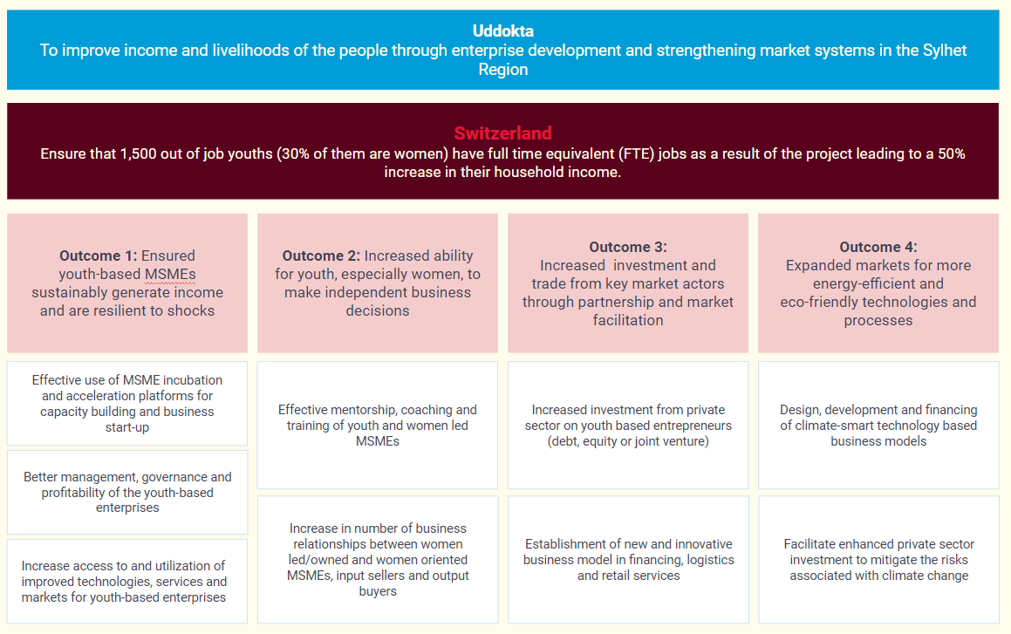
Annex 1: Theory of Change

Annex 2: The Content of the financial proposal (example)
Financial Proposal
Name of the Organization |  |  |  |  |  | Date:
Address
SL | Items | No. of Persons | Unit(Day) | BDT per day or unit | Total Amount (BDT) | Remarks
A | Remuneration
A1 | Team Leader
A2 | Study Co-ordinator
A3 | Qualitative data analyst
A4 | Quantitative data analyst
A5 | Supervisor
A6 | Enumerator Quantitative
A7 | Enumerator Qualitative
A8
Sub Total
B | Travel and Accommodation
B1 | Two way travel
B2 | Accommodation
B3
B4
B5
B6
Sub Total
C | Support Services
C1 | Training venue and food
C2 | Training food
C3 | Print and stationary
C4 | Data entry
C5
C6
Sub Total
 | VAT (15%)
Grand Total
In Words

