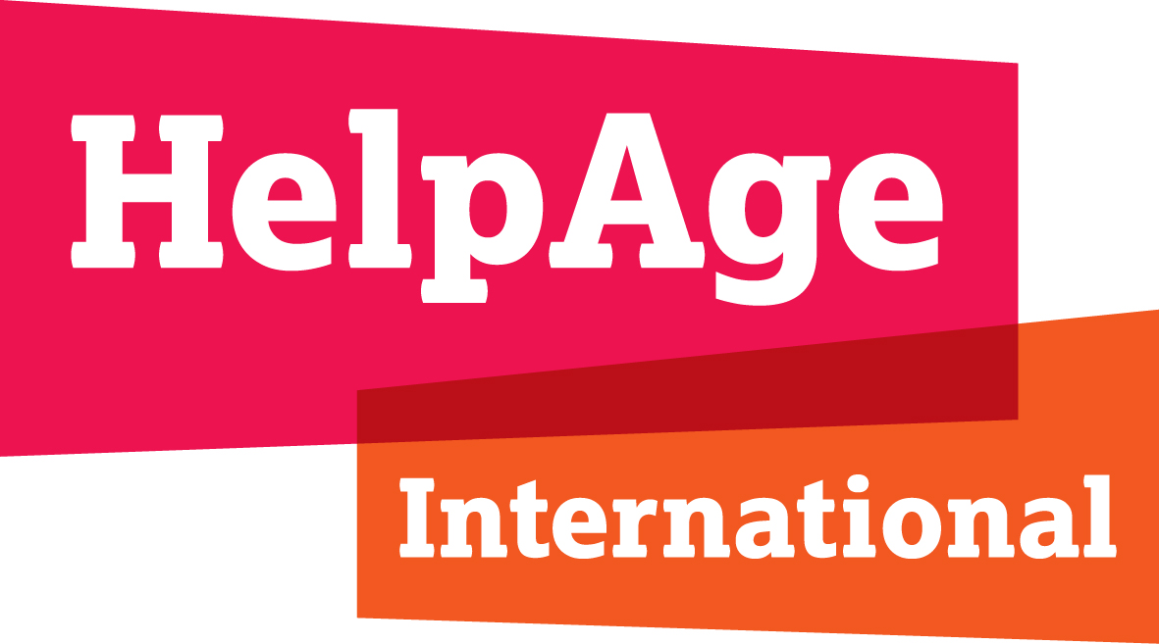
JOB DESCRIPTION

Job Title : Finance and Administration Manager
Location : Dhaka/Cox’s Bazar, Bangladesh
Department : Finance & Administration
Salary : Consolidated BDT 1,20,000.00
Job Grade :05 (National)
Contract Length : Fixed Term for 06 months with possibility of further extension
Responsible to : Country Director
Key functional relation : Country Director, Humanitarian Programme Manager, Finance Officer, HR & Administration Officer, Project Manager
Other relations in the region : Regional Finance Manager, Regional Head of Programmes, Regional HR and Administration Manager
Other relations in HelpAge : Finance and Administration team in other country offices

BACKGROUND
HelpAge International is the Secretariat to the HelpAge Global Network, which brings together a wide range of organisations and individuals working to promote the rights and meet the needs of older women and men, nationally and/or internationally.
The HelpAge Global Network has strong roots in global civil society organisations and enormous potential to expand its existing collaboration to form much wider partnerships influencing positive changes for societies in the context of population ageing and for older people themselves. Harnessing the expertise and reach of a recognised global network presents the best opportunity to shape the ageing agenda for the 21st century and accelerate the way that governments, communities and businesses adapt to ageing and the challenges of population ageing.
We aim to extend the reach and influence of the HelpAge Global Network to all those in a position to help bring about our vision for older people.
HelpAge has been working with affiliates and partners in Bangladesh since 1991, initially with projects mostly through national partners focussing on older people’s access to healthcare and income security, including the Old Age Allowance and Widow’s Allowance. Community-based older people’s associations were formed and federated as a type of “older citizens monitoring” of the rights and entitlements provided by government, and also supported the formation of small-scale savings groups.
We set up our Bangladesh country office in 2009, enabling us to step up our drive for improved wellbeing of older people through advocacy and community-programme delivery. We work in several different areas including emergency responses, disaster risk reduction, healthcare, improving older people's access to their rights and entitlements, empowering older people's associations and influencing social pensions policy.

JOB PURPOSE
Reporting to the Country Director, the Finance and Administration Manager ensures that the delivery of finance and administrative support in Bangladesh country office is effective and efficient in line with the strategic programme objectives. The role is expected to strengthen the existing finance and administrative function by updating and generating timely and updated financial information for accountability purposes. The jobholder ensures compliance with donors’ regulations as well as HelpAge internal policies and procedure and provides support to the regional team as required.

KEY RESPONSIBILITIES:
- Financial Accounting
- Implement and maintain effective accounting systems for the recording of all financial information;

Make payments after verification of the accuracy, validity, legitimacy of all documentation ensuring, completeness of financial documents, (purchase requests, work orders, pro forma invoices), proper coding and approval by responsible managers before payments are made
- Review and ensure the correctness of monthly accounts and cash & bank reconciliations for timely submission into SUN system
- Ensure that supporting documentation and finance procedures are compliant with HelpAge and donor requirements;
- Manage cash flow, ensuring that regular and accurate transfer requests are made;
- Assist the Interim/Country Director in the production of HelpAge financial reports, Financial Planning Sheet (FPS) and year-end as required.
- Responsible for the management of staff payroll ensuring accurate and timely payment;
- Project Reporting
- Set up and produce timely, accurate monthly management reports which analyse financial results, highlight variances, and monitor budgets; and to assist with the interpretation of these reports to budget holders;
- Work with the relevant staff in the regional office to produce project budgets and forecasts as required, including the detailed budget sheets (DBSs);
- Produce donor reports for designated projects.
- Accounting Management
- Support Programme staff in the production of project budgets and proposals, advising on assumptions, risks and opportunities contained within the budgets;
- Review and ensure that the financial aspects of all funding proposals meet HelpAge standards and requirements;
- Identify the financial information needed by the regional office and to set up systems to ensure that these needs are met;
- Undertake visits to field office(s) or partners to help ensure quality is maintained in all aspects of financial management.
- Provision of Technical Support and Advice
- Work with members and partners, helping set up accounting systems and procedures that are required by HelpAge. To monitor this work, highlighting any shortfalls and agree required management actions with relevant staff;
- Contribute to the efficient running of the team by assisting in the development of procedures and the improvement of standards across organisation working in conjunction with the Regional Finance team;
- Ensure that monthly budget monitoring is carried out and proactively keep the Regional Finance Team updated;
- Administration Management
- Responsible for administration function within the country office including logistics, IT and supervision of Cleaner cum Cook and Driver ensuring they are well oriented in their roles.
- Liaise with the Regional HR and Administration Manager on human resources and administrative related issues including timely reporting on staff database, performance management system and planning.
- Responsible for the management of office inventory for both liquid and fixed assets with adherence to donor’s requirements.
- Support the Interim/Country Director as the Security Focal Point for Bangladesh ensure the country security management procedures in place that meets its duty of care to staff, partners and beneficiaries.
Be part of a multifunctional team that can assume tasks or responsibilities that are not necessary defined in this job description. This requires adaptability and high collaborative team spirit.

PERSON SPECIFICATION
The post holder will require the following competencies, skills and experience:
- Essential
- Minimum 06 years of relevant work experience preferably on Humanitarian response and Country office financial management with international NGO in financial management position
- Minimum Master’s degree in Accounting or Finance, CPA certified would be preferred
- Proven experience in financial administration and audit.
- Essential experience in managing administration/office management
- Budget management experience and high levels of financial literacy;
- Hands on experience in working with DFID, EU funded projects and conversant with budget, expanses and reporting guidelines
- Essential experience of working with NGOs or international agencies or multinational business, preferably as Senior Finance Officer or similar
- Significant experience in budget planning skills for multiple donors
- Sound analytical and influencing skills
- Ability to work independently as well as in a team
- Excellent interpersonal and teamwork skills, working with different groups and nationalities
- Strong initiative and self-motivated, with a strong commitment to humanitarian principles
- Excellent information technology skills
- Ability to multi-task and cope with competing demands under tight deadlines, identify priority activities and assignments, adjust priorities as required
- Fluent written and spoken English language.

NOTE
This job description is intended as guidance and should not be viewed as inflexible as it may be varied from time to time in the light of strategic development of HelpAge programme objectives.

-----------------------------------------------------------*******************-----------------------------------------------------------------------

