Terms of Reference (TOR)
Impact Assessment of the Milk for School Project (Phase one)
Ullapara, Sirajganj
1. Background
The Milk for School Project is a joint initiative of Heifer International Bangladesh (HIB), Heifer Korea (HK), and Grameen Danone Foods Limited (GDFL) implemented in Ullapara sub-district of Sirajganj, Bangladesh. The project aims to improve the nutritional status of primary school children while strengthening the livelihoods of smallholder dairy farmers through an inclusive dairy value-chain approach. Under the project, approximately 1100 primary school students received fortified yogurt to address micro-nutrient deficiencies. At the same time, around dairy farmers particularly women farmers were supported through improved milk production practices, assured market access, and the operation of a Milk Chilling Center managed in partnership with cooperatives and GDFL.
As the project period comes to an end, an early sign of results or impact assessment is required to assess the project’s effectiveness, impact, sustainability, and learning outcomes.
2. Purpose of the Assessment
Overall Objective:
- Assess the nutritional status of school students who received nutritional support from the project and effectiveness on the Milk Chilling center in project areas
Specific Objectives:
- Assess the school student's learning behavior like attendance, attitude to the school and educational progress.
- Assess the impact of Milk Chilling Center , especially economic and social impact at the community level in terms of milk production, processing and marketing;

- Assess the school feeding modality and supply chain management and compare with other school feeding program;
- Know the key lessons learned, best practices, and challenges.
4. Scope of Assessment
The assessment will cover:
- Selecte primary schools and beneficiary students at Bangala union under Ullapara, Sirajganj.
- Parents, teachers, and school management committees.
- Dairy farmers supplying milk to the chilling center.
- Operators of the Milk Chilling/Collection Center.
- Project staff, cooperative leaders, and partner representatives.
- An assessment of the project’s sustainability .
5. Methodology
The assessment will apply a mixed-methods approach (e.g., quantitative and qualitative), that include but not limited to:
- Desk review of project documents, reports, daily attendance sheet and M&E data.
- Household surveys for the 315 school student's household.
- Key Informant Interviews (KIIs) with teachers, cooperative member (dairy producers who sells milk to the collection centre), project staff, center managers, and partners.
- 2/3 Focus Group Discussions (FGDs) with farmers/cooperative members, and parents.
- Participant observation of schools and chilling center operations.
6. Determination of sample size
To determine required sample size for a specified absolute precision, contingency %, design effect, confidence level and for the existing total project beneficiaries of the Milk for school project (first phase) project beneficiaries (1100) under the BD2016 project, the following standard statistical formula will be used for sample calculation.
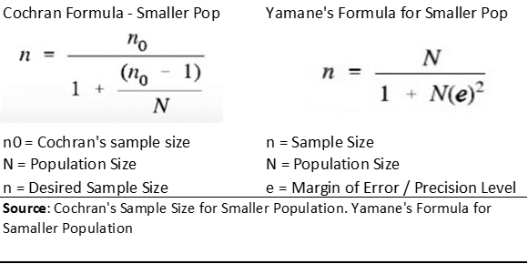
(Source: Heifer International, MERL Department, Sample Size Calculator, July 2023,)
For Small population size 1100 households (school students), with a 95% confidence level, 5% Acceptable Percentage of Error (APR), 10% contingency percentage, and design effect (1, say) and the suggested sample size for the Impact Assessment of Milk for School project (first phase) would be n=286, the sample size will be 315(286+28.6=314.6).
The total sample size 315 should be divided equally in project intervention areas of BD2016 with considering proportional allocation among the total population of 1100 students of the Milk for School project households in project areas.

7. Deliverables
The evaluator(s) will produce:
- An inception report with methodology and work plan of assessment;
- Design the assessment and interview/data collection questionnaire;
- A details Impact Assessment Report discussing the immediate and long term impact of the interventions.
- A presentation summarizing key findings, lessons learned, and recommendations.
- Report publication in internation journal
Consultancy Tenure: 40 working Days
Timeline: February to May 2026
8. Key Qualifications of the Consultant:
- Masters in nutrition /nutrition and food science technology
- 5 years' experience in research particularly on nutrition or food system
- Have at least three study report as lead or associate
- Experience of research work/study under any renowned INGO or UN agency

