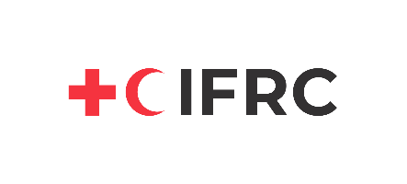
Tender Notice

Please be informed that German Red Cross (GRC) Bangladesh is planning to procure 3300 Household Hand-washing Device in order to support the BDRCS Population Movement Operation in Cox’s Bazar.

In this regard, interested vendors are requested to submit their quotation according to the terms and conditions in documents to be downloaded from the download section:

Name of the project: 3300 Household Hand-washing Device _ MoFA, GRC
Ref.: CXB20200826-01 RFQ

Download the following documents from the download section:
- Request for Quotation (Tender Notice)
- Instructions for submission of quote - Household Hand-washing Device
- Bill of Quantity (BoQ) - Household Hand-washing Device
- Certification Declaration of Conformity
- Federation General Terms & Conditions on Purchasing
- Sample of Work Order

Note: Please read carefully all provided documents from download section and acknowledge with your signature.
Deadline of Quotation Submission: 20.09.2020 (Before 4:30PM)

