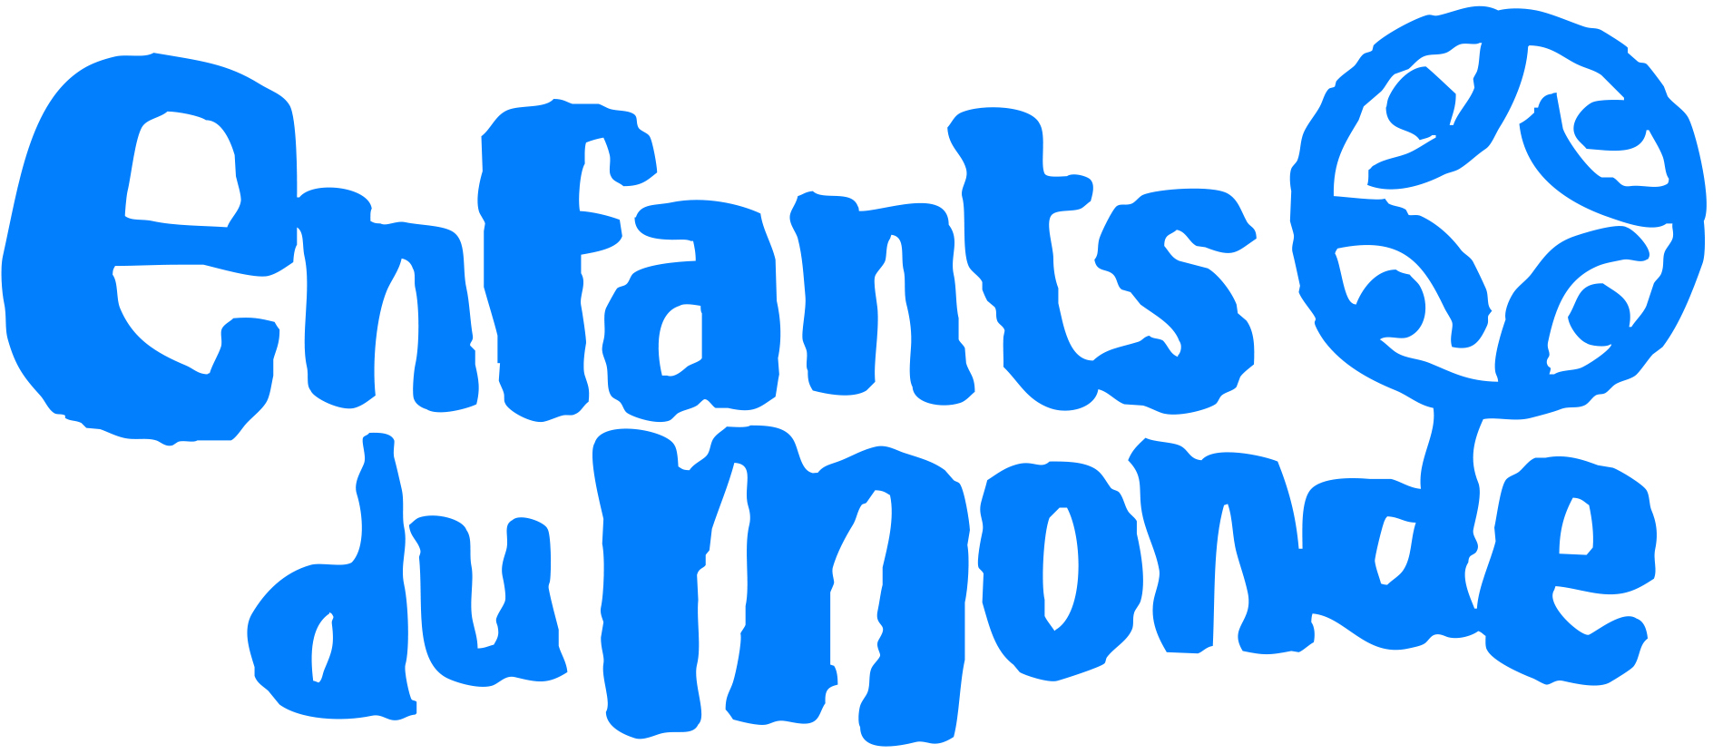

TERMS OF REFERENCE

Recruitment of a security consultant to support the regional coordination of Enfants du Monde (EdM) in Bangladesh in updating its security policy and documents

October 2022

I. Background and rational
Founded in 1968, "Enfants du Monde Suisse" (EdM) is a Swiss-based non-governmental organisation specialising in child relief, focusing on education, health and institutional development. EdM positions itself as an actor for sustainable development whose central concern is to contribute to the establishment of quality processes, viable in the long term and based on local development policies, in its sectors of action. Its basic strategy is based on close cooperation with local partners in a programme approach. The working approach is to focus on and facilitate the development and implementation of joint programmes between different local actors. EdM contributes to these programmes not only financially but also technically through the provision of innovative approaches and highly specialised human resources.
EdM started its activities in Bangladesh in the 80’. The office coordinates EdM's action at the regional level. It is responsible for ensuring the link between local partners and the general secretariat in Geneva, as well as for accompanying and supporting health, education and training programmes.
In Bangladesh, EdM has been working with BRAC since 2019 in the implementation of a health promotion strategy in the field of maternal and newborn health (MNH). This is based, among other things, on the World Health Organization (WHO) strategic framework "Working with Individuals, Families and Communities to Improve Maternal and Newborn Health" (IFC framework). EdM's support to BRAC is based on a phased programme and its commitment for the period 2020-2024 is to improve access to quality health care for pregnant women, new mothers and their children (under 5 years). It is based on two axes: (i) Improvement of the national health system and (ii) Reinforcement of the population's capacity to remain healthy. There are 2 upazilla of concentration (Sarail and Kasba) while some activities will take place at district level or national level.
EdM's Buco has a team of 3 agents and is located- Enfants du Monde, House #18, Flat # 402, Level#3, Road # 24, Block # K, Banani, Dhaka, Bangladesh, Ph- +880-2-222288558.
EdM wishes to strengthen its security management system and tools in Bangladesh.
The present terms of reference are designed to recruit a consultant to assist EdM in updating its security system in Bangladesh.
II. Mission and objectives
The mission of the consultant will be to :
- Support EdM to develop/update the risk analysis of the programme ;
- Orient EdM's Buco staff on security;
- Evaluate the security policy and the tools and procedures currently used by EdM's Buco and propose recommendations adapted to the context;
- Support EdM in updating its security policy and any supporting documents in response to identified shortcomings.
III. Methodology
The following methodology is proposed and should be completed and detailed by the consultant:
- A review of existing documentation ;
- Auditing the office security ;
- Conducting an orientation session for project staff on security ;
- The organisation of a workshop involving EdM's Buco staff and some headquarters staff to update the security policy and related security tools
- The consultant will ensure that security needs are addressed in an inclusive manner, including a gender perspective

IV. Deliverables
- Office security audit report
- Country security plan (including security incident management procedures)
- Standard operating procedures: traffic accident, corruption, checkpoint, evacuation, health and hygiene, financial security, information security, stress, travel management, kidnapping, crossfire, looting, fire, criminal attack
- Contingency plan(s)
- Analysis of the security context
- Risk analysis and responses to security issues
- Analysis of security trends and changes in EdM areas
- Security levels in EdM's activity areas
- List of authorised and prohibited hotels and places
- Contacts of authorities and different structures in the regions
- Directories of main roads and distances between municipalities
- Orientation module for staff on security

V. Provisional timetable
This schedule will be discussed with the consultant and adjusted according to the availability of the EdM team and partners.
Activity | Number of days | Period | Responsible for | People involved
Scoping meeting | 1 day |  | EdM coordination office | Consultant, HQ
Reading and assessment of existing documentation, | 1 day |  | Consultant | EdM coordination office
Preparation of the evaluation report on existing documents | 2 days |  | Consultant | EdM coordination office
Ownership of the report by EdM and its partner | 2 days |  | EdM and partner
Workshop to develop and/or update risk management plans of the programme and to orient staff on safety | 1 day |  | EdM coordination office | Consultants, partners
Workshop to train and update the coordination office EdM security policy and its related tools | 2 days |  | EdM coordination office | Consultant, HQ
Finalisation of the various documents reviewed/produced and preparation of the overall mission report | 4 days |  | Consultant | EdM coordination office

The provisional timetable foresees twenty (20) days of consultancy in total including travel time.

VI. Experience and skills required
- Advanced degree or professional training in a field related to humanitarian action or security management
- At least 5 years of operational experience in security management in an NGO (including at least 2 years in security consultancy in volatile security contexts)
- Experience and knowledge of the Bangladeshi context;
- Diagnostic, assessment, analysis and planning skills related to safety management
- Experience in creating/updating security systems, policies, procedures and tools
- Experience in accompanying NGO staff in the field of security
- Fluent English (read, written, spoken) and mastery of technical vocabulary related to security

VII. File composition
The consultant's bid must include the following documents:
- A technical offer including the detailed methodology and the envisaged process.
- An up-to-date CV (max. 4 pages)
- A minimum of 3 contacts and 3 references from previous assignments on the subject of this consultation;
- The implementation schedule for the whole process
- A financial offer including a detailed budget (nature of costs, cost/day, number of working days) including a total before tax and a total including tax
- Gender expertise (gender in security) an asset

