Request for Expression of Interest (EOI)
for

Multipurpose Boat Building
SUMMARY

Program/Project, Project Number | 3828-MYP
Partner Organization | Disabled Rehabilitation and Research Association (DRRA)
Project start and end dates,  Phase of project | 01/01/2019-31/12/2021
Purpose of the Boat | Help to livelihood as well as disaster preparedness process
Commissioning organization/contact person | Disabled Rehabilitation and Research Association (DRRA)  CBM International
Primary Methodology | Prior the beginning of construction a multipurpose boat building, company will respond to a tender. Part of the tendering process includes the owner considering several different bids from several different boat-building companies. Once a company has been selected, first party will issue a work order mentioning the design, price, and construction timelines.  After making boat, the company will handover boat with fully serviceable condition as consider for buyer’s satisfaction to DRRA along with approval of design, registration document and others papers required.
Proposed timeframe (Start and end) | 26th February, 2021 to 20th May , 2021

Handover Date | 30 April , 2021
Recipient of boat | Disabled Rehabilitation and Research Association (DRRA)

INVITATION TO TENDER TIMETABLE

Particulars | DATE | TIME
Tender published | 10th February 2021
Pre-Bid Meeting (Online/Skype) | 16th February 2021 | 10:00 am to 11: am
Deadline for request for any clarifications from DRRA | 16th February 2021 | By 05.00 pm
Last date of response from DRRA for clarification | 17th February 2021 | By 05.00 pm
Deadline for submission of tenders (receiving date, not sending date) | 24th February 2021 | 15.30 hrs (Sharp)
Opening of bids (in presence of interested bidder if any present) | 24th February 2021 | at 16.00 hrs
Notification of award to the successful tenderer | 28th February 2021

- BACKGROUND OF PROJECT
Vulnerability of women, persons with disabilities and other marginalized groups are high for any natural catastrophes due to lack of awareness, participation and support. The casualties and injuries of people with disabilities may increase due to inappropriate disaster preparedness and management system. Lack of timely and proper early warning, evacuation system and inaccessible shelter, houses and infrastructures may create more vulnerability to life and properties and avoidable fatalities. To reduce the disaster vulnerability of women, persons with disabilities and other marginalized groups in Atulia and Burigoalini unions of Satkhira District, DRRA with support from CBM is implementing a pilot project named Community Centred Disability Inclusive Disaster Risk Management (CCDIDRM). This project has undertaken awareness development, social empowerment and livelihood activities to reduce disaster vulnerability of the targeted population.
The project’s overall objective is to contribute to inclusive and resilient communities leading to improved quality of life of people with disabilities and other vulnerable groups.
The specific objective is to reduce vulnerability of target coastal communities to impact of natural disasters and climate change through improved inclusion approaches in community socio-economic and disaster-risk management policies and programs.
Delivery Location:
Delivery Location: Nildumur Ghat (Forest), Burigoalini, Shyamnagar Upazila in Satkhira District.

- INTENDED USE

The boat will mainly use to evacuate persons with disability during the time of disaster and earn livelihood from eco-tourism activities.

Child Safeguarding

The boat building must consider safeguarding aspects of children and adults-at- risk as well as safe communication during the entire boat building process where children and adults-at-risk are involved. Prior consent in written using prescribed forms following CBM's ‘Safeguarding Children and Adults-at-risk Policy along with DRRA code of conduct must be signed.

- CONDITIONS OF TENDERING

4.1 Questions / Request for clarification
Any requests for clarification may be submitted by email to info@drra-bd.org until the 16 February 2021 by 12:00 pm.

4.2 Clarification/Pre-Bid meeting / site visit

For this supply, we’ll conducting clarification meeting via the skype or physical presence. Interested supplier can write to DRRA to the mentioned email address. Please put the Tender reference number in your email subject when you are writing to DRRA, related to any tender related specification or other issues.

But, our pre-bid meeting may be set to limited with the interested supplier (Online/group) in case of too many requests we receive related to the entity.

Please share your skype address via query mail address: info@drra-bd.org on or before 17 February 2021 by 3.00 pm.

4.3 Alteration or withdrawal of tenders
Tenderers may alter or withdraw their tenders by written notification prior to the deadline for submission of tenders. No tender may be altered after this deadline. Withdrawals must be unconditional and will end all participation in the tender procedure.

4.4 Costs of preparing tenders
All costs incurred by the tenderer in preparing and submitting the tender are not reimbursable. All such costs will be borne by the tenderer.

4.5 Late Proposal
Tenders must be received by 24 February 2021 by 3.30pm. (Bangladesh time). Tenders received after the closing date will not be considered, unless in DRRA sole opinion there are exceptional circumstances, which have caused the delay.

4.6 Eligibility
Participation in tendering is open on equal terms to any natural and legal persons or company.
4.7 Compliance
DRRA reserves the right to reject all bids not submitted in the format specified and any bids where any of the required forms are not completed.

4.8 Submission of Tender Proposal
Tender need to submit the proposal in a sealed envelope marking as follows:
SUBMISSION OF TENDER PROPOSAL FOR Multipurpose Boat Building

To
Tender Evaluation Committee
Disabled Rehabilitation and Research Association
House 2/5, Road 01, Shyamoli, Dhaka 1207

The proposal must have financial and technical proposal including work schedule.

4.9 Bid Security
10% of the total bid amount need to pay order (refundable) in favor of DRRA with the tender proposal. Pay order for unsuccessful bids will be returned upon application within the 05 days after publishing the notification award. For successful bidder, pay order will be refund after successful handover/delivery of the boat and payment.

4.10 Right to reject and accept on all tenders
DRRA reserves the right to accept any tender. DRRA reserves the right, unless the tenderer expressly stipulates to the contrary in the tender, to award batches separately or in any combination.

4.11 Specification
Details of specification are attached in Appendix A.

4.12 Delivery Place:
CCDIDRM Project, Shyamnagar, Satkhira

4.13 Confidentiality
Tenderers must treat the invitation to tender and all associated documentation supplied by DRRA as confidential.

4.14 Tender Process
DRRA reserves the right to negotiate, accept or reject any or all proposals and quotations at its sole discretion and to pursue or act further on any responses it considers advantageous.

4.15 Notification award and contract signature
The successful tenderer will be informed in writing that their tender has been accepted (notification of award). DRRA will agree with the selected tenderer on the final contract version and will send the signed documents in two original copies to the successful tenderer.
The unsuccessful tenderer will be informed by e-mail/letter within the 3 days following the award.
Within 3 working days following the reception, the successful tenderer will sign, date and send back the contract/supply agreement.
If the successful tenderer fails to sign and send back the contract within 3 working days, DRRA can consider (after notification) the award as null and void.

4.16 Ownership of tenders
DRRA retains ownership of all tenders received under this tender process. Consequently, tenderers have no right to have their tenders returned to them.

DRRA guarantees that tender offers shall remain confidential.

4.17 Tender validity
Tenders shall remain valid for a period of THREE MONTHS after the deadline for receipt of tenders.
- METHODOLOGY
Prior the beginning of construction a multipurpose boat building, company will respond to a tender. A tender is a way for an owner (who may be an individual, corporation, or government) to assess who can build the best product for the best price. Responding to a tender can be onerous, with requirements for a design, budget and project plan. Boat building companies will have individuals or departments dedicated to responding to tenders. All this work are done without payment.
Part of the tendering process includes the owner considering several different bids from several different boat-building companies. Once a company has been selected, first party will issue a work order mentioning the design, price, and construction timelines.
After making boat, the company will handover boat with fully serviceable condition as consider for buyer’s satisfaction to DRRA along with approval of design, registration document and others papers required.
However, DRRA representatives shall inspect the boat several times.
- COSTS AND PAYMENTS
Payment should be made in Bangladeshi Taka in the following manners.
- The First installment, 20% of the total contract price shall be paid on signing of the contract.
- The Second installment, 25% of the total contract price shall be paid after completion of the construction of the main deck & upper deck.
- The Third installment, 30% of the total contract price shall be paid upon installation of Engine, Gear, propulsion unit, interior work & other works.
- The Fourth installment, 25% of the total contract price as final payment shall be paid upon completion of painting, final work, launching, test trial and handover.

- VAT and Tax Deduction:
VAT and Tax will be deducted as per government rules.
Technical specifications
For
DRRA RESCUE BOAT

The steel boat to be named ”DRRA RESCUE BOAT” is to be used as a Help to livelihood as well as disaster preparedness process. The boat is designed to be self-propelled. The machinery and other related equipment details are given below.
Vessel Dimension:
Length - 13.72m, Breadth - 04.27m, Depth - 01.07m
All materials, types of machinery (except engine), and equipment required for the construction of the boat will be new & of the best quality.
a) 4 mm M.S plate bottom & side hull
b) 3 mm M.S plate deck, superstructure & roof
c) 3 mm M.S plate checker (walk way, ramp & deck)
d) 2 mm M.S plate
e) 6 mm M.S Angle main frame 50X50X6 mm
f) 5 mm M.S Angle superstructure frame, stiffener 50X50X5mm
g) 5 mm M.S Angle superstructure frame, stiffener partially 38mmX38mm
h) 6 mm M.S Fender fitting by ‘U’ channel (50X100X50X6)
i) 5 mm M.S Flat bar 50mm/38mm/25mm
2. Machinery and Equipment:
- The main engine will be reconditioned engine, 3 cylinder diesel engine Yanmar/Isuzu
- Brand new reduction gear 3:1, Model no- 16 A. Zhenjiang gearbox made in China.
- Propeller will be brass made size: 650mm diameter
- Propeller shaft dia 50mm stern tube, 65mm dia both side leak bush will be brasses, etc.
3. Rudder:
- Rudder fabrication with 3mm plate, two-line horizontal stiffeners on both sides fitting with 38mm shaft & flange fitting, another extension pipe 50mm diameter with a flange bolted on the rudder to joined the long manual handle pipe 50 mm diameter for operation.
- Fuel tank making by M.S plate 3mm, tank measured 700X400X450mm measuring approximate 130 liters capacity, fitting in the Engine room beside the hull. Fuel filling lines, delivery lines & drain lines have to fit properly for cleaning. Also, a visible pipe has to fit to check the fuel level.
4. Doors & Windows:
a) Doors:
- The door shall be provided as shown on the drawing & be constructed in ms angle 38X38X5mm & 2mm sheet with suitable hinged, haze bolt with lock & key. The number of quantity 6 nos. (Door cabin 3 nos, 1 engine room, 1 kitchen & 1 general toilet, measured 1750mm X 600 mm per each leaf.)
- Accessible toilet door measured 1700X900 mm 1 nos.
- The grilled door at the passage entrance will be a two-leaf sliding opening system, measured 600 X1800 each leaf.
b) Windows:
Windows shall be rectangular made of Aluminum extrusions & glass. The number of quantity 4 nos.
c) Porthole:
200 mm diameter porthole shall be round type, made of Aluminum frame & glass. The number of quantity 3 nos.
5. Toilets & basin:
a) In the boat Accessible toilet shall be provided with a European commode along with necessary fittings as follows:
- Wash basin (18’/20’)
- Push shower
- Soap rack
- Towel rack
- Tissue holder
- Tap
- Mirror
- Side hand railing
- M.S scraper pipe fitting
- Plumbing works should be properly settings & fittings
- The floor shall be fitted with non-slipped tiles. Toilet size 1530X1530 mm.
b) General toilet: Toilet shall be provided with Asian type pan & others below.
- Soap rack.
- Towel rack
- Tissue holder
- Tap
- Mirror
- Plumbing & floor work according to disabled person’s toilet.
- The floor shall be fitted with non-slipped tiles. Toilet size 1530X1530 mm.
6. Kitchen: Kitchen shall be furnished with one gas burner table with utensil rack frame making by ms flat bar & wooden plunk setting on the top with RFL branded double stove burner, cylinder gas 12kg
7. Crew bunks: Three cabins shall be provided with one double bunk & one single bunk in the engine room. Bunk frame making by M.S Angle 38X38X5 mm size. 750X1800mm with wooden plank fitting on the bunk frame. Bunk frame setting on the M.S pipe 32mm diameter (legs).
- Double bunk - 3nos.
- Single bunk - 1 no.
8. Ceiling paneling works: All cabin, quantity of cabin 3 (tree) nos ceiling shall be provided with garjon wooden plywood paneling & 38X25 mm wooden batam should be used total area 21 square meter.
9. Pump, water tank & freshwater jar :
- T.C pump 3/4HP shall be provided to collect river water to fill the gravitation tank on the roof. T.C pump generated by the main engine. Tank capacity will be 500 liters. The tank shall be properly mounted on the roof

- Freshwater (drinking water): 20 liters capacity 02 container jar shall be supplied for drinking water for the staff.
10. Upper deck should be provided 25 mm diameter pipe stand post (movable) for used as samiana with polyester cloth size 4X3.70M.
11. Ramp & Ramp winch:
A heavily made ramp with a suitable winch shall be provided on the boat. The ramp shall be designed to work in conjunction with the floating footbridge & be able to be raised to a vertical position. Ramp measured 2440X1220 mm with heavy frame & top plate will be 3mm checker plate. The backside will be flat bar fitting for reinforcement. Beside ramp used lifting hook for wire, heavy hinge fitting in between ramp & boat, pipe post with the pulley will be set properly for easy operation.
12. Bollard (Double):
- On starboard-side - 2 nos.
- On the port side - 2 nos.
- Bollard size 75mm diameter M.S pipe 8mm thickness length 400mm with pin (70mm long X 18 mm diameter).
13.Mooring gears:
The boat shall be provided with mooring equipment –
- polyester rope 38mm diameter 30 meters.
- Fiber rope 25mm diameter 30 meters.
- Anchor (5 kata) made by M.S rod 25 mm diameter. Curved size 25mm diameter. Main handle 38mm diameter M.S rod with rope ring (approximate 20kg).
- Bamboo (logi) 38mm diameter 1 nos.
14. Lifesaving equipment: The boat will be supplied with the following life-saving appliance.
- Lifebuoy frame making & fitting on the cabin front side - 2 nos.
- Lifebuoy - 2 nos.
- Life jacket – 6 nos.
These entire items shall be of the best quality as available in the local market.
15.Firefighting: The boat shall be provided with the following firefighting equipment.
- CO₂ extinguisher (5 L) - 2no
- Sandbox - 1 no.
- Bucket - 1 no.
16. Navigation lamps: 24 volt DC navigation lamps should be provided as follows.
- Searchlight (24volt)
- Port side & star board side lamps - 2 nos.
- Mast headlamp/Anchor lamp - 1 no.
- Cabin room light (24 volt) - 5 nos.
- Cabin room - 3 nos.
- Engine room - 1 no.
- Kitchen front - 1 no.
- Battery 12 volt - 2 nos.
- Dynamo 24 volt - 1 nos.
- Switchboard (socket, switch, etc.) - 5 nos.
- Wiring cabin, Engine room, kitchen, passage area & navigation all point & mast post.
- Horn 24 volt - 1 nos.
Searchlight & horn shall be fitting on the roof with a lock & a key security stand should be provided.
17.Title board writing: The board should be bear the authority name outside of the superstructure will be written by paint & registration number will be welded at both front side (starboard side & port side) & backside at the center of the boat. Another place as cabins, Engine room, kitchen, toilet, etc.
18. Railing:
- Main Deck: Railing shall be fitting in the main deck port side, starboard side & both front side of the ramp. Railing height 900mm & post 32 mm diameter pipe, in middle two numbers horizontal lines, pipe 18mm diameter for children safety guard. Portable pipe setting for the tent from cabin to 3 meters.3 nos. pipe frame & height will be according to the cabin for the tent (size 5mX4m polyester).
- Upper deck: On the upper deck all around will be railing height 600mm & post 25 mm diameter pipe, in middle horizontal line pipe 12mm diameter.
- Ladder: Ladder shall be fabricated with M.S plate & pipe from the main deck to the upper deck.
19. Surface preparation: Surface preparation all through the boat will be power brushing, scraping, and cleaning properly for cleaning works.
20. Painting work:
The paint used shall be the best quality marine type paint approved by the buyer & the color/shade of the final coat shall be chosen by the buyer.
Painting throughout the boat will be applied to all marine quality paint as per the given coating schedule.
i) Out side hull under water level :
1 Coat- Red lead primer, 2 Coat- Anti corrosive, 1 Coat- Anti fouling
ii) Out side hull above water level:
1 Coat- Red lead primer, 1 Coat- Anti corrosive, 2 Coat- Finish coat
iii) Main deck & super structure level:
1 Coat- Red lead primer, 1 Coat- Anti corrosive, 2 Coat- Finish coat.

Primary Design
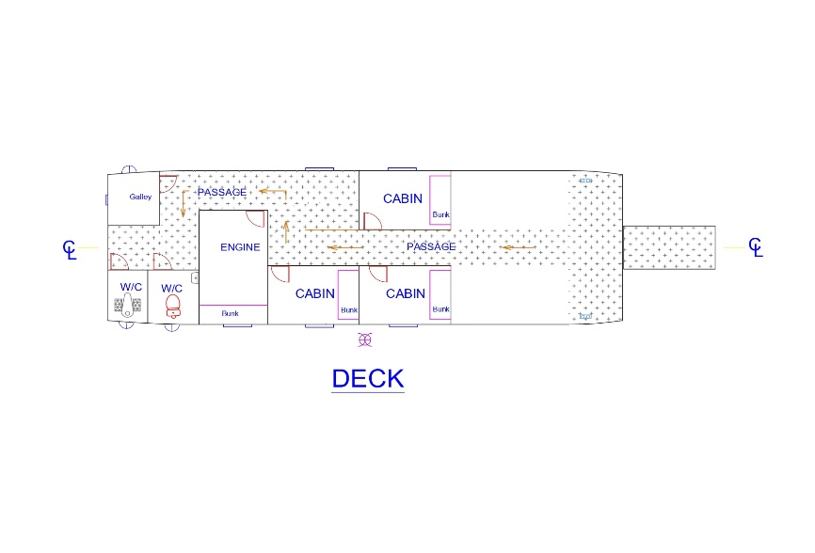

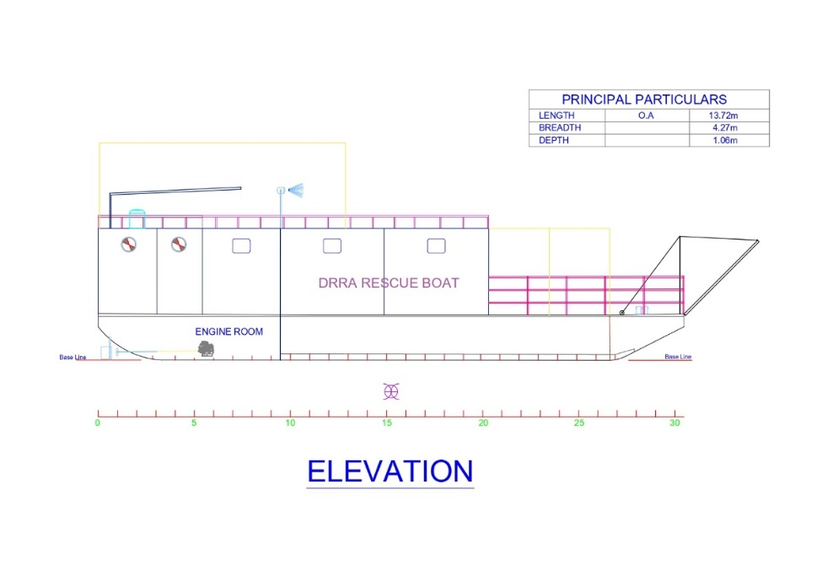

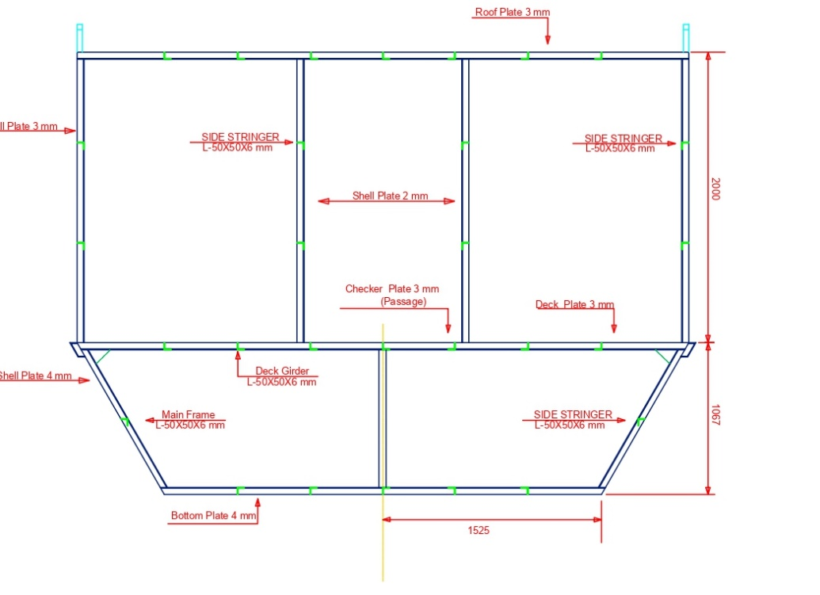
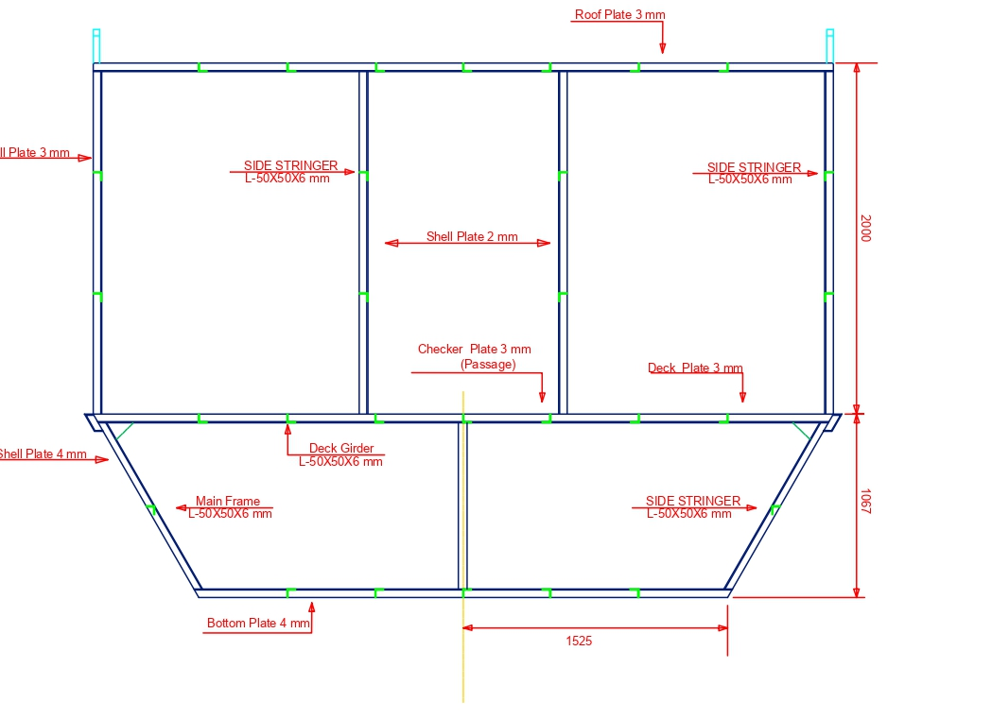

Submission instruction:
You are required to submit ‘Financial and technical Proposal including work schedule’ signed and dated offers on your company letterhead along with relevant documents as requested.
Please submit the proposal by sending email on the following email mentioning the subject on the subject Line:

SUBMISSION OF TENDER PROPOSAL FOR Multipurpose Boat Building

RFQ REF: DRRA/CCDIDRM/2021/02/01

To
Tender Committee
Disabled Rehabilitation & Research Association 2/5, Road no: 1, Shyamoli, Dhaka

Please submit your bid (Financial) to tender box and sign in the register

Any incomplete applications with documents would not be accepted. DRRA reserves the right to accept or reject any or all the proposal without assigning any reason whatsoever.Based on field requirement and to reach the objective, DRRA reserve the right to customize their requirement at any stage with proper agreement of all parties.

