ENLISTMENT SCHEDULE
FOR
CHRISTIAN AID BANGLADESH FOR DIFFERENT GROUPS

ENLISTMENT PERIOD – 3 YEARS
Ref. No: CA-BD-SC-Enlistment-01-2021
LOGISTICS & SUPPLY CHAIN MANAGEMENT
Following the recurrent needs and to meet the future requirements to implement Christian Aid is looking for qualified supplier to enlist in the supply chain system to strengthen the supply channel and ensure compliances as of financial and supply chain regulation and rules.
All procurement of CAID is subject to the relevant polices set forth (adapted/global). All suppliers/service providers must have to follow the Supplier’s Code of conduct and other standard rules with respect of CAID activities in the field and operation as of their mission objective & goal.
Hereby CAID, invites applications for Enlistment from the genuine suppliers/service providers under following Groups & Category.
Supplier/Service Provider Enlistment Category
CA-BD-SC-ENLISTMENT-01-2021
Group | Category | Group | Category
G1 | Printing/Publication | G10 | IT Equipment’s servicing
G2 | Visibility & Protection Materials | G11 | Catering Service - Food & Snacks
G3 | Video Documentary | G12 | Accommodation & Venue
G4 | Advertising Services | G13 | Vehicle Rental Service
G5 | Stationery & Office Consumable | G14 | Travel Agency
G6 | Groceries Items | G15 | Car Servicing
G7 | PPE Items | G16 | Car Insurance
G8 | Toner | G17 | Life Insurance
G9 | IT Equipment’s & Accessories | G18 | General Supplies

The Enlistment application along with other documents mentioned in the enlistment schedule shall be dropped in as submission option 1: sealed condition in the tender box will be kept at Christian Aid Dhaka office by 5:00 pm on or before 30 June 2021. Submission option 2: By email to: bangladesh-procurement@christian-aid.org within 30 June 2021, 17:00 HRS.
Christian Aid Bangladesh invites applications for SUPPLIER/VENDOR ENLISTMENT from the genuine vendors/manufacturers/sole agents/ distributors/ service providers/contractors for the period of August 1, 2021 to July 31, 2024.
Applicants having infrastructure, management capacity, financial strength and relevant experience with INGOs/large organizations / UN agencies are eligible to apply.
This Schedule/Application/Registration process is complete with following Annexes:
ANNEX A: SUPPLIER DECLARATION
ANNEX B: ETHICAL & ENVIRONMENTAL POLICY
ANNEX C: UPPLIER QUESTIONNAIRE

- Application for Enlistment:
1.1. Submission of Enlistment Application:
Suppliers/Vendors need to share their interest through a Cover Letter in their company Letter Head and fill up SUPPLIER QUESTIONNAIRE Form is attached herewith as Annex C, Suppliers need to provide all information as requested in the form and attached following documents with the application:
  - Company Profile
  - Copy of Valid Trade License
  - Copy of TIN Certificate
  - Copy of VAT Registration Certificate (If available)
  - Bank Account details
  - Bank Certificate
  - Experience Certificate/Reference Letter
  - Letterhead Pad (Blank and Marked as SAMPLE with your Seal & Signature)
  - Signed Copy of Annex B, Annex C
Application needs to submit in hard copy in a sealed envelope mentioning the reference and subject as follows:

APPLICATION FOR ENLISTMENT UNDER
“Group & Category ………………………………………” as SUPPLIER REF: CA-BD-SC-ENLISTMENT-01-2021

Submit the Application in the tender box kept in Christian Aid Office, House 42/A, Road 42, Block C WN(A), Floor 1, Gulshan 2, Dhaka - 1212, Bangladesh.

DEADLINE TO SUBMIT APPLICATION: 30 JUNE 2021 17:00HRS (On or Before)
Christian Aid reserves the right to accept or reject all/part applications without assigning any reason whatsoever.

GENERAL TERMS AND CONDITION FOR ENLISTMENT
Applicant (new and existing) shall submit Application for enlistment in the Enlistment box including all documents mentioned in Section 1, Clause 1.1, of Enlistment Schedule. Applicant shall fill up the information given in the Registration Form (Annex A) and along with other required documents as mentioned.
2.1 Eligibility:
Supplier/Vendor who are legally authorised, experienced with INGO, UN, Government may apply for enlistment for single or multiple Groups. For participation in each Group please use separate enlistment schedule (make copy of the Registration Form, Annex A) and shall submit in separate envelope for each Group. Existing Suppliers/vendors who are working with this program also need to submit their application.
2.2 ENLISHMENT PERIOD:
The Enlistment period for initially 3 Years from the date of awarding. However, subject to the requirements, performance of the vendor, the option exists to review the requirement for additional period as required by the Christian Aid.
2.3 SUBMISSION OF APPLICATION
Applicant must submit the application (Section 1.1) along with all relevant documents in hard copy in as submission option 1: sealed condition in the tender box will be kept at Christian Aid Dhaka office by 5:00 pm on or before 30 June 2021. Submission option 2: By email to: bangladesh-procurement@christian-aid.org within 30 June 2021, 17:00 HRS.
Late submission shall not be considered for further evaluation and their application will be NULL and VOID.
2.4 ASSESSMENT OF APPLICATION:
As a part of the application assessment process, the representative of Christian Aid, may visit the Applicant’s business premises to undertake an inspection and assess the suitability of the applicant for Group(s) applied for. It will also check the documents and references submitted by the Applicant during submission of application. Performance of existing vendor will be taken into consideration during evaluation. Failure by the Applicants to grant the Christian Aid access to its premises, or identification of any miss-declaration of information and documents or non-availability of references after contacted, may result in application not being considered further.

SECTION 3: GUIDELINES FOR SUBMISSION OF ENLISTMENT APPLICATION
3.1 Selection of Vendor Group: Applicant will select the Sub Categories-Description against specific enlistment group from the list as per below table. Applicant, intends to apply for multiple Groups, shall submit separate application and shall select item categories separately. Applicant can apply for multiple Sub-Groups under any group but must select the Sub Categories – Description separately for individual Groups.

Group | Category | Sub Category
G1 | Printing/Publication | Graphic Design, Printing Flyers, A3-A4 sheet, Flash Card, Books, Notebooks, Poster, Banner, Festoon, Signboard, Billboard, Sticker, Desk Calendar, Folder, Writing pad, Brochure, flyers, factsheets etc.
G2 | Visibility & Protection  Materials | T-Shirt, Cap, Umbrella, Raincoat, Mug, Pen, Backpack, Bag
G3 | Video Documentary | Video Documentary on development work
G4 | Advertising Services | Tender, Job and other circulars
G5 | Stationary & office consumable | Office Stationery, Toiletries, Housekeeping, Cleaning materials etc
G6 | Groceries Items | Tea, Coffee, Sugar, Milk and Groceries items etc
G7 | PPE Items | Coverall, Face shield, Safety Goggles, Surgical Face Mask, surgical gown, Comfit Examination Gloves, N95 Mask, Heavy duty rubber boots, Hand Sanitizer, Hand Rub, Handwash etc.
G8 | Toner | Printer & Copier toner
G9 | IT Equipment’s and accessories | Supply of IT Accessories (HDD, RAM, Modem, Pen drive etc),  Supply of Router, LAN Card, Network Switch, Connector, Network Cables & Cabling works, etc.  Projector, Printer, Scanner, Label Printer, ID Card Printer, Label Printer Paper,  Tablet, Mobile & Smart Phone, IP Phone Set,  CCTV Camera, Access Control System and Accessories,  TV, Electrical Appliance (Refrigerator, Washing Machine, Fan, Lights, Microwave etc.)  IPS, UPS (Online and Off-line) and Battery
G10 | IT Equipment’s servicing | Laptop, Desktop, Netbook and monitor Photocopier and maintenance Services
G11 | Catering Service - Food & Snacks | Supplying Food & Snacks for meeting/trainings/workshop
G12 | Accommodation & Venue | Hotel Accommodation with Training Venue  Facilities and Event Organize facilities.
G13 | Vehicle Rental Service | Different type and seater vehicle, New/Reconditioned Sedan Car, Micro Bus (2WD/4WD), Prado, Pajero
G14 | Travel Agency | Domestic & International Air Ticket
G15 | Car servicing | Office Car maintenance
G16 | Car Insurance | Office Car
G17 | Life Insurance | Office Staff
G18 | General Supplies | Any item exists in the readymade/import/manufacturing market

SECTION 4: GENERAL TERMS AND CONDITIONS OF CONTRACT FOR ENLISTED VENDORS
4.1 LIST/POOL OF SUPPLIER:
Humanitarian Response Program, Christian Aid will create the pool of selected supplier under each group and sub category and the number of supplier in each group will be decided by the Procurement Committee based on the existing requirement, future need, market & item type.
4.2 COMMUNICATION:
The program supply chain could request for quote from the enlisted vendors through email, manually following limited, tender, Open tender process.

4.2 CODE OF CONDUCT & POLICY:
Enlisted firm(s) are required to follow the suppliers code of conduct (Annex B) and other relevant and applicable policy of Christian Aid and / or Public Procurement Rules of Government of Bangladesh, wherever applicable, as guided by the Christian Aid. Enlisted firm(s)/supplier(s) must be compliant with the labour laws of the country.
4.5 MODE OF PROCUREMENT:
Enlistment does not mean that Christian Aid is obliged to work only with the enlisted Supplier/Vendor, whereas it is required and applicable as of need/type and time beside the enlisted suppliers Christian Aid preserve the rights to decide the procurement method at any need and in any condition/situation.

4.6 PAYMENT:
Christian Aid prefer to make all payment through Account Payee Cheque/Bank Transfer after completion and submission of invoice in general. All invoices must contain the reference numbers and standard documents attached as of instruction will provided through Purchase Order/Purchase Contract

4.7 TAX & VAT:
Wherever applicable, Tax & VAT will be deducted at source as of government rules & regulation (ref: National Board of Revenue, NBR).

4.8 SUPPLIER PERFORMANCE
Performance shall be evaluated on periodical/supply delivery performance along with others applicable, will be the basis for the exist in the pool and agreement review accordingly. INDICATORS (10 points)
2points | Delivery - On Time
1point | Delivery - On Demand
3points | Quality Acceptance – Confirming specification
1point | Service included in the Supply process, Level of Understanding and Documentation
1point | Reply all calls/request for price/quotation against market survey
2point | Competitive Price

Based on evaluation of performance of enlisted supplier/vendor will be terminate on each review. Each review bottom 25% of vendors/suppliers, for each group based on performance should be removed from the pool. A performance feedback will be communicated with the supplier on request.

Appendix A: SUPPLIER DECLARATION

We the Undersigned accept in full and without restriction the conditions governing this tender as the sole basis of this competition, whatever its own conditions of sale may be, which we hereby waive. We have examined carefully, understood and comply with all conditions, instructions, forms, provisions and specifications contained in this tender dossier including the contract template with its annexes and the Christian Aid Ethical and Environmental Policy. We are aware that failure to submit a tender containing all the information and documentation expressly required, within the deadline specified, may lead to the rejection of the tender at Christian Aid’s discretion.

We hold no reservation in regard to the tender dossier; and are aware that any reservation may result in the rejection of the tender by Christian Aid.

We are not aware of any corruption practice in relation to this competition. Should such a situation arise, we shall immediately inform Christian Aid in writing.

We declare that are affected by no potential conflict of interest, and that we and our staff have no particular link with other Tenderers or parties involved in this competition. Should such a situation arise during performance of the contract, we shall immediately inform Christian Aid in written.

Company name and address:
Company’s Representative name:
Title of Representative in the Company:
Representative’s signature and stamp:
City, date:

Appendix B: ETHICAL AND ENVIRONMENTAL POLICY

Section 1: Policy Statement
Christian Aid recognises the importance of sustainable development for people living in poverty, and the long term benefits of becoming a more sustainable organisation. Christian Aid takes responsibility for and is committed to managing the labour and environmental standards in its operations and supply chains. In order to embed appropriate management of these standards, the associated framework must be adopted.

Qualifications to the policy
The humanitarian imperative is paramount. Where speed of deployment is essential in saving lives, Christian Aid will purchase necessary goods and services from the most appropriate available source.

Section 2: Policy Details
2.1 Labour and Environmental Standards
Christian Aid is committed as a minimum to complying with all applicable labour and environmental legal requirements in its both operations and supply chains.

In addition, Christian Aid is committed to meeting the labour and environmental standards below and applying a continuous improvement approach within an agreed timeframe where it is known that standards are not met.

When Christian Aid sources from small producer groups, it applies the principles of Christian Aid International’s Values Based Approach to FairTrade.

Labour Standards
Christian Aid has adopted the Ethical Trading Initiative Base Code for its labour standards:

Employment is freely chosen:
- There is no forced, bonded or involuntary prison labour.
- Workers are not required to lodge “deposits” or their identity papers with the employer and are free to leave their employer after reasonable notice.

Freedom of association and the right to collective bargaining are respected:
- Workers, without distinction, have the right to join or form trade unions of their own choosing and to bargain collectively. • The employer adopts an open attitude towards the legitimate activities of trade unions.
- Workers representatives are not discriminated against and have access to carry out their representative functions in the workplace. • Where the right to freedom of association and collective bargaining is restricted under law, the employer facilitates, and does not hinder, the development of parallel means for independent and free association and bargaining.

Working conditions are safe and hygienic:
- A safe and hygienic working environment shall be provided, bearing in mind the prevailing knowledge of the industry and of any specific hazards. Adequate steps shall be taken to prevent accidents and injury to health arising out of, associated with, or occurring in the course of work, by minimising, so far as is reasonably practicable, the causes of hazards inherent in the working environment. • Workers shall receive regular and recorded health and safety training, and such training shall be repeated for new or reassigned workers.
- Access to clean toilet facilities and potable water, and, if appropriate, sanitary facilities for food storage shall be provided. • Accommodation, where provided, shall be clean, safe, and meet the basic needs of the workers.
- The company observing the standards shall assign responsibility for health and safety to a senior management representative.

Child Labour shall not be used:
- There shall be no new recruitment of child labour.
- Companies shall develop or participate in and contribute to policies and programmes, which provide for the transition of any child found to be performing child labour to enable her/him to attend and remain in quality education until no longer a child. • Children and young people under 18 years of age shall not be employed at night or in hazardous conditions.
- These policies and procedures shall conform to the provisions of the relevant International Labour Organisation (ILO) standards.

Living wages are paid:
- Wages and benefits paid for a standard working week meet, at a minimum, national legal standards or industry benchmarks, whichever is higher. In any event wages should always be high enough to meet basic needs and to provide some discretionary income.
- All workers shall be provided with written and understandable information about their employment conditions in respect to wages before they enter employment, and about the particulars of their wages for the pay period concerned each time that they are paid. • Deductions from wages as a disciplinary measure shall not be permitted nor shall any deductions from wages not provided for by national law be permitted without the express and informed permission of the worker concerned. All disciplinary measures should be recorded.

Working hours are not excessive:
- Working hours comply with national laws and benchmark industry standards, whichever affords greater protection.
- In any event, workers shall not on a regular basis be required to work in excess of 48 hours per week and shall be provided with at least one day off for every 7 day period on average. Overtime shall be voluntary, shall not exceed 12 hours per week, shall not be demanded on a regular basis and shall always be compensated at a premium rate.

No discrimination is practised:
- There is no discrimination in hiring, compensation, access to training, promotion, termination or retirement based on race, caste, national origin, religion, age, disability, gender, marital status, sexual orientation, union membership or political affiliation.

Regular employment is provided:
- To every extent possible work performed must be on the basis of a recognised employment relationship established through national law and practice.
- Obligations to employees under labour or social security laws and regulations arising from the regular employment relationship shall not be avoided through the use of labour-only contracting, subcontracting or home-working arrangements, or through apprenticeship schemes where there is no real intent to impart skills or provide regular employment, nor shall any such obligations be avoided through the excessive use of fixed-term contracts of employment.

No harsh or inhumane treatment is allowed:
- Physical abuse or discipline, the threat of physical abuse, sexual or other harassment and verbal abuse or other forms of intimidation shall be prohibited.

Environmental Standards
Christian Aid is committed to reduce its reliance on finite/scarce resources and to minimise the environmental impact of its operations including its supply chain, and will work to achieve the standards listed in this section.

Climate change:
Monitor and actively seek to reduce the Greenhouse Gas (GHG) emissions associated with its operations and:
- Set absolute GHG reduction targets for operations in industrialised countries or Economies in Transition, such as those identified in Annex I of the United Nations Framework Convention on Climate Change below
- Set and report on targets for improved efficiency in countries where Christian Aid runs programmes, such as those that may be regarded as non-Annex I countries under the UNFCCC Waste:
- Reduce waste to landfill.
- Monitor operations, including procurement, to ensure waste minimisation and high product and process efficiency.
- Effective controls of waste in respect of ground, air, and water pollution are adopted.
Materials:
- Reuse, recycling and the use of recycled and recyclable materials are strongly encouraged.
- Avoid where practicable reliance on materials that are heavily dependent on finite resources.
Packaging:
- Actively avoid undue and unnecessary packaging wherever practicable and use recycled and recyclable materials wherever appropriate.
Wood and forest products:
- Ensure that all forest products purchased are as a minimum legal in origin and provide evidence of due diligence to ensure this if requested by Christian Aid
- Suppliers of paper products sourced from Christian Aid affiliate home country offices and retail products carrying the Christian Aid Brand must source forest products from recycled sources or well managed forests which have been certified to a credible standard. Exceptions will be made for products which are Fairtrade marked or produced by members of the World Fair Trade Organisation as appropriate. Christian Aid views the Forestry Stewardship Council (FSC) as the most credible certification for the sustainable sourcing of wood and forest products.
- Suppliers must never knowingly become involved in, collude with or purchase timber from illegal logging operations.

Energy:
- Work to reduce energy consumption and where practicable use energy from renewable resources.

Transport and travel:
- Reduce staff travel wherever practicable.
- Monitor and reduce transport logistics to ensure efficient distribution and delivery of products and services.

Conservation of biodiversity:
- Seek to minimise the impact of operations on fauna, flora and land to ensure the conservation of biodiversity and habitats.

Water:
- Develop a better understanding of its impact on water use and develop management processes where appropriate

Annex I countries, United Nations Framework Convention on Climate Change
Australia, Austria, Belarus, Belgium, Bulgaria, Canada, Croatia, Czech Republic, Denmark, Estonia, European Union, Finland, France, Germany, Greece, Hungary, Iceland, Ireland, Italy, Japan, Latvia, Liechtenstein, Lithuania, Luxembourg, Malta, Monaco, Netherlands, New Zealand, Norway, Poland, Portugal, Romania, Russian Federation, Slovakia, Slovenia, Spain, Sweden, Switzerland, Turkey, Ukraine, United Kingdom of Great Britain and Northern Ireland, United States of America.

2.2 Christian Aid Procurement Integrity Principles
Christian Aid is committed to ensure that its procurement processes are run with integrity and to further this commitment Christian Aid actively promotes principles for suppliers and staff as detailed below.

Procurement Integrity Principles for Christian Aid Suppliers
Christian Aid expects suppliers as a minimum, to follow the belowmentioned principles:
- Accept responsibility for labour and environmental conditions under which products are made and services provided. This includes all work contracted or sub-contracted and that conducted by home or other out-workers.
- Be open and transparent about the labour and environmental standards in their supply chains. To provide information requested by Christian Aid to enable our assessment of labour and environmental standards in their supply chains.
- Support workers to realise their rights and minimise the barriers which prevent workers from achieving them.
- Demonstrate ability to meet local labour and environmental laws. • Demonstrate commitment to achieve conformance with the Labour and Environmental Standards in section 2.1 above and commitment to continuous improvement of their labour and environmental standards as agreed with Christian Aid.
- Suppliers importing from small scale producer groups facilitate trade in-line with Christian Aid’s values based approach.
Christian Aid will seek alternative sources where the conduct of suppliers demonstrably violates the basic rights of Christian Aid’s intended beneficiaries, and there is no willingness to address the situation within a reasonable time period.
Christian Aid will not knowingly enter into contract or partnership with suppliers that participate in the activities outlined below:

List of activities that Christian Aid suppliers should not be involved in:
Christian Aid will seek alternative suppliers if we identify the following activities:
- Actively lobby to undermine public policies to tackle climate change or push for continued expansion of fossil fuel use
- Arms manufacture;
- The sale or export of arms or strategic services to governments which systematically violate the human rights of their citizens, or where there is internal armed conflict or major tensions, or where the sale of arms may jeopardise regional peace and security.
- Tobacco production and sale;
- The sale of baby milk outside the World Health Organisation (WHO) Code of Conduct;
- Pesticide sales outside the Food and Agriculture Organisation (FAO) guidelines for pesticide retailing
- Extractive industries
- Production or publication or broadcast of adult entertainment
- Knowingly become involved in, collude with or purchase timber from illegal logging operations.
- Any other activities which violate the basic rights of Christian Aid’s intended beneficiaries.
- Activities which contravene the Procurement Integrity Principles listed in section 2.2

Suppliers must declare any formal party political involvement or activity.

Procurement Integrity Principles for Christian Aid Staff
To ensure we procure with Integrity, Christian Aid staff will:
- Recognise that our suppliers may not be able to achieve all the labour and environmental standards laid out in sections 2.1 immediately and we will support suppliers to work toward conformance within a reasonable timeframe.
- Recognise the impact of all supply decisions on meeting the labour and environmental standards outlined in section 2.1 of this policy. We will involve our suppliers in addressing issues that may arise and expect them to assist us in minimising any negative effects. • Ensure that our supply requirements are adequately defined and specified in sufficient time to allow the supply market to react to our demand.
- Ensure that our supply activities comply with all applicable international and national laws, regulations, conventions and agreements that are in force in the countries from where our requirements are being procured, and ensure that the specific supply related requirements of our donors are adhered to. • Not engage in any activity with suppliers, or buyers from other organisations, which might be deemed to be anti-competitive or in breach of any statutory requirements in any country or trading region.
- Not terminate purchase arrangements or relationships without due regard to all material circumstances, appropriate communication and notification to the supplier. We will however terminate supplier relationships where serious breaches of Christian Aid’s labour and environmental standards persist after reasonable attempts have been made to work with the supplier to implement improvements, and where there is no reasonable prospect of securing improvements. Such terminations will be carried out in a responsible way.
- Act impartially and objectively in all their purchasing activities and to keep written records where appropriate to demonstrate that their actions have been fair and above reproach.
- Declare in advance any interest commercial or otherwise, they may have with a supplier to Christian Aid and to be prepared to withdraw from those dealings if required.
- Maintain an unimpeachable standard of integrity in all their business relationships and to foster the highest possible standards of professional competence in all their supply activities. • Not accept any personal gifts or other inducements, as individually or cumulatively these will be adjudged as an attempt to influence a purchasing decision.
- Seek the views of its suppliers over their ability to meet Christian Aid’s labour and environmental standards given existing buying practices, and assists them to meet their concerns. • Recognise the contribution that stable business relationships can make to the observance of the labour and environmental standards, and endeavour to establish long-term relationships with its suppliers.

Appendix C: SUPPLIER QUESTIONNAIRE
ALL Suppliers and Subcontractors to complete Sections 1-6 and the declaration. Suppliers providing branded products and services, rental vehicles and construction projects to also complete section 7 and 8.

1 A) Company Profile |  |  |  |  | Christian  Aid Use only
Name of Company
Name of Christian Aid staff member you have contact with; if any. (Name, Department, Location)
Registered Office address
Ordering Address (if different)
Payment Address (if different)
Telephone Number
Email
Website
Company Registration number
(Please attach a copy of the certificate)
Year established
Please state your position in the supply chain e.g. Agent, Manufacturer, Service Provider, Importer, Trader
Please specify the product/service being supplied to Christian Aid
Do your goods or services carry the Christian Aid brand?
Company turnover in trading currency
(please attach recent financial statement)
Turnover of the part of the business that would serve Christian Aid
Location of other operational sites (national and international), their functions and approximate numbers of employees where Christian Aid goods or services could be
positioned
1 B) Total Number of Workers
 |  | Men (%) | Women (%) | Total
Permanent Workers
Temporary directly employed workers
Agency indirectly employed workers
Homeworkers/outworkers
Management
Is your company committed to achieving the labour, environmental and business integrity standards in Christian Aid 's Ethical and Environmental Policy |  |  |  | Yes
 |  |  |  | No
2) Health & Safety
Is there anyone designated as being  responsible for Health and Safety issues in your company? | Yes/ No. Give details
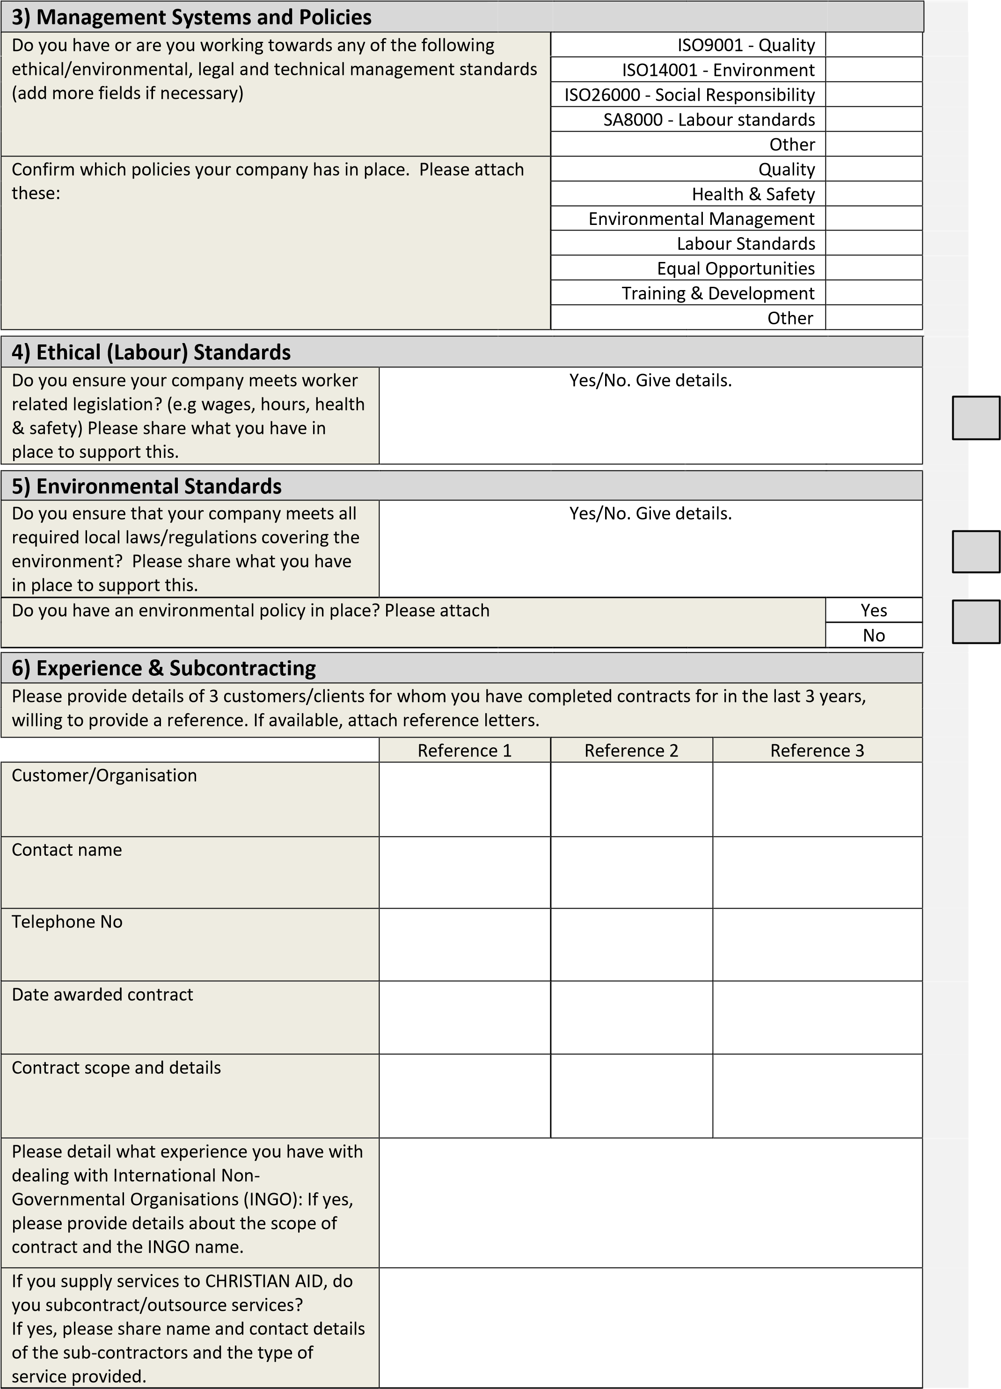
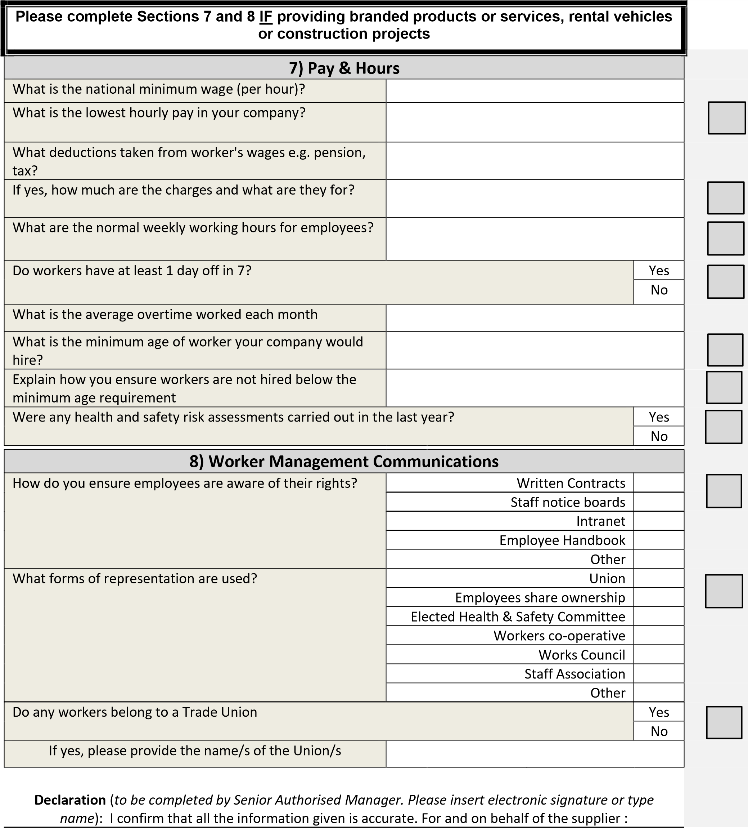
Name : | Position :
Date : | Signature :

For Christian Aid use only - Risk Rated by
NB There are some industries Christian Aid has run campaigns on to highlight the harm they can cause to poor communities. If your company, or any parent or subsidiary, has any involvement with the production or sales of weapons, pharmaceuticals, infant formula or pesticides; or with the Finance industry please tell your Christian Aid contact.
 | Name : | Position :
 | Date : | Risks :

