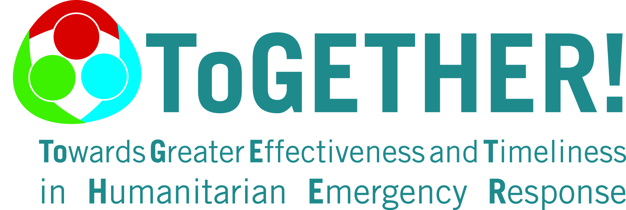
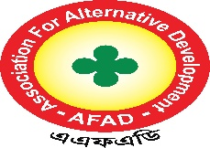
Terms of Reference (TOR)

For the hiring consultant for Website Development of 3 Peer Humanitarian Partners (PHPs) of AFAD

Background
AFAD is a women led non-profit organization working in the norther Bangladesh since 1999. It is dedicated to empowering women and girls. It mission is to create a world where women have equal opportunities and the ability to realize their full potential. It works tirelessly to promote gender equality, provide education, and resources, and support women in need. AFAD focuses on a range of issues affecting women, including access to education, economic empowerment, health and wellness, and ending gender-based violence. AFAD believes that by addressing these challenges, we can help women lead fulfilling and successful lives. Our team consists of passionate and dedicated professionals who are committed to making a positive impact in the lives of women and girls. AFAD carried out a variety of programs and initiatives to support our mission, from providing educational scholarships to young women to running campaigns to raise awareness about the challenges women face. We also work closely with local communities and partner organizations to ensure that our efforts have the greatest possible impact. AFAD is registered (No. 2443) with NGO Affair’s Bureau (NGOAB) of Prime Minister’s Office of People's Republic of Government of Bangladesh, and it got the registration (No. DWA/Kuri/Reg/29/99 ) from the Directorate of Women’s Affairs (DWA) in 1999. At the same time, AFAD has registration from the Directorate of Youth Development, Government of Bangladesh.
With the support of Malteser International, AFAD has been implementing a localization project titled "ToGETHER! - Towards Greater Effectiveness and Timeliness in Humanitarian Emergency Response" in Bangladesh since 2021. The project aims to transcend organizational boundaries, enabling local and international partners to develop approaches to humanitarian responses and create synergies during crisis response collaboratively. It also supports local actors in enhancing their capabilities in humanitarian response, preparedness, coordination, and advocacy. Additionally, the program aims to create opportunities for establishing complementary partnerships and promoting the roles of local partners. Capacity-strengthening and exchange measures are based on LHPs' self-defined needs and priorities, as well as the broader humanitarian context within their countries and contexts. As part of the project’s partner organizational capacity strengthening initiatives, AFAD intends to hire qualified Consultant (s) or Firm to support the development of the Peer Humanitarian Partners’ (PHPs) Chilmari distressed Development Foundation Chilmari(CDDF), Bakultali Mohila Sangsad, Bhurungamari (BMS),& Rural Society Development Association, Rowmari,(RSDA) Kurigram organizational websites. This effort aligns with AFAD’s broader commitment to enhancing organizational sustainability, accountability, and resource mobilization across the partnership network.
Objectives:
- To create a modern and user-friendly website that reflects the values and mission of three Peer Humanitarian Partners.
- To improve the online presence of three Peer Humanitarian Partners and increase its visibility.
- To provide a platform for three Peer Humanitarian Partners to showcase its activities, events, and success stories.
- To allow for online donations and volunteer applications.
- To ensure that the website is mobile-friendly, accessible, and easy to navigate.

Scope of Work:
- Designing and developing a website for 3 PHPs, based on its requirements and objectives.
- Creating content for the website, including text, images etc.
- Ensuring that the website is optimized for search engines and is compatible with different browsers.
- Integrating a donation and volunteer application system into the website.
- Providing training and support to the NGO staff on how to update and maintain the website.
Deliverables:
The consultant is expected to deliver the following:
- A detailed project plan, including timelines and milestones as well as domain name and hosting charge.
- A fully functional and responsive website, with all required features including content writing.
- Training and support for the Peer Humanitarian Partners staff.

Timeline & Duration
The contract period is from 05 January 2026 to 05 March 2026. The assignment is expected to take (2 Month) from the signing of the contract.

Qualifications:
The consultant should have the following qualifications:
- Proven experience in website design and development, with a portfolio of previous projects.
- Knowledge of modern web development technologies and frameworks.
- Experience in creating user-friendly and accessible websites.
- Familiarity with online donation and volunteer application systems.
- Excellent communication and project management skills.
Selection Criteria:
The consultant will be selected based on the following criteria:
- Relevant experience and qualifications.
- Quality of previous work.
- Proposed approach and methodology as well as cost effectiveness. .
Reporting:
The consultant will report directly to the Chief Executive of AFAD.

Confidentiality:
All information shared and collected during this assignment must remain confidential and be used exclusively for the purpose of developing website.

Special Consideration:
AFAD reserves the right to withhold payment if the consultant fails to meet agreed deadlines or deliverables. AFAD will not cover any travel, accommodation, and other associated cost for the consultancy. The Consultant will be responsible for covering these expenses. AFAD will only provide the venue, other logistics of the consultancy.

Mode of payment:
The Consultant/ Firm is to receive payment from AFAD in 2 instalments:
1st Payment: 20 % upon signing of the contract.
Final Payment: 80% upon submission of the final training report and deliverables, subject to acceptance by AFAD. Payments shall be made in BDT by bank transfer/cheque to the consultants account as indicated by the consultant

VAT and Income Tax:
AFAD will deduct Tax and VAT at source according to the Govt. policy and deposit the said amount into government treasury.
Application Process:
Interested consultants/firms are requested to submit their proposals by 5:00 PM, December 27, 2025 via email or in-person at the AFAD office.

The application should include:
Curriculum Vitae (CV): Highlighting relevant experience and qualifications.
Technical Proposal: Outlining the understanding of the TOR, methodology, and a detailed work plan.
Financial proposal: Itemized budget proposal that should include the consultancy fees, operational costs, and all associated costs including VAT and tax. AFAD will select potential candidates and will invite them for an online interview after the application deadline.

The proposal should be addressed to:
Email: rozina.afad@gmail.com
Or drop the proposal by in-person / courier.
AFAD Head office, R.K Road Khalilganj Bazar, Kurigram
For further information, please contact to,
Name: Rozina Akter
Designation: Project Focal Point_ToGETHER
Mobile: 01746192480
Email: rozina.afad@gmail.com

