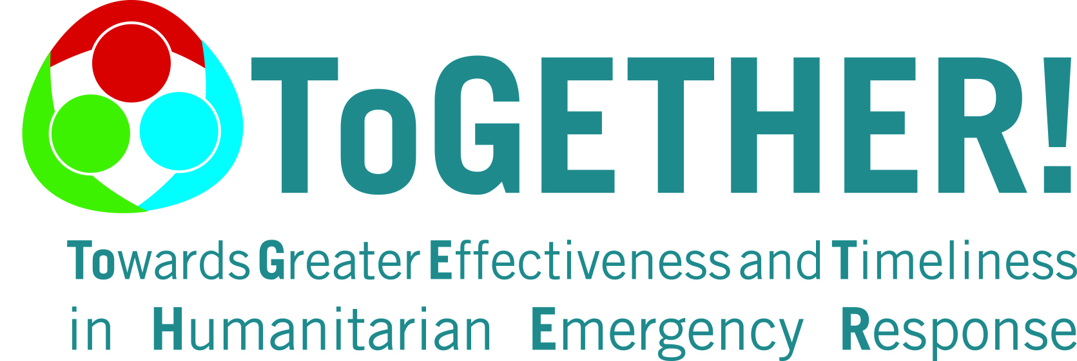
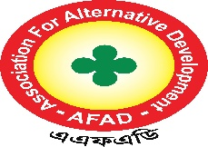
Terms of Reference (ToR)
For
Hiring Consultant for Developing
Safeguarding & PSEAH policy of three (03) Peer humanitarian Partners (PHP) Association for Alternative Development (AFAD).
Summary of the Document:
Name of the Organization | Association for Alternative Development (AFAD)
Type of Training | To Develop Safeguarding & PSEAH Policy for three Peer Humanitarian Partners (PHP’s) of Association for Alternative Development (AFAD).
Purpose | The purpose of developing a Safeguarding and PSEAH (Protection from Sexual Exploitation, Abuse, and Harassment) Policy is to create a safe, respectful, and protective environment for all individuals particularly children, women, persons with disabilities, and other vulnerable groups who engage with the organization. The policy aims to prevent any form of harm, abuse, exploitation, or neglect by establishing clear standards of behavior, accountability mechanisms, and reporting procedures. It guides staff, volunteers, and partners to act responsibly and ethically, ensuring dignity, rights, and well-being are upheld in all organizational activities. Ultimately, the policy strengthens organizational integrity, transparency, and trust with communities, donors, and stakeholders by demonstrating a strong commitment to protection and zero tolerance toward any form of sexual harassment, exploitation, or abuse.
Contact person | Rozina Akter, Project Focal Point-ToGETHER
Primary methodology | • Assessment of Risks and Needs: Identify potential safeguarding risks in organizational operations and interactions with communities.  • Review of Standards and Frameworks: Align the policy with international safeguarding principles, donor requirements, and national laws.  • Stakeholder Consultation: Involve staff, management, community representatives, and partners to ensure relevance and ownership.  • Drafting the Policy: Develop clear principles, definitions, and codes of conduct, reporting procedures, and response mechanisms.  • Validation and Approval: Share the draft with stakeholders for feedback and obtain formal endorsement from management/board.  • Capacity Building and Awareness: Train staff, volunteers, and partners on safeguarding & PSHEA responsibilities and procedures.  • Implementation and Monitoring: Establish reporting channels, accountability systems, and periodic reviews to strengthen practice.
Proposed Consultancy start and end dates | Start: 05th January 2026, End: 15th February 2026
Anticipated report release date | 20th February, 2026
Recipient of final report | Sayda Yesmin, Chief Executive, AFAD
Background

AFAD (Association For Alternative Development) is a women-led non-profit organization based in northern Bangladesh, actively working since 1999 to empower women and girls for a world of equal opportunities and full potential. AFAD is a dynamic force for positive change, championing gender equality and women's empowerment. The organization addresses a wide range of critical issues, including gender equality, education, economic empowerment, disaster risk reduction (DRR), climate change resilience, WASH, livelihood, and the localization of humanitarian aid. AFAD is registered with the NGO Affairs Bureau (NGOAB) of the Chief Advisor Office of the People's Republic of the Government of Bangladesh, with registration number 2443. It also obtained registration from the Directorate of Women's Affairs (DWA). Simultaneously, AFAD is registered with the Directorate of Youth Development, Government of Bangladesh.
With the support of Malteser International, AFAD has been implementing a localization project titled "ToGETHER! - Towards Greater Effectiveness and Timeliness in Humanitarian Emergency Response" in Bangladesh since 2021. The project aims to transcend organizational boundaries, enabling local and international partners to develop approaches to humanitarian responses and create synergies during crisis response collaboratively. It also supports local actors in enhancing their capabilities in humanitarian response, preparedness, coordination, and advocacy. Additionally, the program aims to create opportunities for establishing complementary partnerships and promoting the roles of local partners. Capacity-strengthening and exchange measures are based on LHPs' self-defined needs and priorities, as well as the broader humanitarian context within their countries and contexts. As part of the project's partner organizational capacity strengthening activities, AFAD is going to hire Consultant to enhance organizational sustainability, accountability, and resource mobilization, plans to conduct a comprehensive training on recognizes the urgent need to establish a comprehensive Safeguarding & PSEAH Policy. This policy will ensure the protection of children, women, vulnerable adults, staff, volunteers, and community members from all forms of abuse, exploitation, neglect, and harassment for three Peer humanitarian Partners (Chilmari distressed Development Foundation Chilmari, Bakultali Mohila Sangsad, Bhurungamari,& Rural Society Development Association, Rowmari, Kurigram.
Objectives
The primary objective of this assignment is to develop a comprehensive Safeguarding and PSEAH Policy that will:
• Ensure the protection of all individuals, especially children, women, and vulnerable groups, from harm, abuse, exploitation, and harassment.
• Promote a safe, respectful, and inclusive organizational environment.
• Establish clear accountability mechanisms and zero-tolerance approaches toward sexual harassment, exploitation, and abuse.
• Provide guidance and standards for staff, volunteers, and partners on safeguarding practices.
• Support the organization in preventing, reporting, and responding effectively to any safeguarding or PSEAH concerns.
Scope of Work
The consultant/firm will be responsible for:
- Reviewing Three (03) Peer Humanitarian Partners’ existing policies, practices, and gaps in safeguarding.
- Conducting consultations with management, staff, volunteers, and community representatives.
- Drafting a Safeguarding Policy and PSEAH that covers (but not limited to):
  - Principles and commitments (rights-based, People centered, zero tolerance).
  - Scope of application (staff, volunteers, partners, contractors, visitors).
  - Code of conduct for staff and representatives.
  - Child protection guidelines.
  - Protection of Sexual Exploitation, Abuse, and Harassment (PSEAH).
  - Whistleblowing and reporting mechanisms.
  - Case handling and referral procedures.
  - Roles and responsibilities of staff, board, and safeguarding focal points.
  - Awareness, training, and capacity building plan.
  - Monitoring, compliance, and review mechanisms.
- Sharing draft with management and board for feedback.
- Finalizing the Safeguarding Policy and conducting staff orientation.
Deliverables
- Inception report with work plan.
- Prepared draft Safeguarding and PSEAH policies for three Partner Humanitarian Projects (PHPs).
- Final Safeguarding and PSEAH Policies (soft and hard copies) of 3 PHP’s.
- Orientation/training session for staff (PHP’s) and board members.
Duration
- The assignment is expected to take 1.5 Months (Including Peer Humanitarian Partners office visit) from the signing of the contract.
Consultant/Team Qualifications:
- Demonstrated expertise in safeguarding, child protection, and PSEAH in NGO/INGO settings.
- Knowledge of national child protection and safeguarding laws and international standards.
- Proven experience in policy development and staff training.
- Strong facilitation, communication, and writing skills.
Reporting:
The consultant will report directly to the Chief Executive of AFAD.
Confidentiality:
All information shared and collected during this assignment must remain confidential and be used exclusively for the purpose of developing the Safeguarding PSEAH Policy.
Special Consideration:
AFAD reserves the right to withhold payment if the consultant fails to meet agreed deadlines or deliverables. AFAD will not cover any travel, accommodation, and other associated cost for the consultancy. The Consultant will be responsible for covering these expenses. AFAD will only provide the venue, other logistics of the consultancy.
Mode of payment:
The Consultant/ Firm is to receive payment from AFAD in 2 instalments:
1st Payment: 20 % upon signing of the contract.
Final Payment: 80% upon submission of the final training report and deliverables, subject to acceptance by AFAD.
Payments shall be made in BDT by bank transfer/cheque to the consultants account as indicated by the consultant

Vat and Income Tax:
AFAD will deduct Tax and VAT at source according to the Govt. policy and deposit the said amount into government treasury.
Application Process
Interested consultants/firms are requested to submit their proposals by 5:00 PM, December 27, 2025 via email or in-person at the AFAD office.

The application should include:
Curriculum Vitae (CV): Highlighting relevant experience and qualifications.
Technical Proposal: Outlining the understanding of the TOR, methodology, and a detailed work plan.
Financial proposal: Itemized budget proposal that should include the consultancy fees, operational costs, and all associated costs including VAT and tax. AFAD will select potential candidates and will invite them for an online interview after the application deadline.

The proposal should be addressed to:
Email: rozina.afad@gmail.com
Or drop the proposal by in-person /courier.
AFAD Head office, R.K Road Khalilganj Bazar, Kurigram
For further information, please contact to,
Name: Rozina Akter
Designation: Project Focal Point_ToGETHER
Mobile: 01746192480
Email: rozina.afad@gmail.com

