Terms of Reference
for
Hiring a Firm to Conduct Pilot Survey of Municipalities Competitiveness Index (MCI)

1. Introduction

1.1 Background
PRABRIDDHI is a Local Economic Development (LED) project, funded by the Government of Bangladesh and Switzerland, and co-implemented by the Local Government Division (LGD) and Swisscontact. The pilot phase of PRABRIDDHI came to a successful end by August 2020. Phase 1 of the projects started in January 2021 for a period of four years and focuses on further development of the LED approach in participating municipalities, capacity building of stakeholders and facilitators of LED and an anchoring of the approach on national level. Throughout the phase, the project will be implemented in seven municipalities. Shibganj, Jashore, Bogura, and Bhairab, are the four municipalities where the project has been operating. In 2023, PRABRIDDHI has started implementation in three new municipalities, Dinajpur, Cox’s Bazar and Kushtia.

1.2 Approach

The LED program’s aim is to create a Business Enabling Environment and support better services for key actors by the municipalities and private sector stakeholders. A “territorial change management initiative” will be induced to foster Local Economic Development. The program supports the municipalities and local businesses to create a common platform and processes for identifying key blockages for business growth which impact wealth generation and employment creation. At this moment, multiple projects, and investments (financed by GOB as well as Development partners) are focusing on the evolvement of municipalities and to improve the infrastructure at municipal level. The LED program complements these investments by utilizing resources, both physical and administrative, to foster business growth. PRABRIDDHI supports municipalities and local business associations to identify key activities for economic growth while synergies are made with other initiatives of the government or development partners. The program also supports private companies and businesses through partnerships to reduce the risks associated in piloting new business and growth strategies that create economic opportunities for the poor.

1.3 Context

PRABRIDDHI aims to facilitate the development of the Municipalities Competitiveness Index (MCI) which will capture the business climate at the partner municipalities by surveying representatives from the private sector, public sector and CSOs. It will have a set of indicators to assess the competitiveness in terms of local governance, sector competitiveness, supporting services, infrastructure and human resources.

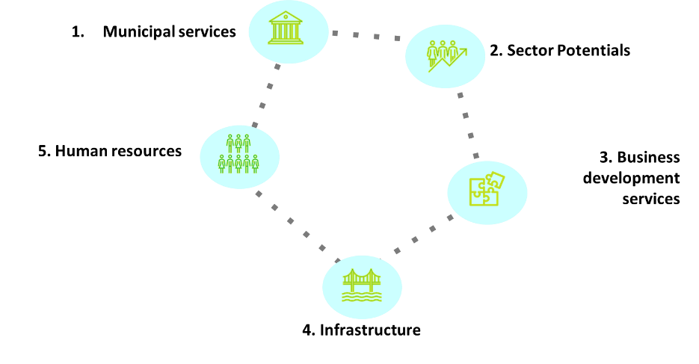
Figure: Five drivers of Local Economic Development

The main goal of this index in Bangladesh will be two-fold: a) to allow residents and businesses within a municipality to assess the overall strength and weaknesses of the business environment in terms of public and private service providers; b) to demonstrate the strength and weakness of business environment, economic dynamism, and competitiveness of a municipality to potential investors; and c) the MCI shall facilitate policy dialogue between key stakeholders in the municipality. The underlying methodology of the index needs to be simple and cost-effective so that a suitable national level anchor is motivated to own the index in the long run.

In 2023, PRABRIDDHI had signed a Memorandum of Understanding (MoU) with Bangladesh Investment Development Authority (BIDA) to foster economic growth and decentralization by working together through a number of interventions. Bangladesh Investment Development Authority (BIDA) is the apex investment promotion Body in Bangladesh. The BIDA Act 2016, issued on September 1, 2016, mandated BIDA to provide diversified promotional and facilitating services with a view to accelerating the industrial development and investment promotion of the country. BIDA's functions can be broadly categorized as investment promotion, investment facilitation and policy advocacy. To improve the business climate of the country, BIDA has launched “Bangladesh Investment Climate Improvement (BICI) Program” to facilitate business and investment across the country. Under this program, primarily 110 reforms have been identified under 7 pillars under BICI program. 7 working groups against 7 pillars have been constituted to update the program and a taskforce have been constituted to implement the program.

As a part of the collaboration, PRABRIDDHI will facilitate the development of the Municipality Competitiveness Index (MCI) and a virtual platform which is being developed by BIDA for showcasing the Index and reform agendas. The index will capture the ease of doing business at the municipalities by surveying representatives from the private sector, public sector, and CSOs. The main goal of this index in Bangladesh will be two-fold: a) to allow residents and businesses within a municipality to assess the overall strength and weakness of business environment in terms of public and private service providers; b) to demonstrate the strength and weakness of business environment, economic dynamism, and competitiveness of a municipality to potential investors; and the MCI shall facilitate policy dialogue between key stakeholders in the municipality The MCI shall inform policymakers about opportunities to improve the productivity and performance of the local economy. The index shall also help to identify scopes for reducing barriers, eliminating redundant administrative procedures, enhancing a fair legal environment, and providing the necessary infrastructure for businesses, farmers, and industries at the local level. The underlying methodology of the index needs to be simple and cost-effective so that a suitable national level anchor is motivated to own the index in the long run.

To develop a methodology and conduct the pilot survey for the MCI, PRABRIDDHI is seeking to engage a Consultancy/Research firm.

2. Objective

The objective of this assignment is to anchor Municipality Competitiveness Index (MCI) with BIDA and finalise index design, develop methodology, conduct survey for the development of MCI and showcase through national anchoring partner BIDA in Bangladesh.

3. Scope of Work

The scope of work for this assignment are in twofold a) a technical expert to backstop the overall development and anchoring with national stakeholders b) the project team led by the technical expert to develop methodology, conduct survey and showcase index result. Specific tasks are as below:

Technical Expert:
- Support in the designing and developing the Municipality Competitiveness Index (MCI) and provide technical guidance to the PRABRIDDHI team for integrating and uptake of the MCI into national anchoring partner’s program (BICI) strategy.
- Support PRABRIDDHI team to develop strategies to build capacity of anchoring partner for continuing the survey beyond the first phase and help align the concept between BIDA and LGD.
- Initiate dialogue with BIDA to give national coverage of MCI and set benchmark by showcasing MCI to attract municipal level funding, improvement in municipal level service delivery and create enabling environment for local businesses.
- Provide strategic inputs to assist PRABRIDDHI team in developing sustainable concept for replication beyond this first survey.
- Support in facilitating knowledge dissemination events, dialogues and discussion on MCI.
- Support in maintaining liaison with national anchoring partner to integrate and launch MCI.

Survey Team including Technical Expert:
- Develop MCI /Index methodology and finalise in consultation with PRABRIDDHI, LGD and BIDA.
- Develop survey strategy and sampling framework in consultation with project team and BIDA.
- Develop a sustainable concept for replication beyond this first survey.
- Undertake necessary secondary analysis and stakeholder interviews to bring in thematic and sectoral perspectives relevant for competitiveness at municipal level.
- Developing tools and instruments for data collection in consultation with PRABRIDDHI, LGD and BIDA.
- Conduct a pilot survey in selected municipalities to test and fine-tune instrument.
- Conduct full scale survey (2 rounds) in all the target municipalities to collect data in an accurate and timely manner, ensuring data validity and integrity.
- Conduct in-depth interviews of the municipality officials and relevant stakeholders at the local level.
- Conduct data analysis and further stakeholder interviews to validate data analysis results.
- Prepare draft report of the Municipality Competitiveness Index and collect feedback from key stakeholders.
- Develop a concept for dissemination, policy dialogue and effective launch of the results in close consultation with BIDA.
- Provide technical support in continuous dialogue with BIDA regarding MCI and its links to BICI program. Support BIDA in highlighting MCI related messages/communication/ interactions with BICI program’s working group and other relevant government agencies.
- Identify reform requirements opportunities and help identify links to BICP for reform implementation.
- Develop initial ideas for future replication of the MCI without project support in close consultation with BIDA.
- Conduct a pilot of the digital kiosk in selected municipalities to collect data from service seekers during survey and test the model for replication beyond the first survey.

4. Deliverables
Serial No. | Tasks | Deliverables | Time
1. | Finalise the survey methodology | Finalized concept note including methodology | May 2024
2. | Develop the survey strategy and sampling framework for selected municipalities | Final survey strategy framework | May 2024
3. | Develop sub-index wise questionnaires | Sub-index wise questionnaire | June 2024
4. | Conduct pilot survey in seven municipalities (to make changes to the questionnaire and methodology) including digital kiosk | Brief report on the work done | June 2024
5. | Recruitment and training of the interviewers/enumerators | Manual/Module, List of trained interviewers, Training session plan | June 2024
6. | Conduct full-scale survey in selected municipalities | Brief report on the survey conducted | June-July 2024 & May-June 2025
7. | Develop draft report including detailed concept for dissemination and advocacy and policy dialogue activities | Draft report | October 2024
8. | Develop the final report and launch | Final report | November 2024 & July 2025
9. | Conducting post-launch dissemination and delivering presentations at various BIDA/BICIP/MCI meetings | Presentation slides and meeting minutes | December 2024
10. | Technical expert to organise meeting or high-level discussion with Senior/Top government officials for MCI | Timesheet for the total days of work done | As per need
11. | Strategies developed for integrating and showcasing MCI into anchoring partner’s portfolio and to build capacity of anchoring partner for continuing the survey beyond the first phase | Meeting minutes, report, timesheet | Throughout
12. | Technical expert will assist in preparation knowledge dissemination event | Timesheet for the total days of work done | As per need

5. Timeline
The total duration of the assignment will be 16 months.

6. Reporting Structure

The research firm will report to the Team Leader – PRABRIDDHI and work closely with the Senior Manager – Institutionalization & Advocacy, PRABRIDDHI.

7. Selection Criteria
The selection criteria are divided into two parts:
- Technical Proposal (70% of the total possible score).
- Financial Proposal (30% of the total possible score).
The contracts are subject to VAT and AIT deduction as per government regulations.
- The technical proposal (TP), not exceeding 10 pages, should include the following elements:
- Understanding of the assignment and an initial work plan detailing the study as per requirments of above outlined ToR, including workplan with assignments of responsibilities.
- Description of individual/organizational capabilities and related experiences.
- .
- Technical competencies, key skills, and expertise of the expert team (Please see section on Team Composition and Key Requirements). CV to be attached as an Annex.
- Experience of similar work/service undertaken through weblinks or soft copies of relevant previous work

- The financial proposal should provide:

- Cost breakdown including monthly rates and/or daily rates as per working modality of the expert or the firm.
- The financial proposal will be opened only for the applicants scoring 50% and above in the technical proposal. The financial proposal would be evaluated based on:
- Competitiveness of the financial offer.
- Relevance and consistency with the technical proposal.
In addition to the technical and financial proposals, it is mandatory for the bidders to submit necessary documents demonstrating their legal, taxation and financial statuses. The documents should be part of the technical proposal and include the following:
- A certificate of incorporation (for individual companies- a trade license).
- Joint stock registration certificate (if applicable).
- An organizational organogram of key personnel, inclusive of the names of such personnel.
- Tax Identification Number (TIN).
- VAT registration number.
- Proof of a segregated account (providing the name and address of such an account).
- Other valid papers (Provided by Government institutions).
- The vendor must bear all Advance Income Tax (AIT) and VAT. The total amount of VAT should be mentioned in the financial proposal.
- The vendor must bear all Advance Income Tax (AIT) and VAT. The total amount of VAT should be mentioned in the financial proposal.

8. Payment Schedule
The payment schedule will be decided in consultation with the selected service provider/firm before issuing the contract.

9. Submission procedure
Interested firms should submit the sealed envelope containing hard copies of portfolio and sample work, financial proposals, and other relevant documents separately addressing the following person by 18th April 2024.

Samaun Bhuiyan
Coordinator – Business Administration
PRABRIDDHI: Local Economic Development (LED)
Swisscontact
SWISS FOUNDATION FOR TECHNICAL COOPERRATION
House 28, Road 43, Gulshan-2, Dhaka 1212, Bangladesh

The technical proposal should also be sent to bd.prabriddhi@swisscontact.org. ‘Submission of Application for Conducting Pilot Survey of Municipalities Competitiveness Index (MCI)’ should be mentioned in the subject line of the e-mail.

For more information, please e‐mail to bd.prabriddhi@swisscontact.org

N.B.: Swisscontact reserves the right to reject or cancel any application.

