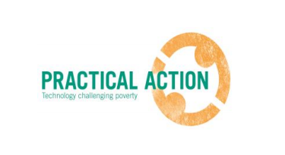

Terms of Reference (TOR)
for
Mid-term evaluation

Project: Securing Employment and Economic Development around Jute Textile and Light- Engineering Sector in North-West Bangladesh (EC- PRISM) Project

- Project Background
Practical Action has been implementing a project tilted “Securing Employment and Economic Development around Jute Textile and Light- Engineering Sector in North-West Bangladesh (EC- PRISM)” with funding support from European Commission and in partnership with RDRS, Karupannya Rangpur Ltd., Rangpur Chamber of Commerce and Lathe Machine Sromik Union. The project envisions to strengthen the skills and employability of workers, entrepreneurs in the cottage and small enterprises in order to enhance their competitiveness. The specific objective of the project is to strengthening Jute Textile Product and Light Engineering value chain increasing employability and income of entrepreneurs, workers within small and cottage industries around two sectors. With 3 years of duration, the project is being implemented in 15 Upazilas of 4 Districts of North West Bangladesh, namely Rangpur, Kurigram, Gaibandha and Lalmonirhat.

This project is being addressed some major problems such as hazardous labor in jute processing, jute diversification constrained by poor quality jute fibre, weak integration between small, micro and large jute industries, women participation, lack of proper job service, negotiation skills with poor vocational job training and policy support and direction. To achieve the main objectives and overcoming the problem statements, there are five interlinked Expected Results and Nine Target Groups. All the target groups linked with Jute Textile and Light Engineering sector value chain. In these two sectors, income of relevant target groups, skills enhancement and sustained employment will increase and ensure and relevant localized problems regarding jute and light engineering will be addressed through different activities and involving different stakeholders in the project.

In the long term, the project will contribute to (a) Increased income and sustained employment of 5,850 poor small jute entrepreneurs, traders, weavers and retailers through establishing new small jute processing entrepreneurs and enhancing skills and strengthening jute supply chain; (b) Strengthened the light engineering value chain on agro-mechanisation through introducing ideas of adapting new agro-machines in 100 metal workshops, enhancing skills of 1,000 metal workshop artisans (welders and others); (c) Increase access to job information in small and cottage industries for 3,000 (2,000 male, 1,000 female) through the use of ICT and mobile based information service to various employment seekers; (d) Greater collaboration between value chain actor’s particularly small and large industries, buyers and sellers and relevant government and private sector; (e) Policy engagement, well organised knowledge service for eco-friendly jute product diversification and market led small scale mechanisation.

- Key objective of this mid-term study
The key objective of this mid-term evaluation is to assess the process, progress and changes of the project against each expected result and output derived after 1.5 years and also to recommend for further programmatic improvement with respect to adaptive management. In addition to this, this study will also to evaluate performance against specific objectives and expected results outlined in the result framework with specific indicators.
The evaluation must look into – employment, growth of SMEs, income of TG, Diversification in products & services, skills quality, gender inclusiveness, access to job information and integration between large industry and SMEs.

- Study framework of this mid-term study
This mid-term study will be carried out based on the Organisation for Economic Co-operation and Development (OECD) standard criteria and other key learning agenda, as described below:

Criteria | Learning agenda/questions
Project design and validity | - Does the project design address the key needs and demands of , target group and its associated stakeholder’s?  - Does the implementation strategies are good fit with the existing indicators and expected results?  - Does the implementation fit with the EC and Practical Action’s strategic goal and objective?  - Are all the problem statements mentioned in the project document being addressed by different activities?  - Does the interventions remain valid for the local economic development?
Relevance | - Does the project’s methodology is being implemented as per plan?  - Does the Theory of Change consider in all actions?  - Assess the contribution of the project towards the achievement of Expected Result.  - Does the need and demands of the beneficiaries (target groups) are met in terms of enhancing skills, equity and inclusion?  - Assess the relevance of the process undertaken by the project for creating scope of employment, growth of SMEs and enough income of the TG.  - Assess the relevance and usefulness of technical assistance and input support to all beneficiaries.  - Does the business model approach proposed in the project document executed properly?  - Does it bring any environmental degradation due to any activities?
Effectiveness | - What worked and what did not in the two sector and TTCs?  - What are the current capacities of our staff, partner and mentioned agencies to deliver different services and inputs from the project?  - What is the current cost structure based on beneficiary cost ratio? (includes – fixed cost, running cost, depreciation cost, return or revenue, profit of any business/enterprise)  - What is the change in production and income level of the target groups?  - Review whether the project has accomplished its outputs. In particular, the evaluator should review:  -Area selection criteria and its implementation process  -Group targeting strategy for the identification of project beneficiaries including both men and women.  - Assess the effectiveness of the cost/ sharing and leveraging issues among key stakeholders (BJRI/others, Chamber of Commerce, Leath Shromic Union etc), Karuponnya Ltd., SMEs.  - Assess the current status of self and wage employment in various sector/trade and its job placement, drop out?
Efficiency | - Assess whether the project has utilized project funding (burn rate) as per the agreed work plan to achieve the projected targets.  - Analyse the performance of the Monitoring and Evaluation procedure of the project using various M&E tools/format for extracting/tracking results.  - Identify internal and external factors and constraints which have affected project implementation.
Sustainability and impact (uptake) | - What is current status of hazardous labor in jute retting and metal workshops?  - What is current status of jute fibre quality due to the introduction of new machine and improved retting process?  - What are the top five diversified jute products linked to national and export market? How it’s affecting to local economic development?  - Any significant improvement in the light engineering sector?  - Any change in TTC vocational education curriculum?  - Any significant relationship with Rangpur Chamber of Commerce & SMEs and Leath Shromic Union?  - Assess the uptake process of the key three solutions – machine, skills training, SMEs link to market.  - Check – scale up plan of the jute textile , market & sales plan of SMEs
Network/linkages | - What is the current status of role and responsibilities of different key stakeholders?  - Evaluate the engagement level, degree and representation by the beneficiaries (TG) and key stakeholders, (government and donor partners etc.) in the project.  - Assess the project’s knowledge management strategy through Union based Knowledge Bazars, web-based job portal activities, print brief, and Krishi Call centre and media.
Lessons leant | - Does the staff/partners identifies key lessons areas and defined the process of capturing systematic leaning?  - Does hazardous labour in jute processing is reducing?  - Does the quality jute fibre is being produced diversified jute products? What is their market demand and value?  - Is there any business integration between small, macro and large jute industries?  - Does this project increase participation of women and PWD in different income and employment generation components?  - Does this project enhance job related information and negotiation skills?  - Is there any policy level implication or engagement though different activities of project’s partners and co-applicants?

- Key indicators to be assessed
Five interrelated Expected Result are set to reach out the main goal and objectives of this project. Thus, the hired consultant/firm will develop a set of key learning questions based on the Logical Framework and our suggested key leaning questions, which would help to measure the changes (success and failure) of its implementation at different stages. We are envisioned that the resultant outputs of this mid-term study would help understand the process and progress against each indicator and implementation component of this project. Moreover, some strategic recommendations will help to adjust the project for improving quality outputs and sustainability. The main key indicators of this project are in listed in the image below-
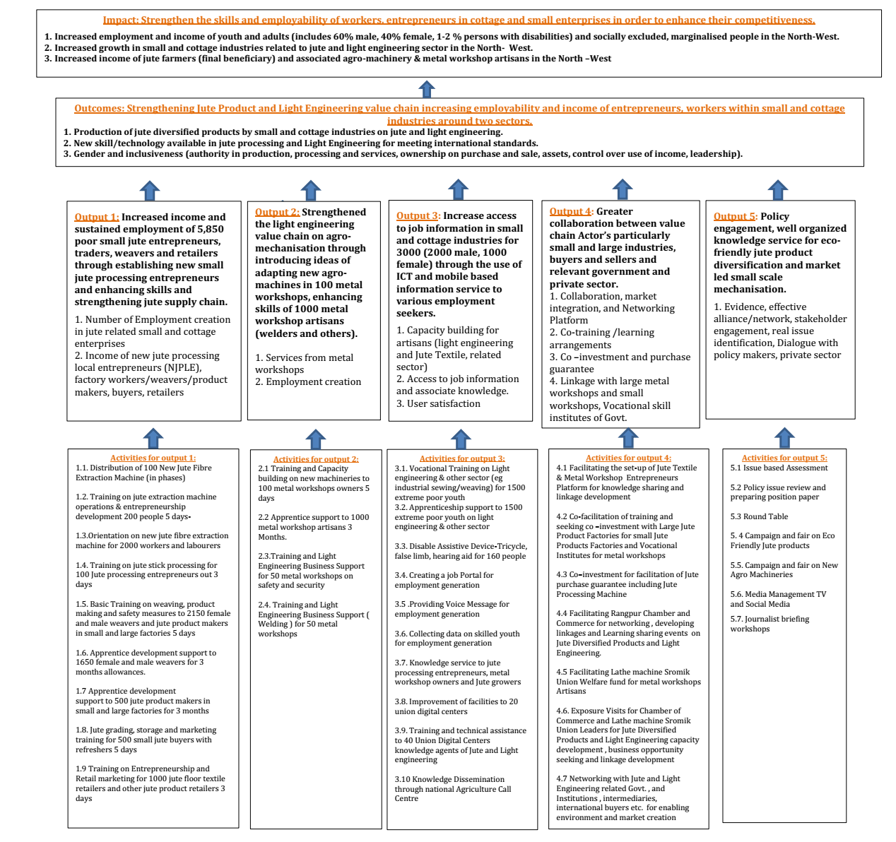

- Methodology
The consultant/ firm will propose an appropriate methodology to conduct this survey. However, Practical Action prefers to apply explorative approach and mixed methods for data collection. Therefore, a methodology comprising qualitative (FGD, KII, Case Studies) and quantitative (survey) methods would be given preference. In addition, a consultant/firm having mobile phone or tab based data collection competencies will be given priority too. In addition, based on the given population the consultant is also expected to propose a minimum but statistically acceptable sample size for this study (following a scientific calculation and justification). This project is expected to cover or reach out 33,000 people (final beneficiary) by securing employment and economic development from 11,350 direct beneficiaries (target groups).

- Outputs/ deliverables
- An indicative work plan and detailed methodology should be submitted and approved within 7 working days.
- A verbal and written presentation of the findings (after first draft of the report).
- A comprehensive report highlighting the key results of process, progress and realistic recommendation for improving the project
- An infographic of the report based on the findings of the report

- Indicative timeframe
The selected consultant/firm will develop a detailed work plan and timeframe, and seek approval from Practical Action. However, the assignment needs to be completed within 30 days from the contract signing date. A tentative timeframe is added in the table below.

Sl | Major Work | Number of days (indicative)
 | Reviewing project documents | 02
 | Necessary survey tools development | 05
 | Collection of field test data, analysis and modification, as needed | 03
 | Final field data collection | 10
 | Reporting (following given structure) with presentation | 8
 | Editing (language, coherence and data consistency) | 2
 | Total Working Days | 30

- Coordination and reporting
The Consultant/firm will report to Md. Shareful Hassan, Manager- Monitoring & Evaluation, Learning and Research (MELR) for all sorts of communication and technical aspects. He can be reached through Shareful.Hassan@practicalaction.org.bd. For anything related to the project, Kazi Morshed Alam (Morshed.Alam@practicalaction.org.bd) can be contacted.

- Eligibility: The consultant/ firm must have
- Experience in leading mid-term evaluation on agriculture, poverty, light engineering and their value chain
- Excellent data collection & data management skills
- Strong analytical and report writing skills

- Payment and Financial Modality
- The payment for the consultancy will be made through check. All TAX and VAT will be deducted at source at the rate of movement of Bangladesh order for the year.
- 30% of the total budgeted amount will be paid on receipt of detailed methodology, survey tools and satisfactory work plan.
- The remaining sum will be paid on receipt of a satisfactory final report presentation and submission. The payment will be done through account payee cheque.

- Proposals evaluation
A proposal including both technical and financial aspects should be emailed to practicalaction@practicalaction.org.bd by 21 October 2018. Please include a detailed CV of the experts (only) highlighting relevant experience. No late and hard-copy submissions will be accepted. Practical Action reserves the sole right to select the consultant.

According to EC’s direct and indirect beneficiary guideline

