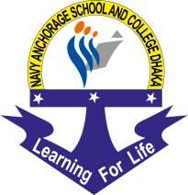

Navy Anchorage School and College Dhaka
Khilkhet Naval Area, Namapara Khilkhet, Dhaka-1229

Amendment Notice for Jobs Circular
Job Circular published on 25 March 2019 on bdjobs online website has been amended as follows:
For: Educational Requirement
- Should have Honors and Masters in respected field with minimum 2nd class or equivalent CGPA in all examinations.

Read: Educational Requirement:
- Chemistry: Honors and Masters in Chemistry/ Applied Chemistry/ Pharmaceutical science/ Chemical Engineering subject with minimum 2nd class or equivalent CGPA in all examinations.

- Physical Education: Honors and Masters in any subject with B PEd/ M PEd.

N.B: Updated Educational Requirement has been uploaded on 27 March 2019. Please Discard Previous notice.

