Request for Quotations (RFQ)

RFQ Number: AUHC-2019-011

Issuance Date: March 12, 2019

Deadline for Offers: March 20, 2019

Description: Supply of Curtain for Surjer Hashi Network (SHN)

For: Advancing Universal Health Coverage (AUHC) Activity

Funded By: United States Agency for International Development (USAID),
Contract No. AID-388-C-17-00001

Implemented By: Chemonics International Inc.

Point of Contact: procurement@auhcproject.org
Joseph P. Urban, jurban@auhcproject.org

***** ETHICAL AND BUSINESS CONDUCT REQUIREMENTS *****

Chemonics is committed to integrity in procurement, and only selects suppliers based on objective business criteria such as price and technical merit. Chemonics expects suppliers to comply with our Standards of Business Conduct, available at https://www.chemonics.com/our-approach/standards-business-conduct/.

Chemonics does not tolerate fraud, collusion among offerors, falsified proposals/bids, bribery, or kickbacks. Any firm or individual violating these standards will be disqualified from this procurement, barred from future procurement opportunities, and may be reported to both USAID and the Office of the Inspector General.

Employees and agents of Chemonics are strictly prohibited from asking for or accepting any money, fee, commission, credit, gift, gratuity, object of value or compensation from current or potential vendors or suppliers in exchange for or as a reward for business. Employees and agents engaging in this conduct are subject to termination and will be reported to USAID and the Office of the Inspector General. In addition, Chemonics will inform USAID and the Office of the Inspector General of any supplier offers of money, fee, commission, credit, gift, gratuity, object of value, or compensation to obtain business.

Offerors responding to this RFQ must include the following as part of the proposal submission:
- Disclose any close, familial, or financial relationships with Chemonics or project staff. For example, if an offeror’s cousin is employed by the project, the offeror must state this.
- Disclose any family or financial relationship with other offerors submitting proposals. For example, if the offeror’s father owns a company that is submitting another proposal, the offeror must state this.
- Certify that the prices in the offer have been arrived at independently, without any consultation, communication, or agreement with any other offeror or competitor for the purpose of restricting competition.
- Certify that all information in the proposal and all supporting documentation are authentic and accurate.
- Certify understanding and agreement to Chemonics’ prohibitions against fraud, bribery and kickbacks.

Please contact Chief of Party James Griffin with any questions or concerns regarding the above information or to report any potential violations. Potential violations may also be reported directly to Chemonics’ Washington office through the contact information listed on the website found at the hyperlink above.

Section 1: Instructions to Offerors

- Introduction: The Advancing Universal Health Coverage (AUHC) Activity is a USAID funded health initiative, implemented by Chemonics International, to assist the goals of the Government of Bangladesh to significantly expand access to safe, affordable and quality health services, while increasing financial protection, particularly of the poor, in support of the Government of Bangladesh’s National Health Care Financing Strategy (2012-2032), under which Universal Health Coverage is a key priority. As part of project activities, AUHC requires curtain for Surjer Hashi Network(SHN).

Offerors are responsible for ensuring that their offers are received by Chemonics in accordance with the instructions, terms, and conditions described in this RFQ. Failure to adhere with instructions described in this RFQ may lead to disqualification of an offer from consideration.

- Offer Deadline and Protocol: Offers must be received no later than 5:00PM local Dhaka time on March 20, 2019 by only email to procurement@auhcproject.org with cc: to Joseph P. Urban jurban@auhcproject.org

Please reference the RFQ number in any response to this RFQ. Offers received after the specified time and date will be considered late and will be considered only at the discretion of Chemonics.

- Specifications: Section 3 contains the technical specifications of the required items. All commodities offered in response to this RFQ must be new and unused. Offerors should note that prior to award, the apparently successful offeror will be required to submit sample curtains for quality inspection. They do not necessarily need to be draft samples of the curtains in the attached specifications in Section 3; however, if submitting samples of past work, the samples must be of the same material and printing standard as shall be used in creating the curtains requested under this RFQ.

Please note that, unless otherwise indicated, stated brand names or models are for illustrative description only. An equivalent substitute, as determined by the specifications, is acceptable.

- Quotations: Quotations in response to this RFQ must be priced on a fixed-price, all-inclusive basis, including delivery and all other costs. All quotations must present VAT as separate cost. Pricing must be presented in Bangladeshi Taka (BDT). Offers must remain valid for not less than thirty (30) calendar days after the offer deadline. Offerors are requested to provide quotations on their official quotation format or letterhead; in the event this is not possible, offerors may complete the table in Section 3.

In addition, offerors responding to this RFQ are requested to submit the following:
- Organizations responding to this RFQ are requested to submit a copy of their official registration or business license along with VAT Registration copy.
- Individuals responding to this RFQ are requested to submit a copy of their identification card.

5. Delivery: The delivery and installation location for the items described in this RFQ is Surjer Hasi Network (SHN) Head Office Located at Abedin Tower (6th Floor-East Part), 35, Kamal Ataturk Avenue, Banani C/A, Dhaka-1213, Bangladesh. As part of its response to this RFQ, each offeror is expected to provide an estimate (in calendar days) of the delivery timeframe (after receipt of order). The delivery estimate presented in an offer in response to this RFQ must be upheld in the performance of any resulting contract.

- Source/Nationality/Manufacture: All goods and services offered in response to this RFQ or supplied under any resulting award must meet USAID Geographic Code 937 in accordance with the United States Code of Federal Regulations (CFR), 22 CFR §228. The cooperating country for this RFQ is Bangladesh.

Offerors may not offer or supply any commodities or services that are manufactured or assembled in, shipped from, transported through, or otherwise involving any of the following countries: Cuba, Iran, North Korea, Syria.

- Warranty: Warranty service and repair within the cooperating country is required for all commodities under this RFQ. The warranty coverage must be valid on all commodities for a minimum of twelve (12) months after delivery and acceptance of the commodities, unless otherwise specified in the technical specifications. At the time that any commodity is transferred to another entity within the cooperating country, all rights to warranty support and service shall be transferred with the commodity to that entity’s end-user.

- Taxes and VAT: In accordance with the agreement under which this procurement is financed, Chemonics is exempt from payment of taxes, VAT, tariffs, duties, or other levies imposed by the Bangladesh government. Offerors must include taxes, VAT, charges, tariffs, duties and levies in accordance with the laws of the Bangladesh as a separate cost line. Chemonics will provide the successful offeror with a VAT coupon for VAT amount, VAT coupon will be issue upon submission of Mushok-11

- DUNS Number: Companies or organizations, whether for-profit or non-profit, shall be requested to provide a Data Universal Numbering System (DUNS) number if selected to receive an award in response to this RFQ valued greater than or equal to USD$30,000 (or equivalent in other currency). If the Offeror does not have a DUNS number and is unable to obtain one before proposal submission deadline, Offeror shall include a statement noting their intention to register for a DUNS number should it be selected as the successful offeror or explaining why registration for a DUNS number is not possible. Contact Dun & Bradstreet through this webform to obtain a number: https://fedgov.dnb.com/webform. Further guidance on obtaining a DUNS number is available from Chemonics upon request.

- Eligibility: By submitting an offer in response to this RFQ, the offeror certifies that it and its principal officers are not debarred, suspended, or otherwise considered ineligible for an award by the U.S. Government. Chemonics will not award a contract to any firm that is debarred, suspended, or considered to be ineligible by the U.S. Government.

Evaluation and Award: The award will be made to a responsible offeror whose offer follows the RFQ instructions, meets the eligibility requirements, meets or exceeds the minimum required technical specifications, and is judged to be the best value based on a lowest-price, technically-acceptable basis.

Please note that if there are significant deficiencies regarding responsiveness to the requirements of this RFQ, an offer may be deemed “non-responsive” and thereby disqualified from consideration. Chemonics reserves the right to waive immaterial deficiencies at its discretion.

Best-offer quotations are requested. It is anticipated that award will be made solely on the basis of these original quotations. However, Chemonics reserves the right to conduct any of the following:
- Chemonics may conduct negotiations with and/or request clarifications from any offeror prior to award.
- While preference will be given to offerors who can address the full technical requirements of this RFQ, Chemonics may issue a partial award or split the award among various suppliers, if in the best interest of the AUHC Project.
- Chemonics may cancel this RFQ at any time.

Please note that in submitting a response to this RFQ, the offeror understands that USAID is not a party to this solicitation and the offeror agrees that any protest hereunder must be presented—in writing with full explanations—to the AUHC Project for consideration, as USAID will not consider protests regarding procurements carried out by implementing partners. Chemonics, at its sole discretion, will make a final decision on the protest for this procurement.

- Terms and Conditions: This is a Request for Quotations only. Issuance of this RFQ does not in any way obligate Chemonics, the AUHC Project, or USAID to make an award or pay for costs incurred by potential offerors in the preparation and submission of an offer.

This solicitation is subject to Chemonics’ standard terms and conditions. Any resultant award will be governed by these terms and conditions; a copy of the full terms and conditions is available upon request. Please note the following terms and conditions will apply:
- Chemonics’ standard payment terms are net 30 days after receipt and acceptance of any commodities or deliverables. Payment will only be issued to the entity submitting the offer in response to this RFQ and identified in the resulting award; payment will not be issued to a third party.
- Any award resulting from this RFQ will be firm fixed price, in the form of a purchase order.
- No commodities or services may be supplied that are manufactured or assembled in, shipped from, transported through, or otherwise involving any of the following countries: Cuba, Iran, North Korea, Syria.
- Any international air or ocean transportation or shipping carried out under any award resulting from this RFQ must take place on U.S.-flag carriers/vessels.
- United States law prohibits transactions with, and the provision of resources and support to, individuals and organizations associated with terrorism. The supplier under any award resulting from this RFQ must ensure compliance with these laws.
- The title to any goods supplied under any award resulting from this RFQ shall pass to Chemonics following delivery and acceptance of the goods by Chemonics. Risk of loss, injury, or destruction of the goods shall be borne by the offeror until title passes to Chemonics.

Section 2: Offer Checklist

To assist offerors in preparation of proposals, the following checklist summarizes the documentation to include an offer in response to this RFQ:

□ Cover letter, signed by an authorized representative of the offeror (see Section 4 for template)
□ Official quotation, including specifications of offered equipment (see Section 3 for example format)
□ Copy of offeror’s registration or business license (see Section 1.5 for more details)

Section 3: Specifications and Technical Requirements

The table below contains the technical requirements of the commodities/services. Offerors are requested to provide quotations containing the information below on official letterhead or official quotation format. In the event this is not possible, offerors may complete this Section 3 and submit a signed/stamped version to Chemonics.

Quotation Submission
SL # | Items Name | Detailed Specifications | Image Description | Quantity | Unit Price in BDT | Total Price in BDT
1 | Supply Window Curtain with SS logo | Size: L 6.5” W 4”  Fabric: Polyester & Cotton blend (65% & 35%) 165 GSM  Screen Print SS Logo, 4 color  Print size: 1 FT/ 1 FT  Color: White  . | 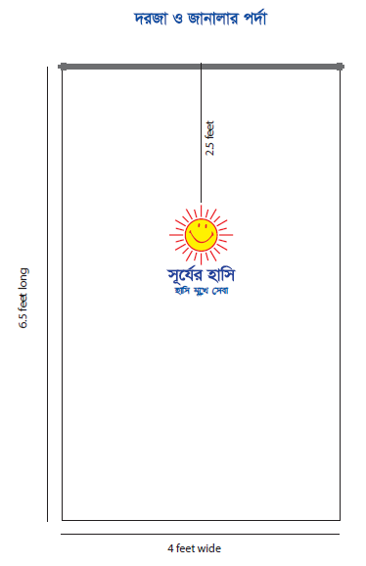 | 4000 Pcs
 |  |  | Total Amount (including Tax)
 |  |  | Add: VAT @ ….%
 |  |  | Total including VAT & Tax
Amount in Word:

**All prices must be in Bangladeshi Taka (BDT)**

Delivery time (after receipt of order): calendar days

Length of warranty on offered equipment: years

Offered validity: ________________________________

Payment Terms: _______________ calendar days

Location of service center(s) for after-sales service, including warranty repair:
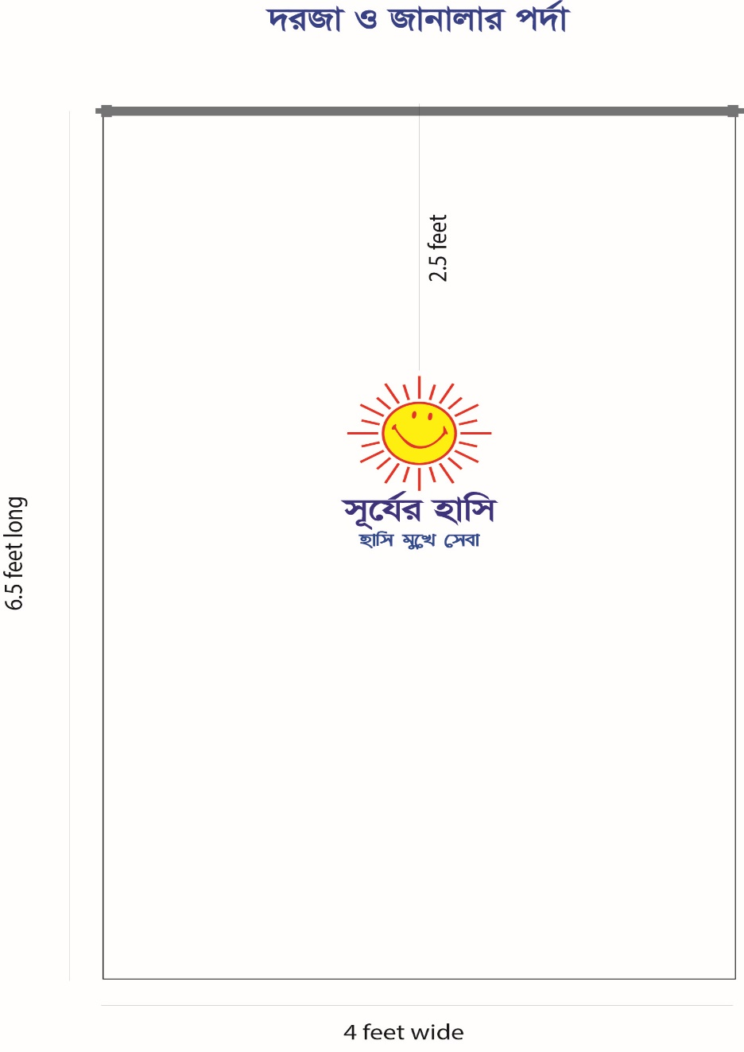

Color Code:
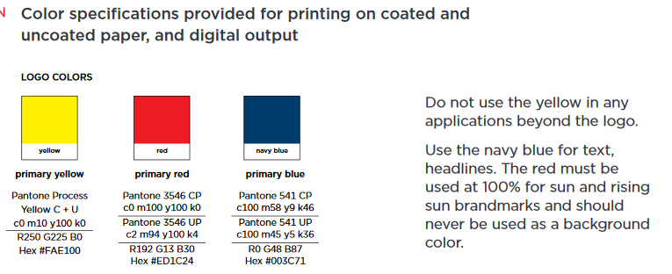
Section 4: Offer Cover Letter

The following cover letter must be placed on letterhead and completed/signed/stamped by a representative authorized to sign on behalf of the offeror:

To: Deputy Chief of Party (DCOP)
USAIDs Advancing Universal Health Coverage (AUHC) Activity
H-CWN(A) 3A, Suit 14 A-B, 3A, 13th Floor, Road-49,
Kamal Ataturk Avenue, Gulshan-2, Dhaka, Bangladesh

Reference: RFQ No. AUHC-2019-011

To Whom It May Concern:

We, the undersigned, hereby provide the attached offer to perform all work required to complete the activities and requirements as described in the above-referenced RFQ. Please find our offer attached.

We hereby acknowledge and agree to all terms, conditions, special provisions, and instructions included in the above-referenced RFQ. We further certify that the below-named firm—as well as the firm’s principal officers and all commodities and services offered in response to this RFQ—are eligible to participate in this procurement under the terms of this solicitation and under USAID regulations.

Furthermore, we hereby certify that, to the best of our knowledge and belief:
- We have no close, familial, or financial relationships with any Chemonics or AUHC project staff members;
- We have no close, familial, or financial relationships with any other offerors submitting proposals in response to the above-referenced RFQ; and
- The prices in our offer have been arrived at independently, without any consultation, communication, or agreement with any other offeror or competitor for the purpose of restricting competition.
- All information in our proposal and all supporting documentation is authentic and accurate.
- We understand and agree to Chemonics’ prohibitions against fraud, bribery, and kickbacks.

We hereby certify that the enclosed representations, certifications, and other statements are accurate, current, and complete.

Authorized Signature:

Name and Title of Signatory:

Date:

Company Name:

Company Address:

Company Telephone and Website:

Company Registration or Taxpayer ID Number:

Company DUNS Number:

Does the company have an active bank account (Yes/No)?

Official name associated with bank account (for payment):

Bank Accounts Details Information (completed/signed/stamped by a representative authorized to sign on behalf of the offeror):
Sl. | Particulars | Information
1 | Account Name:
2 | Account Number:
3 | Account Type:
4 | Name of Bank:
5 | Name of Bank Branch:
6 | Address of Branch:
7 | Bank Routing Number: If possible

Signature with seal:

Name :
Designation :
Date :

