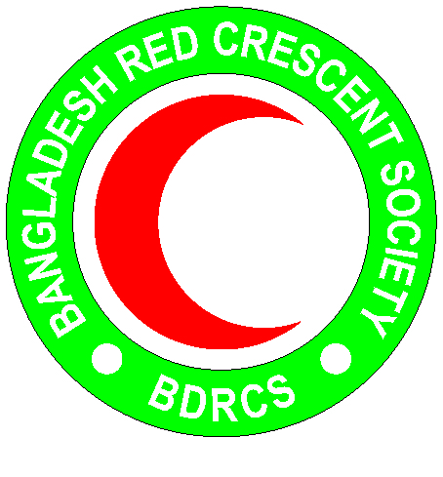
Bangladesh Red Crescent Society
National Headquarters
684-686, Red Crescent Sarak, Bara Mogh Bazar, Dhaka-1217

Vacancy Announcement

Job title : WaSH Officer (Engineer/Plumber)
Duration of contract : Up to December 2019
Department : Disaster Response department (PMO)
Salary : Negotiable
Number of Post : 01
Age : 40 years maximum(Age limit will be relaxed in case of potential candidates)
Duty station : Cox’s Bazar

Duties and responsibilities
- Plan, organize and follow up of the community mobilization in target communities on issues related to implementation of WaSH activities based on plan of action.
- Responsible for construction, operation and maintenance of WaSH facilities.
- Establish the technical aspect of the internal purchase order and tender documents for construction and rehabilitation of WaSH facilities
- Ensure the quality of WaSH materials as supplied by supplier/contractor
- Responsible for site management: general supervision of contractors and ensuring the safety of construction sites and community participation
- Validate the progress and quality of work of the contractors and coordinate/liaise with BDRCS (DR dept) and IFRC to ensure their payments
- Design, organize and implement training for installation and use of WaSH facilities at household level
- Follow up logistics/budget management/site supervision for small scale works(installation/ rehabilitation of water points or latrines etc)
- Follow-up of activities in the field of WaSH facilities in relation to capacity building of beneficiaries.
- Ensure that construction works is integrated with hygiene promotion and community participation component, to ensure sustainability of the infrastructure built
- Coordinate with other local actors (governmental and non-governmental) regarding WaSH activities
- Ensure the integration of gender, child protection, environment and other cross cutting issues to the design, implementation and development of WaSH construction/training activities and ensure that activities take into account the needs of specific groups and individuals, especially children, the elderly and disabled
- Plan, organize and facilitate PHAST tools in the communities
- Perform any other work related duties and responsibilities that may be assigned by the line manager.

PERSON SPECIFICATIONS:
Education and experience:
- B.Sc in civil engineering
- Minimum 2 years of relevant working experience on WaSH related activities
- Experience in PHAST tool implementation in the community and field level
- Experience with working with donors and contractors
Skills & abilities:
- Good Computer skills
- Organization, coordination and planning skills
- Sound knowledge in subject area
- Fluent in English
Personal qualities:
- Adhere to the 7 fundamental principles of Red Cross and Red Crescent movement
- Act at all times in accordance with the Code of Conduct
- Able to work in a team and respects opinions of others
- Honest and high level of integrity
- Assist the organization on occasion, in times of national, international, local emergencies or major disasters

