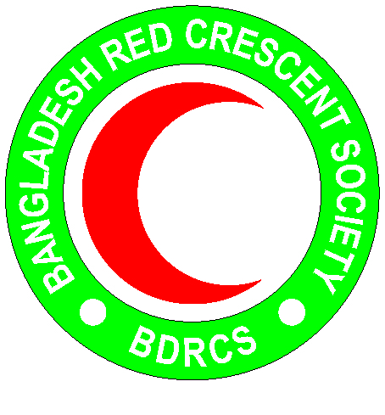
Bangladesh Red Crescent Society
National Headquarters
684-686, Red Crescent Sarak, Bara Mogh Bazar, Dhaka-1217

Vacancy Announcement

Job title : Shelter Officer
Duration of contract : Up to December 2019
Department : Disaster Response department (PMO)
Salary : Negotiable
Number of Post : 01
Age : 45 years maximum(Age limit will be relaxed in case of potential candidates)
Duty station : Cox’s Bazar

Roles and responsibilities:
- Manage and implement the planned activities related to emergency shelter for the target communities.
- Continuously assess shelter needs in the community and undertake gap analysis for development of shelter activities.
- Safe shelter training (PASSA) and technical support, orientation to community (people in camps and host community)
- Design and support inclusive Shelter solutions that ensure access of all regardless of their age, gender and disability
- Apply conflict sensitive management tools in shelter programming
- Provide support to Shelter/NFI distribution activities as directedand perform with Logistics spot checks for NFI quality control
- Organize different awareness session in the community
- Undertake field visit to monitor and review the program performance and share the findings with the project team
- Provide Shelter technical assistance to the project team and ensure compliance with accountability mechanisms in line with different standards such as the SPHERE standards and Shelter cluster performance standards in coordination with project team.
- Represent BDRCS in relevant coordination platforms for Shelter at Cox Bazar and Dhaka
- Support monitoring and evaluation and reporting team of the project to document helter activities.
- Assist Logistics to prepare procurement plan and ensure timely procurement of goods and services related to Shelter
- Based on rational workload assessment, support in ongoing/potential emergency response work in other areas
- Perform any other duties assigned by the Project Director/ Senior Shelter Officer

Qualifications and skills:
- Candidate should be master’s degree in social science, Development Studies, University degree in Civil-Engineering or related field
- Minimum of 5 years of relevant experience
- Good computer skills, especially in MS Office.
- Demonstrated experience and ability in project management, specifically in the field of SHELTER in emergency and relief, humanitarian aid, assistance to refugees,
- Experience in supporting emergency response;
- Experience / skills in procurement procedures and tendering. Background and knowledge of projects management systems, administrative and procurement procedures, tendering, etc.
- Excellent communication skills in Bangla and English
- Priority will be given to the candidates who demonstrate a high level of motivation and good communication in social and interpersonal skills.
- Proficiency in MS Word, Excel, Access, PowerPoint.
- Ability to understand and communicate in Burmese/Rohingya language is an advantage

Personal Qualities:
- Adhere to the 7 fundamental principles of Red Cross and Red Crescent movement
- Act at all times in accordance with the Code of Conduct
- Assist the organization on occasion, in times of national, international, local emergencies or major disasters

