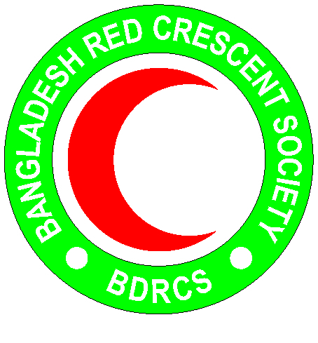
Bangladesh Red Crescent Society
National Headquarters
684-686, Red Crescent Sarak, Bara Mogh Bazar, Dhaka-1217

Vacancy Announcement

Job title : Disaster Risk Reduction (DRR) Coordinator
Duration of contract : Up to December 2019
Department : Disaster Response department (PMO)
Salary : Negotiable
Number of Post : 01
Age : 45 years maximum(Age limit will be relaxed in case of potential candidates)
Duty station : Cox’s Bazar

Roles and Responsibility:
- Support implementing and assessing DRR program/project activities in the different target CAMP and host communities, including regular visits to observe progress of program/project implementation
- Support planning monthly activities as per established targets (monthly, quarterly, annually) and deadlines within the Program/Project Plan of Action in close collaboration with the DRR Manager.
- Support the DRR project team with establishing monthly work plans and ensure that activities are implemented at the field level.
- Report on any activity or target changes/modifications to the DRR Manager.
- Conduct monitoring and evaluation activities to identify best practices or determine areas for improvement.
- Adhere to reporting guidelines for field trips, trainings etc.
- Facilitate with addressing programmatic questions and concerns.
- Manage day-to-day logistics, administration, and personnel activities in accordance with national law and organizational guidelines
- Facilitate and support with the planning of meetings, workshops and field visit as required
- Act as a focal person between the DRR volunteers on field level (CAMP/host community) and DRR Manager to support with project coordination and implementation.
- Ensure quality of work on field level as per set and agreed standards in close collaboration with the DRR Manager and Resilience Coordinator.
- Monitor and supervise on performance of CAMP/host communities volunteers and seeks pro-actively solutions for improvement if needed

Roles and Responsibilities related to Community Engagement & Accountability (CEA) + Protection, Gender and Inclusion (PGI):
- Ensure that the Minimum Standards for PGI in emergencies are mainstreamed in the DRR program
- Ensure that all DRR interventions are participatory
- Ensure the active involvement of communities in the assessment of risks and hazards, as well as the capacities they have for dealing with them
- Set up community-based risk-reduction activities to prevent or lessen the effect of expected hazards, risks and vulnerabilities
- Establish and roll out innovative approaches for two-way communication with communities and early warning messaging
- Collect disaggregated data in disaster risk assessments
- Set up community-based Disaster Management Committees and encourage women to participate
- Consult girls, women and people with different gender identities to distinguish and address their risks
- Ensure that DRR personnel have clear understanding about how to identify vulnerable cases and that referral pathways are understood among all DRR staff and volunteers.
- Include cyclone/monsoon hazard awareness and risk reduction at all RC/RC community centres
- Build the capacity of BDRCS to integrate CEA and PGI into their ways of working
- Coordinate CEA and PGI activities in the DRR program with the CEA and PGI teams from IFRC/BDRCS, as well as with external actors from the Communication with Communities working group
- Perform any other work-related duties and responsibilities that may be assigned by the line manager

Educational Qualification:
- Graduate degree from a reputable accredited university in in Social Science, Disaster Management, Environmental Protection and/or relevant field is required. A Master’s Degree is preferred.
Person’s Specifications:
- At least 3 years experiences working as a professional in the Disaster Management Field particularly community resiliency and community based DRR
- 5 years plus experience with program design and project management; ability to design and manage all stages of disaster risk mitigation, preparedness, recovery and livelihood projects
- Experience collaborating with government agencies, international organizations and working with local implementing partners
- Demonstrated success in proposal writing and securing funding and analytical report writing
- Excellent skills in budgeting and financial management, problem solving, conflict resolution, advocacy, and stakeholder coordination
- Good level of understanding about organizational change
Knowledge and Skills:
- Excellent interpersonal skills and able to work effectively in a team and respects opinions of others
- High degree of integrity, discretion, and personal conduct
- Flexible and adaptable to changing working conditions
- Self-motivated and proactive, with good judgment and initiative
- Able to prioritize and meet deadlines
- Good Analytical thinking skills
- Good computers skills (Windows, Spreadsheets, Word Processing)
- Fluent in English and Bangla (written and spoken) required.
- Ability to understand and communicate in Burmese/Rohingya language is an advantage

Personal Qualities:
- Adhere to the 7 fundamental principles of Red Cross and Red Crescent movement
- Act at all times in accordance with the Code of Conduct
- Assist the organization on occasion, in times of national, international, local emergencies or major disasters

