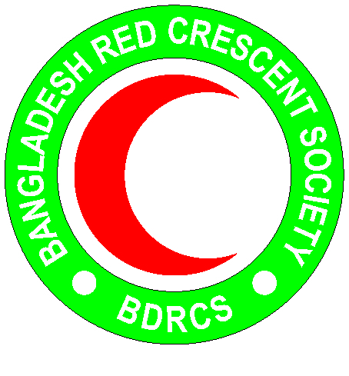
Bangladesh Red Crescent Society
National Headquarters
684-686, Red Crescent Sarak, Bara Mogh Bazar, Dhaka-1217

Vacancy Announcement

Job title : Technical Project Assistant (Contractual)
Contract period : Upto March 2019 (possibility of extension)
Salary : Negotiable
Age : 36 years maximum (age limit will be relaxed in case of potential candidate)
Reportable to : Project Officer or equivalent
Duty station : Cox’s Bazar

Purpose:
The overall responsible of the Technical Project Assistant of ECHO DRR project is to implement in close coordination with his / her supervisor project activities at Camp and host communities at Teknaf/Ukhia in Cox’s Bazar. She / he will be responsible for organizing and facilitating workshops, meetings, trainings and drills and others project assigned tasks.

Roles and Responsibility:

Under the supervision of the Project officer/equivalent and in close coordination with the Senior project officer:
- Co-responsible for the implementation of ECHO DRR project activities at camp and host community in line with defined action plan and in very close coordination with BDRCS PMO and BDRCS Unit Cox’s Bazar
- Organizing and implementing the project activities
- Organizing workshops, meetings / sessions, trainings, rallies, awareness raising, contingency planning etc. at camp and host community.
- Organizing drills and simulations at camp and host community.
- Work with CiC, camp focal, Union Parishad and other relevant stakeholders, like the for defined project activities and to ensure a linkage between different stakeholders of the project
- Ensure women’s full and effective participation in project activities
- Supervise and provide necessary support to volunteers
- Participate in project related meetings/trainings/workshop.
- Collaborate with other Partners of the project (IFRC, ARC, IOM, UNDP etc.) at field level
- Provide regular updates and write regular reports
- Perform any other duty as assigned by supervisor
General responsibilities
- Work towards the achievement of BDRCS / GRC goals in Bangladesh, operating through effective coordination and lateral relations and teamwork
- To abide by and work in accordance with the Red Cross / Red Crescent principles and values
- To ensure understanding of roles, responsibilities, lateral relations and accountabilities
- To maintain an efficient and harmony working environment among employees, partners and managers
- Perform proactively and to follow any other tasks assigned by the supervisor

Person Specification:
Education and experience:
- Graduate in Social work, development studies, disaster management or relevant discipline
- At least 3 years working experiences in related field or 5 years RC/RC volunteers
- Experience in working in Cox’s Bazar
- Experiences in emergency preparedness, contingency planning, emergency response
Skills and knowledge:
- Valid driving license for motorcycle is preferred
- Required fluent in Bangla and English
- Required good command of MS software: Excel, Word, Outlook
- Strong organizing, training and communication skills
- Ability to motivate and to lead staff/volunteers by example

Personal qualities:
- Adhere to the 7 fundamental principles of Red Cross and Red Crescent movement
- Act at all times in accordance with the Code of Conduct
- Sound interpersonal and organizational skill
- High level of attention to details in all respect of work responsibilities
- Willingness and ability to learn, flexibility and adaptability
- Ability to get on well with a wide variety of people
- Excellent team player and gender sensitive
- Integrity and high standards of personal conduct

Lateral relationships:
  - Establish and ensure effective working relationships with members in the team of GRC/IFRC, PNSs, PMO team and respective RC unit

