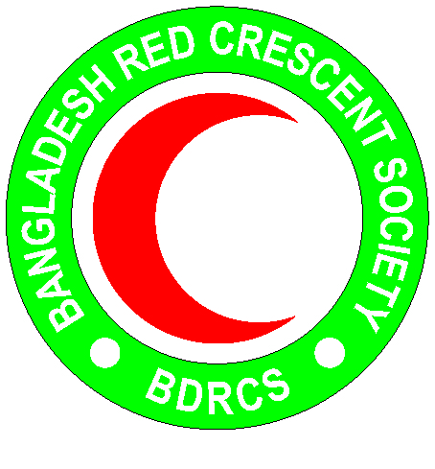
Bangladesh Red Crescent Society
National Headquarters
684-686, Red Crescent Sarak, Bara Mogh Bazar, Dhaka-1217

Vacancy Announcement

Job title : Field Officer (Contractual)
Position : Two (1 female & 1 male)
Duration of contract : 12 months (with possibility to extend)
Salary : Negotiable
Reporting to : Sr. Program Officer, BDRCS – PMO
Age : 36 years maximum (age limit will be relaxed in case of potential candidate)
Duty station : Cox’s Bazar

Purpose: To implement the coastal Disaster Risk Reduction (DRR) program of BDRCS – PMO, supported by American Red Cross (AmRC) and International Federation of Red Cross and Red Crescent Societies (IFRC) in the camp settlements of displaced Rakhine people set in Ukhiya and Teknaf and other areas in Cox’s Bazar.
Key Role: Under the direct supervision of Senior Program Officer, the Field Officer will be responsible for implementation of field activities under the PMO and coastal DRR program. The position will work closely with project management team and will maintain strong coordination with all camp in-charges, site management teams, and all other stakeholders.

Specific duties/ responsibilities and accountabilities:
- Assist Project Coordinator/Sr. Program Officer/team for any requirement as per demand of the project.
- Implement field activities in the camp settlements as per project requirement
- Organize trainings, orientations, simulation exercise in coordination with the BDRCS/CPP/AmRC/IFRC and site management teams
- Supervise and monitor camp mobilizers
- Frequently visit the project areas and support the Sr. Program Officer in planning and monitoring activities
- Support in implementing camp PoA developed by the camps, based on Vulnerability and Capacity Assessment (VCA) exercise.
- Ensure continuous monitoring of the progress of DRR activities undertaken in the population Movement Operation and others.
- Supervise all Field staff in organizing training, awareness campaign and dialogue as per plan
- Closely work with Cyclone Preparedness Programme (CPP) to organize any events like trainings, simulation etc.
- Ensure project resources are used properly and in case of any misuse or wrong doing immediately bring it to the attention of the Project Coordinator/Manager.

Roles and responsibility:
- Work closely with the programme team members and BDRCS PMO colleagues at all aspects
- Support the programme team, volunteers and CPP to effectively assess, design, monitor and report on the project activities
- Work closely with the IFRC/AmRC and Cyclone Preparedness Programme during the assessment, project planning, and implementation, monitoring and reporting process
- Plan and carry out with the programme team members, volunteers and CPP the following tasks to improve DRR support and reduce the vulnerability of the beneficiaries (Rohingya and host communities) by:
    - ensuring all interventions are adequately assessed, planned, appropriate, implemented, monitored and reported.
    - Ensuring majhis, leaders of CPP camp volunteers, CPP host community volunteers, community leaders and key stakeholders (especially CiCs and Site Management teams) are involved in any assessment process
    - ensuring appropriate DRR support is provided to all members of the target group
- Provide technical support or guideline on DRR to the field staff
- Work as a team member and share views and plans with BDRCS/AmRC/IFRC colleagues, and management
- Provide full support to programme or other interventions when appropriate
- Visit the programme site(s) regularly and submit weekly monitoring reports to the management
- Coordinate with CICs, Site Management team, IFRC/AmRC and CPP to contribute in the field of DRR and attend the weekly coordination meetings at camps to update all regarding DRR interventions
- Establish and maintain effective working relationships with all relevant stakeholders
- Assist the programme team in ensuring CEA process and PGI while implementing any activities in camps and host communities
- Perform any other work-related duties and responsibilities that may be assigned by the line manager
- Responsible for the overall monitoring and effective implementation of DRR activities in time as per plan.
- Assist Team/Project manager to prepare the reports of the project.
- Ensure organizing monthly/bi-monthly/Quarterly project team coordination meetings and to share the meeting minutes.
- Support developing/capturing IEC Materials, case studies, stories, most Significant Change, visibility, etc.
- Support ensuring all project files, records, archives and databases (documentation, meeting minutes, etc.) are kept in good order and updated when required.

PERSON SPECIFICATIONS:
Education and experience:
- Post-graduate degree in a field related to development, preferably social science or disaster management background
- Minimum 3 years of relevant experience on DRR
- Experience in working with local communities, civil society, partners, LGIs and governments officials

Skills & abilities:
- Self-supporting in computers (Windows, spread sheets, word-processing)
- Chittagonian or Chittagong Bangla or Chatgaya language will be advantage
- Skills in training and developing staff
- Fluent in English & Bangla
- Analytical skills, Results-oriented
Personal qualities:
- Adhere to the 7 fundamental principles of Red Cross and Red Crescent movement
- Act at all times in accordance with the Code of Conduct
- Integrity & high standards of personal conduct
- Listening skills; Cultural sensitivity; Flexibility & adaptability; Team player and gender sensitive
- Assist the organization on occasion, in times of national, international, local emergencies or major disasters
Lateral relationships:
- Establish and ensure effective working relationships with members in the team of AmRC/IFRC, PNSs, PMO team and respective RC unit

