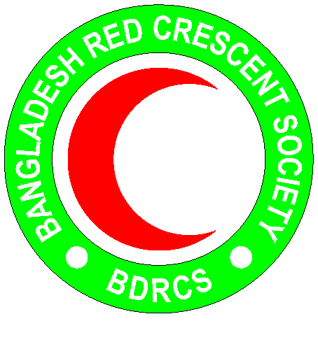
Bangladesh Red Crescent Society
National Headquarters
684-686, Red Crescent Sarak, Bara Mogh Bazar, Dhaka-1217

Vacancy Announcement

Job title : HR Officer
Duration of contract : 12 months
Department : Human Resource department
Salary : Negotiable
Reporting line : Director, HR & Admin
Age : 40 years maximum(age limit will be relaxed in case of potential candidate)
Duty station : Dhaka

Qualifications:
- Minimum Bachelor degree. BBA or MBA (Major HR) will be given priority.
- Priority will be given to candidates who demonstrate a high level of motivation and good communication, social, and interpersonal skills.
- Proficiency in MS Word, Excel, PowerPoint. Required fluency in both spoken and written in English language.
- At least 10 years working experiences with INGO/NGO

Roles and Responsibility:
- Maintains the work structure by updating job requirements and job descriptions for all positions.
- Maintains organization staff by establishing a recruiting, testing and interviewing program; counseling managers on candidate selection; conducting and analyzing exit interviews; recommending changes.
- Prepares employees for assignments by establishing and conducting orientation and training programs.
- Ensures planning, monitoring and appraisal of employee work results by training managers to coach and discipline employees; scheduling management conferences with employees; hearing and resolving employee grievances; counseling employees and supervisors.
- Maintains employee benefits programs and informs employee of benefits by studying and assessing benefit needs and trends; recommending benefit programs to management; directing the processing of benefit claims; obtaining and evaluating benefit contract bids; awarding benefit contracts; designing and conducting educational programs on benefit programs
- Ensures legal compliance by monitoring and implementing applicable human resource organizational requirements; conducting investigations; maintaining records; representing the organization at hearings.
- Maintains management guidelines by preparing, updating, and recommending human resource policies and procedures.
- Maintains historical human resource records by designing a filing and retrieval system; keeping past and current records.
- Maintains professional and technical knowledge by attending educational workshops; reviewing professional publications; establishing personal networks; participating in professional societies.
- Completes human resource operational requirements by scheduling and assigning employees; following up on work results.
- Maintains human resource staff by recruiting, selecting, orienting and training employees
- Maintains human resource staff job results by counseling and disciplining employees; planning, monitoring and appraising job results.
- Contributes to team effort by accomplishing related results as needed

Personal Qualities:
- Adhere to the 7 fundamental principles of Red Cross and Red Crescent movement
- Act at all times in accordance with the Code of Conduct
- Able to work in a team and respects opinions of others
- Honest and high level of integrity
- Assist the organization on occasion, in times of national, international, local emergencies or major disasters

