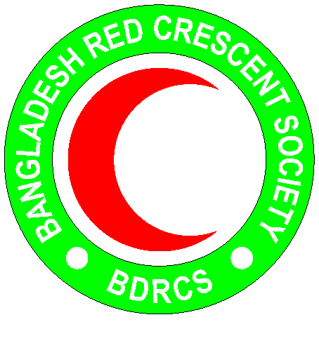
Bangladesh Red Crescent Society
National Headquarters
684-686, Red Crescent Sarak, Bara Mogh Bazar, Dhaka-1217

Vacancy Announcement

Job title : Community Mobilizer (Shelter)
Duration of contract : 6 months
Department : Disaster Response department (PMO)
Salary : Negotiable
Reporting line : Shelter officer/Expert of the PMO
Age : 36 years maximum(age limit will be relaxed in case of potential candidate)
Job nature : Contractual
Duty station : Cox’s Bazar

Qualifications:
- Candidate should be diploma in civil engineering.
- Computer literature competency needed.
- Fluency in both spoken and written in English language.
- At least 3 years relevant working experience in designing and construction of shelters in disaster recovery programs.
Roles and Responsibility:
- Manage and implement the planned activities related to emergency shelter for the target communities of the project.
- Continuously assess shelter needs in the community and undertake gap analysis for development of shelter activities.
- Design and support inclusive shelter solutions that ensure access of all regardless of their age, gender and disability.
- Apply conflict sensitive management tools in shelter programming
- Provide support to Shelter/NFI distribution activities as directed by the BDRCS, and perform with Logistics spot checks for NFI quality control
- Organize different awareness session regarding safe shelter in the community.
- Undertake field visit to monitor and review the program performance and share the findings with the team
- Represent BDRCS in relevant coordination platforms for WASH and Shelter at Cox Bazar and Dhaka
- Support monitoring and evaluation and reporting team of the project to document Shelter activities.
Assist Logistics to prepare procurement plan and ensure timely procurement of goods and services related to Shelter
- Based on rational workload assessment, support BDRCS in ongoing/potential emergency response work in other areas
- Perform any other duties assigned by the Project Manager
Personal Qualities:
- Adhere to the 7 fundamental principles of Red Cross and Red Crescent movement
- Act at all times in accordance with the Code of Conduct
- Able to work in a team and respects opinions of others
- Honest and high level of integrity
- Assist the organization on occasion, in times of national, international, local emergencies or major disasters

