Dhaka Ahsania Mission
UNIQUE II Project
Recruitment of Consultant/s for Conducting Final Evaluation of UNIQUE II Project
Terms of Reference (ToR)
  - Background: Supported by European Union, Unique intervention for Quality primary education (UNIQUE II) project is a non-formal primary education program for the out of school children has been implementing from December 2011 in 84 upazila and 26 district under 6 different regions across Bangladesh. Under the leadership of Dhaka Ahsania Mission (DAM), six other organizations (ASOD, CCDB, DORP, PMUK, SUROVI, VARD and YPSA) as a partner organization are working collaboratively for implementing the project for reaching its goals. Plan International, Bangladesh is its technical partner. This is a 6-year project started in December 2011 and was supposed to be completed in November 2017. The project has however been extended upto September 2018. The major objectives of the project is to impart quality primary education to out of school and drop out children of aged 6-14 particularly from the disadvantaged group of geographically susceptible upazila through the multi-grade teaching learning approach. It also intends to provide pre-school as well as subject based remedial services to the slow learners of the targeted government and registered primary schools. UNIQUE-II aims at promoting, facilitating and managing greater community involvement and allowing the local community to participate at all stages of the project cycle. The project works for creating sufficient ownership of local people with the aim of turning them into a vibrant community. The overall objective of the UNIQUE II Project is to contribute to develop a collaborative basic education system enabling all primary school-age children to avail quality education.
  - Major Activities of UNIQUE II Project
- Organizing 4230 Children Learning Centres (CLC) for 205,992 children
- Community based pre-primary education for 61,475 children in CLCs
- Replication of multi-grade teaching-learning approach
- Setting 423 Learning Resource Centre at union level for technical support
- Organizing 300 Learning Camp for 30,000 low performing school students
- School Improvement Programme in 157 primary schools
- Collaboration between formal and non-formal primary education
- Promoting pro-active role of local government bodies for quality education
- Development and use of contextualized learning materials at local level
- Family Life Education for the parents/guardians
- Parental linkage with livelihood opportunities to support children education
- Disaster preparedness for uninterrupted children education in 13 upazilla
- Promoting mother language education for early learning in 9 upazilla
- Sharing of lessons among primary education actors for cross learning

- Objectives of the assignment:
The aim of this assignment is to conduct final evaluation of UNIQUE II Project.
- Criteria of the Evaluation:
The final evaluation will examine all activities being implemented under the UNIQUE II project working areas located in the six regions with eight partner organizations since December 2011.The consultant will provide more forward looking recommendations and impact of the project activities based on the findings and lessons learned. The final evaluation will be conducted base on the following criteria:
- Relevance: The analysis of relevance will focus on context of geographical location, targeted stakeholder and their needs, contributes to national target and policy in relation to the design of the project.
- Effectiveness: The effectiveness relates to the achievement of the goal and objectives of the project. The effectiveness criterion, concerns how far the project’s results were attained, and the programme’s specific objectives achieved, or are expected to be achieved.
- Efficiency: The efficiency concerns with sound management and value for money in term of various activities, resources mobilization, expected results, operational work planning and implementation, management of the budget according to the design of the project.
- Sustainability: The sustainability relates to the outcomes of the project intervention and the project intervention’s continuation after the end of donor funding flow. The sustainability issues include community participation in intervention and monitoring, community contribution and commitment, institutional capacity, financial capacity, etc. in relation to the design of the project.
- Impact:The terms ‘impact’ denotes the relationship between the project’s specific and overall objectives. The consultant will identify the extent to which the objectives of the project have been achieved, what extent to which the changes of community and other relevant stakeholders’ awareness, behavior, practices have been made.
- Visibility: The terms ‘visibility’ mentions the display of the project outcomes. The consultant will mention visibility according the guideline of European Union.

- Methodologies of the Evaluation:
For details on the methodologies of the evaluation, please see the Annex 1.
- Expected Outputs and Timeframe of this Assignment
Expected Output | Timeframe
- Inception Report | Within three working days after signing MoU
- Draft Find Evaluation Report | Within five working weeks after signing MoU
- Find Evaluation Report | Within six working weeks after signing MoU

- The estimated start date for the work is 12th May 2018. The entire assignment is to be completed within 6 working weeks (42 working days) spread-out in 8 working weeks from the date of signing the MOU. Therefore the consultant will have to submit a detailed work-plan with the proposal.
- The consultant must be willing to revise the final report based on the feedback till the contracting authority is fully satisfied.
- Structure of the Final Evaluation Report: For details of the structure of the final evaluation report, Annex 2 to be followed.
- Payment Schedule: The UNIQUE II project, Dhaka Ahsania Mission will make all payments (Lumpsum basis) by account payee cheque. However, the payment will be made as per the Finance Act of Bangladesh Government. The payment schedule will be as follows:
- 1st Payment: 25% of total contract value will be paid with the signing of the MOU.
- 2nd Payment: 50% will be paid after submission of draft report in the suggested format as per Annex 2. The payment will be made after approval of the draft report by the respective authority.
- Final Payment: Rest of the 25% payment will be made after the final report is submitted with entire satisfaction and after approval by the respective authority.
- Consultant’s expected profile:
- An International/ National consultant who has a post graduate degree, preferably a Ph.D with research experience in multi-sectorial education projects.
- S/he must have extensive experience in conducting evaluation of EU funded projects (preferably non-formal primary education projects) with proven experience in preparing baseline reports, project evaluation report of development organizations such as international or National NGOs
- Publications in the national and international recognized journal will be an advantage
- Thorough understanding of Bangladesh development context.
- Requirements from the consultant to submit the proposal:
- With the proposal, the consultant must provide (a) forwarding letter with detailed CV (b) evidence/certificates of research/study experience (c) updated income tax certificates (d) a detailed work plan and (e) the technical proposal and the expected cost statement/budget (all inclusive) to accomplish the entire assignment (therefore s/he must be aware of VAT/Tax rules of Bangladesh Government prior to submit the proposal) and (f) a signed declaration as per the template mentioned in Annex -3.
- It is to be noted that the project office shall not provide any office/logistics/vehicles support to the consultant. But, necessary support service from field based staff can be provided to the consultant. Therefore, the consultant to include all related expenses in the estimated cost statement.
- The Project will not provide any full time space for desk work. However, if available, limited space can only be provided for meetings with project staff/stakeholders during the evaluation. Others logistics like laptop, printer, paper, internet support, camera, tape recorder and other accessories will be managed by respective consultant.
- Disclaimer
UNIQUE II Project/ Dhaka Ahsania Mission (DAM) reserves the right to accept or reject any or all proposals/application without assigning any reason whatsoever. However, value-for-money will be an important criterion in selection of the consultant.

The sealed proposal along with all documents as mentioned in section 10 to be addressed to:
Deputy Director-PSS,
Dhaka Ahsania Mission
House-19, Road-12 (New), Dhanmondi R/A, Dhaka-1209
The envelop should be marked on top ‘Final Evaluation Consultant- UNIQUE II, DAM’.
Deadline for submission: May 12, 2018
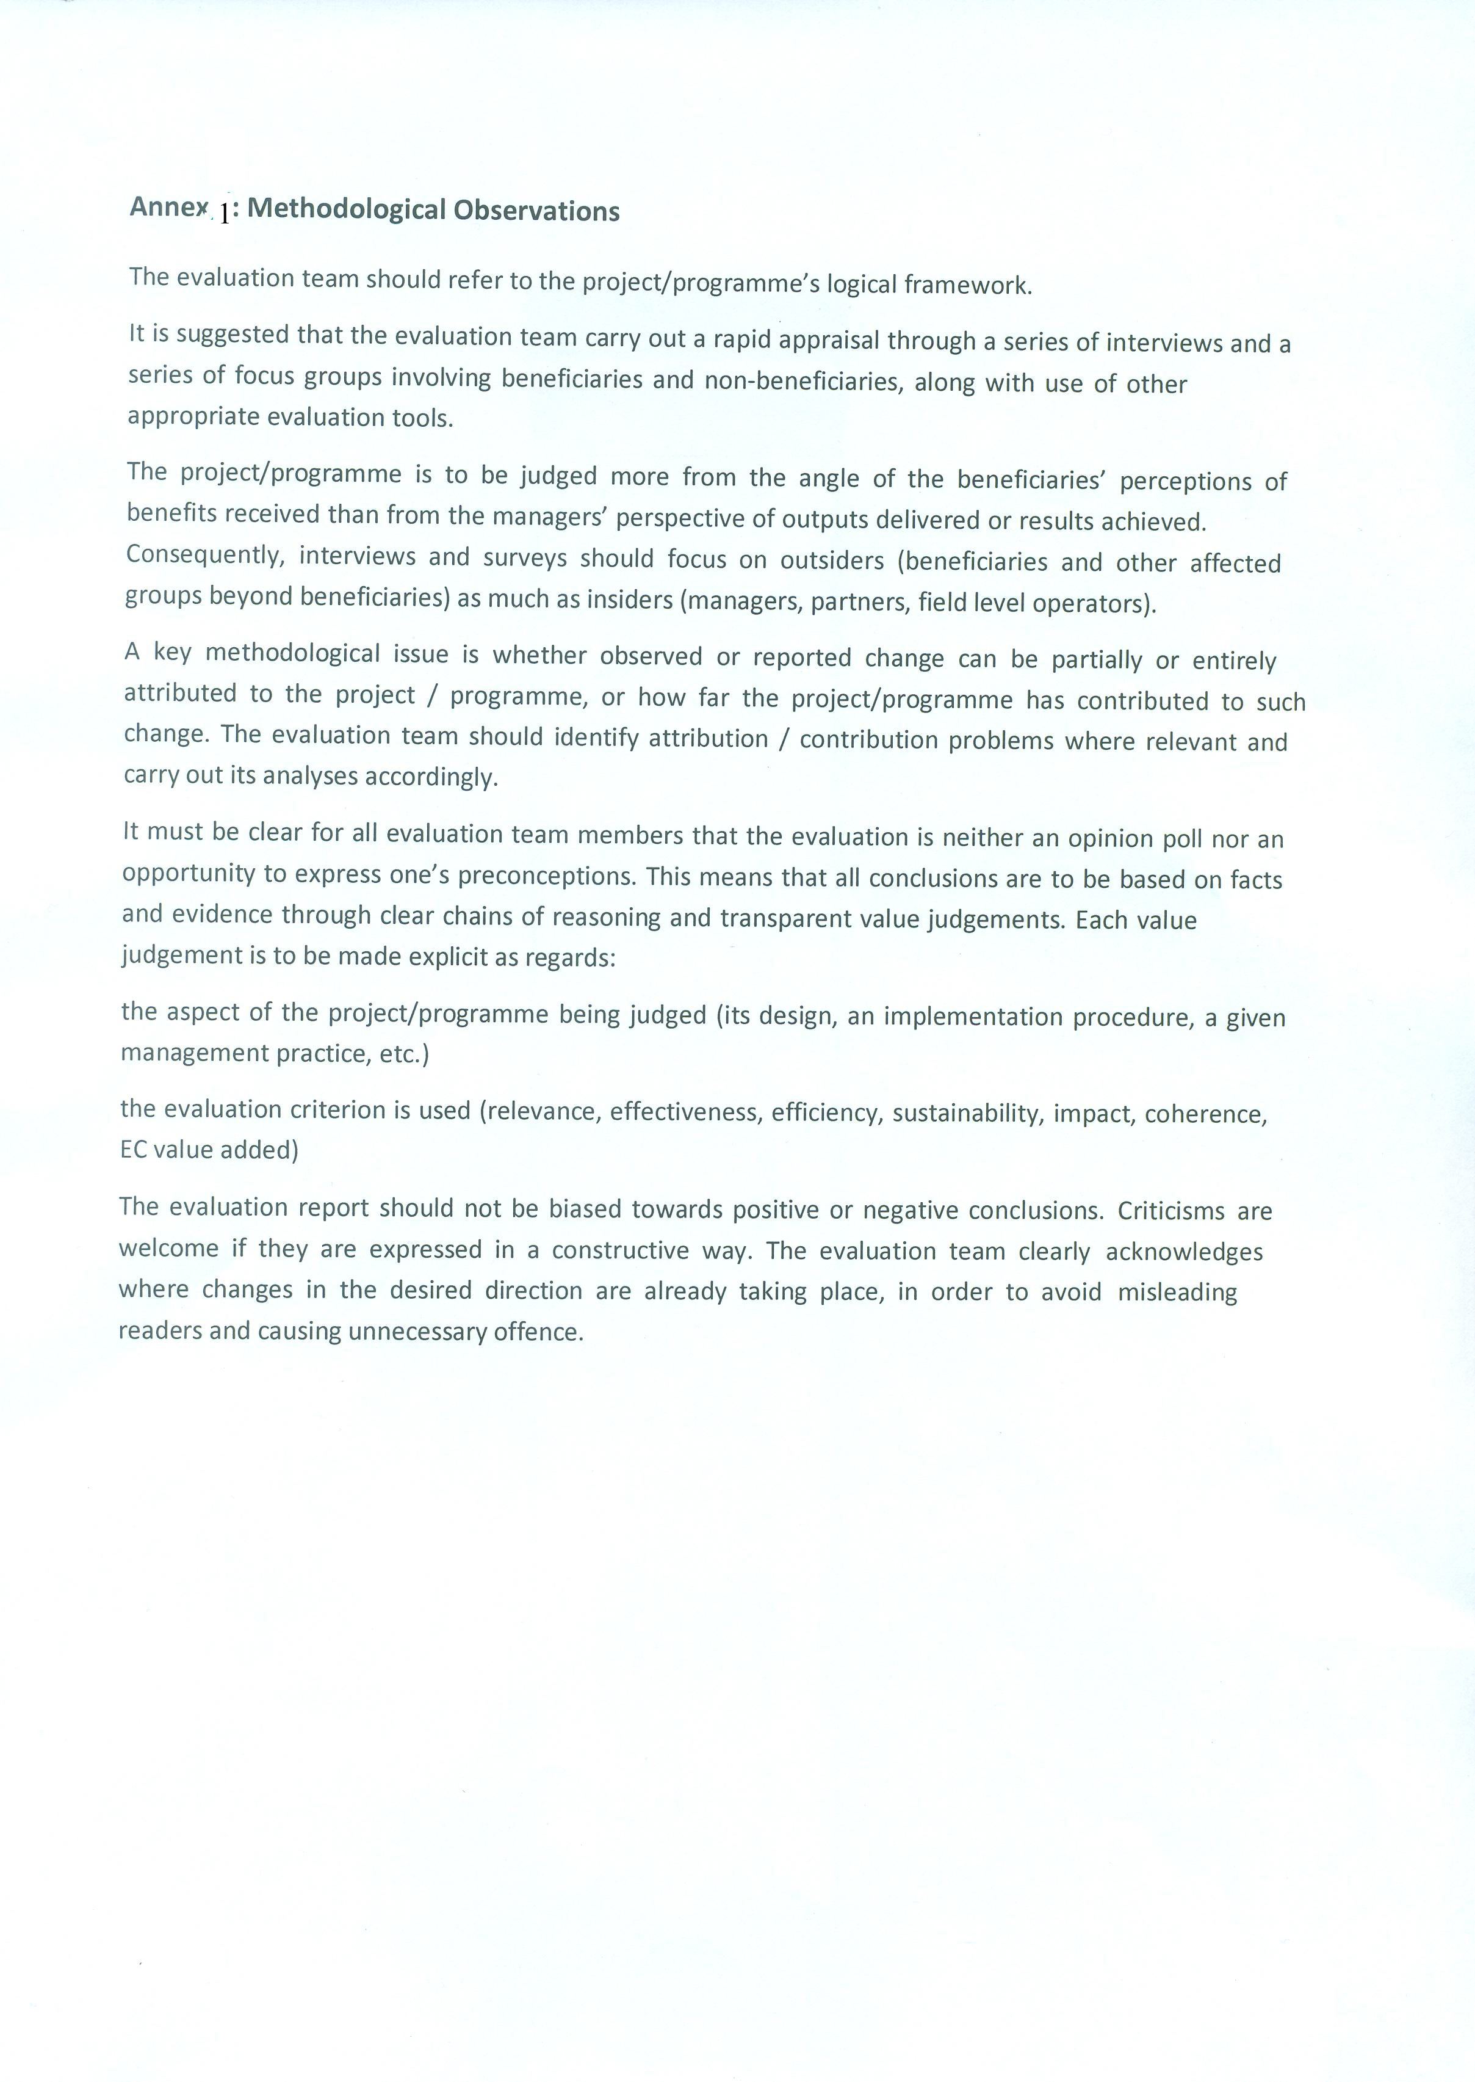
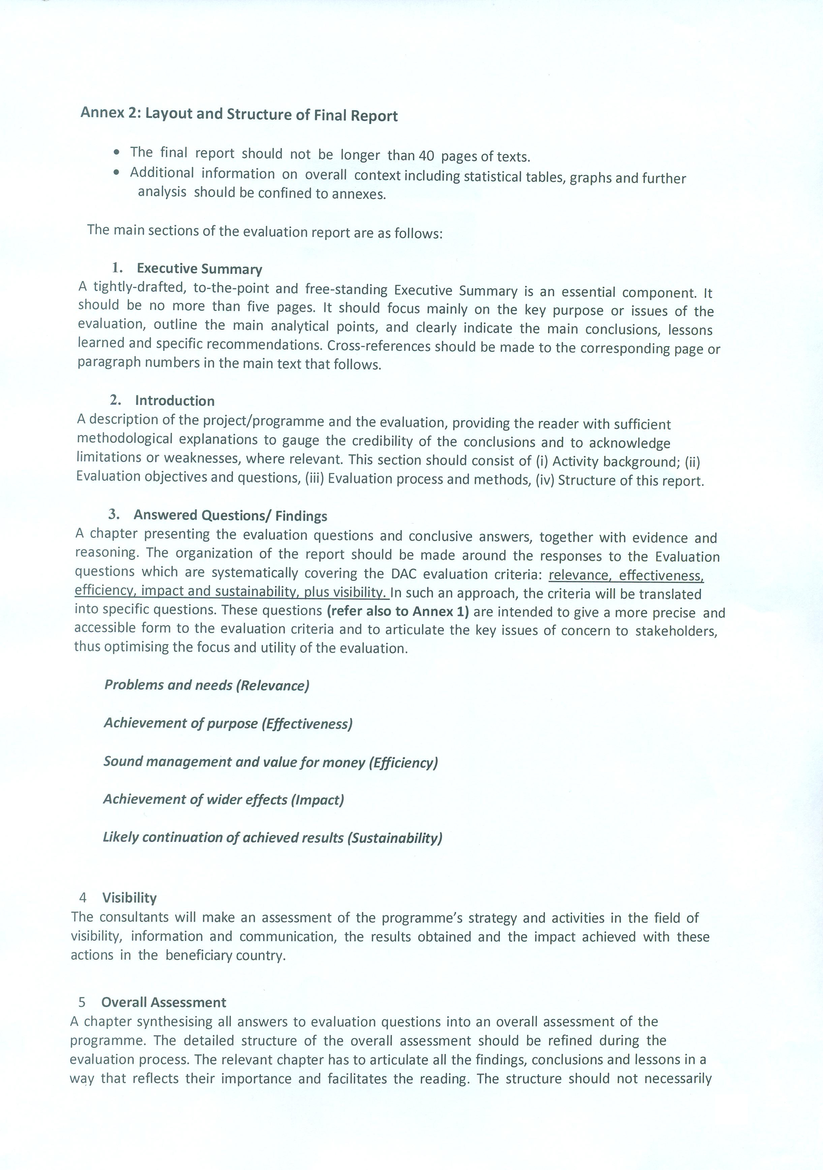
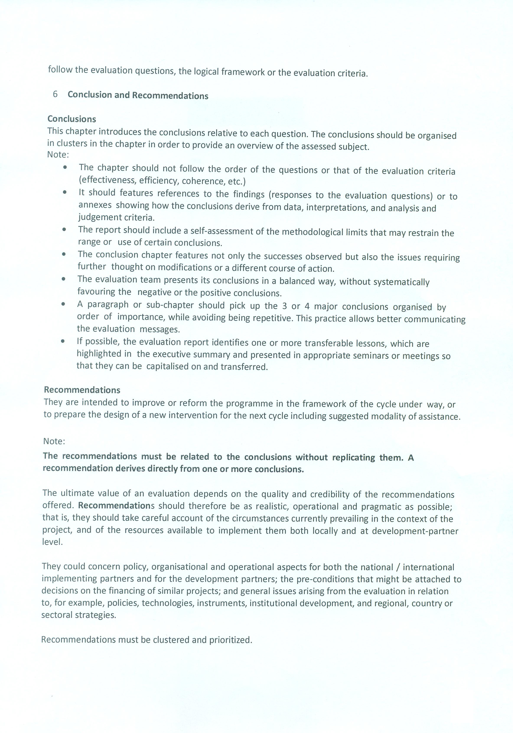
Annex: 3

To Date :
Deputy Director-PSS
Dhaka Ahsania Mission (DAM)
House # 19, Road # 12 (New)
Dhanmondi, Dhaka.

I/we/our entities hereby certify that I am/we/our entities are not in one of the following situations (per section 2.4, Annex IV of the grant contract DCI-ASIE/2011/262-796 between the beneficiary, DAM and the contracting authority, EU):

- I am/we/our entities are bankrupt or being wound up, are having my/their affairs administered by the courts, have entered into an arrangement with creditors, have suspended business activities, are the subject of proceedings concerning those matters, or are in any analogous situation arising from a similar procedure provided for in national legislation or regulations;
- I am/we/our entities have been convicted of an offence concerning my/our/our entities’ professional conduct by a judgment which has the force of res judicata (a matter that has been adjudicated by a competent court and may not be pursued further by the same parties.);
- I am/we/our our entities have been guilty of grave professional misconduct proven by any means which the Beneficiary can justify;
- I am/we/ our entities have not fulfilled obligations relating to the payment of social security contributions or the payment of taxes in accordance with the legal provisions of the country in which I am/we/ our entities are established or with those of the country of the Beneficiary or those of the country where the contract is to be performed.
- I am/we/ our entities have been the subject of a judgment which has the force of res judicata for fraud, corruption, involvement in a criminal organisation or any other illegal activity detrimental to the Communities’ financial interests;
- I am/we/ our entities are currently subject to an administrative penalty referred to in section 2.3.5 of the Practical Guide to contract procedures for EC external actions.
- I am/we/ our entities are subject to a conflict of interest;
- I am/we/ our entities are guilty of misrepresentation in supplying the information required by the Beneficiary as a condition of participation in the contract procedures or fail to supply this information.

2.3.5.Visibility: Unless otherwise requested or agreed by the European Commission, all EU partners, whether they may be contractors, grant beneficiaries or entities managing funds on behalf of the European Commission, must ensure the visibility of EU financing. If required, a communication plan must be submitted for approval of the Contracting Authority, according to the requirements and guidelines provided in the Communication and Visibility Manual for EU External Actions, published at: http://ec.europa.eu/europeaid/work/visibility/index_en.htm.

Thanking you

Yours Faithfully

Name and signature of the candidate/s or tenderers (on behalf of entities)

